**IBANDA DISTRICT ACADEMIC BOARD**

**P.7 INTEGRATED SCIENCE**

**LESSON NOTES 2025**

**TOPIC 1: MUSCULAR – SKELETAL SYSTEM**

**VOCABULARY**

* **Skeleton**
* **Exo-skeleton**
* **Endo-skeleton**
* **Posture**
* **Hinge joint**
* **Ball and socket**
* **Pivot joint**
* **Gliding joint**
* **Voluntary muscles.**
* **Involuntary muscle**
* **Antagonistic muscles**
* **Suture joint**

**MUSCULAR – SKELETAL SYSTEM**

1. **What is muscular –skeletal system?**

Muscular system is a system that gives organisms shape and ability to move.

* Muscular-Skeletal system is a composed of bones and muscles.

**SKELETON**

1. **What is a skeleton?**

A skeleton is the part of the body that forms the supporting structure of an organism.

**TYPES OF SKELETONS**

1. **Exo-skeleton**

Exoskeleton is the type of skeleton found outside the body of an organism.

**Examples of organisms with exo skeleton**

* Insects like houseflies, butterflies, cockroaches, bees, mosquitoes, tsetse flies etc.
* Crustaceans like crabs, lobsters, prawns and woodlouse.
* Organisms or animals with exoskeleton grow by shedding their outer cuticle and this process is called **ecdysis / moulting.**

1. **Endoskeleton**.

Endoskeleton is the type of skeleton found inside the body of an organism.

**Examples of organisms with endoskeleton**

* Human beings (people)
* Monkeys
* Snake
* Crocodiles
* Cattle
* Baboons
* Lions
* Lizards
* Frogs
* Bird

**Note**; Endoskeleton is made up of bones and cartilages.

**Hydrostatic skeleton**

Hydrostatic skeleton is the type of skeleton where the body of an organism is filled with fluid under pressure and action of the surrounding muscles to produce movement.

* Hydrostatic skeleton is where the pressure of the fluid and action of the surrounding muscles are used to change the shape of an organism and produce movement.
* Hydrostatic skeleton is the type of skeleton where support is provided by the liquid under pressure in the body of an organism.

**Examples of organisms with hydrostatic skeleton**

* Snails
* Earth worms
* Slugs
* Star fish
* Jelly fish
* Caterpillars
* Sea urchins etc.

**ACTIVITY**

**Observing the parts of the human skeleton**

**EXERCISE**

1. **How many bones does a normal human being possess?**
2. **Write down three types of skeleton.**
3. **How is ecdysis important to insects?**
4. **What type of skeleton do the following have;**
5. **Snails**
6. **Snakes**
7. **A tortoise**
8. **Caterpillars**
9. **Why is ecdysis referred to as a biological change?**

**HUMAN SKELETON**

**3. What is a human skeleton?**

Human skeleton is the frame work of bones in the body.

An adult human being has about **206 bones**

**STRUCTURE OF THE HUMAN SKELETON**

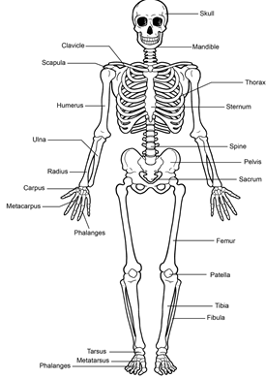

**The human skeleton is composed of two major regions namely;**

1. **Axial skeleton**

The axial consist of the skull, vertebral column, ribs and breast bone (sternum)

1. **Appendicular skeleton**

The appendicular consists of the limbs and the limb girdles (pelvis and shoulder girdle)

**FUNCTIONS OF THE SKELETAL SYSTEM**

**1.** A skeleton protects the delicate body organs like,

* The brain ________________________ Skull
* Eyes____________________________ Orbits (eye sockets)
* Heart, lungs and liver______________Ribcage
* The spinal cord____________________vertebrae (backbone) or spine
* Reproductive organs_______________Pelvis(pelvic girdle)

**2.** Skeleton provides support to the body.

**3.** A Skeleton aids body movement.

**4.** A skeletonstores minerals like calcium and phosphorus.

**5.** Skeleton manufactures body cells like Red blood cells, white blood cells and blood platelets in the bone marrow

**6**. Skeleton provides room for attachment of muscles.

**BONES**

1. **What is a bone**?

A bone is the hardest tissue found in the body of vertebrates.

* Bones contain living cells which are supplied with food and oxygen by the blood vessels.
* Bones are made from mineral salts and proteins. The process by which bones are formed is called **ossification.**
* Mineral salts that help in bone formation are calcium and phosphorous.

**Function of bones in the human body.**

* Bones provide attachment for the internal body organs
* Bones provide framework to support the body
* Bones produce blood cells in the bone marrow.
* Bones store calcium and phosphorous in the body.

**CLASSIFICATION OF BONES (TYPES OF BONES)**

Bones are classified according to their shapes lengths.

1. **LONG BONES.**

Long bones are found in both upper (arms) and lower limbs (legs).

**Examples of long bones in the upper limbs (arms)**

* Radius
* Ulna
* Humerus
* Phalanges

**Diagram showing long bones in the upper limbs (arms)**

**Examples of long bones in the lower limbs (legs)**

* Femur (longest and strongest bone in the body)
* Fibula
* Tibia
* phalanges

**Diagram showing long bones in the lower limbs (legs)**

**SHORT BONES**

Short bones are found in the feet (wrist) and hands (ankles).

**Examples of short bones in the body**

* Carpals
* Tarsal

**FLAT BONES**

Flat bones are bones having sides that are almost parallel to each other

**Examples of flat bones in the body**

* The scapula (shoulder
* blade)
* The cranium (skull)
* The sternum (breast bone)
* The pelvis and ribcage

**Diagram showing sternum (breast bone) and rib cage**

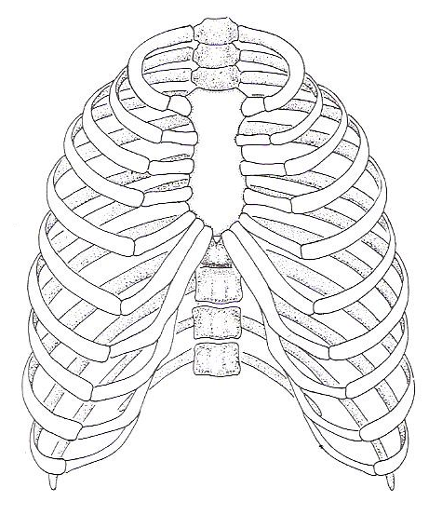

**Diagram showing pelvis (pelvic girdle)**

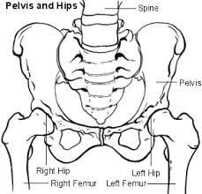

**IRREGULAR SHAPED BONES**

**Examples of irregular bones**

* Backbone (spinal column)
* Neck vertebra
* Sacrum

**ACTIVITY**

1. **What scientific term describes the hardest tissue in the body of vertebrates?**
2. **Identify the largest bone in the human body.**
3. **Name the part of a skeleton that protects the heart and lungs.**
4. **Name the bone in the body in which the ribs are attached.**
5. **Which mineral helps in the proper growth of bones in the body?**
6. **What is ossification?**
7. **Mention the body system protected by pelvic girdle.**
8. **How is ecdysis important to insects and some reptiles?**
9. **Why do babies have more bones than adults?**
10. **What is a bone marrow?**
11. **How does muscular and skeletal system essential to circulatory system?**
12. **How are bone marrows important in our body?**
13. **State any one example of each of the bones below**
14. **Long bones in the upper and lower limb.**
15. **irregular bones**
16. **Short bone**
17. **How do the skeletons protect the delicate body organs?**
18. **(a) Which type of skeleton is possessed by an animal drawn below.( snail)**
19. **Match list A to those in list B**

**List A List B**

**Femur Ankles**

**Ulna Upper limb**

**Tarsals Lower limbs**

**Carpals wrists**

**JOINTS**A joint is a part of the body where two or more bones meet.

**How is a joint adapted to a friction free movement?**

* A joint contains synovial fluid which reduces friction at the joint.  
  -The bones are covered with cartilage at the ends.

**THE STRUCTURE OF A JOINT**

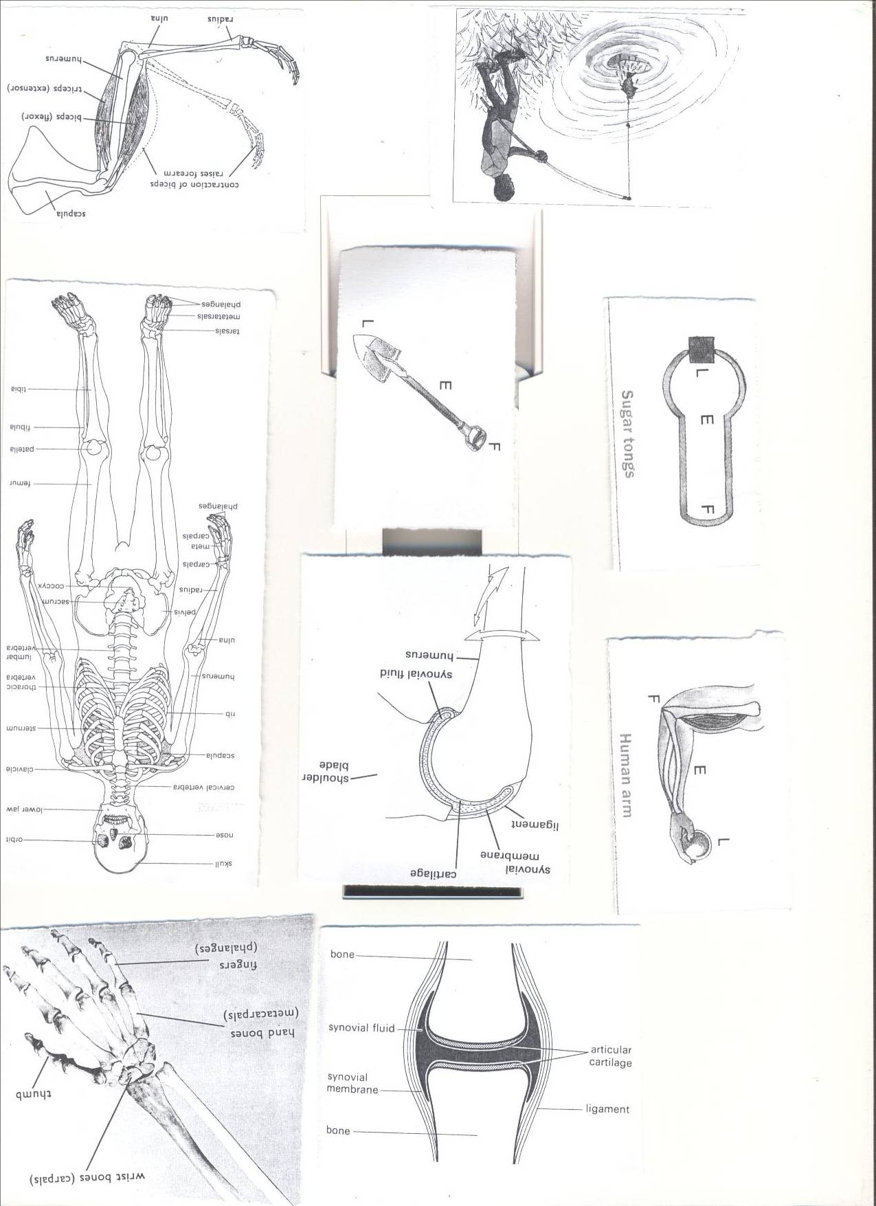

1. **Tendon**

**A tendon** is a tough fibrous tissue that connects muscles to bones.

1. **Ligament**

Ligament is a fibrous elastic tissue that joins a bone to a bone.

1. **Cartilage**

A cartilage is soft tissue that covers most of the end parts of bones in the body of an organism.

-A cartilageprevents the bone ends from frictional damage after rubbing directly onto each other.  
Inside a joint is **a lining of synovial membrane** which secretes **synovial fluids.**

1. **Synovial fluid**

Synovial fluid reduces **friction** in a joint.

**TYPES OF JOINTS**

1. Movable joints

2. Immovable joints

**MOVABLE JOINTS**

**1. What are movable joints?**

Movable joints are joints which allow movement.

* Movable joints are held together by ligaments and tendons.

**Examples of movable joints**

* Hinge joints
* Ball and socket joint
* Pivot joints
* Gliding/plane joints

1. **HINGE JOINTS**

**What are hinge joints?**

Hinge joints are type of movable joint which allow movement in one plane.

* Hinge joints are type of joints which allow to and fro or up and down movement.
* Hinge joints are found in the knee and elbow.

**Examples of hinge joints**

* The elbow joint
* The knee joint
* Knuckle

**Note:** They are called hinge joints because their movement is like the hinges of the door.

**Diagram showing a knee joint**

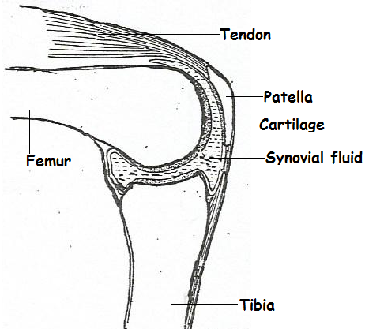

**Diagram showing an elbow joint**

1. **BALL AND SOCKET JOINT**
2. **What is a ball and socket joint?**

A ball and socket joint is type of movable joint which allow movement in three planes.

* Ball and socket joints are found in the shoulder and pelvic girdle (hip)

**Examples of ball and socket joint**

* The shoulder joint
* The pelvic girdle (hip) joint

**Note:** They are called ball and socket because the ball shaped end of one bone fits into a socket in the other bone.

**Diagram showing ball and socket joint**

1. **PIVOT JOINTS**

Pivot joint is the type of joint which allows rotation of certain parts of the body on the other parts.

* Pivot joints enable us to nod our heads.

**Example of pivot joints**

* Neck vertebra

1. **GLIDING/PLANE JOINTS**

Gliding or plane joint is a type of movable joint where two flat moving bones slide over one another easily.

* Gliding joints are found in the wrists and ankles.

**Diagram showing gliding joints**

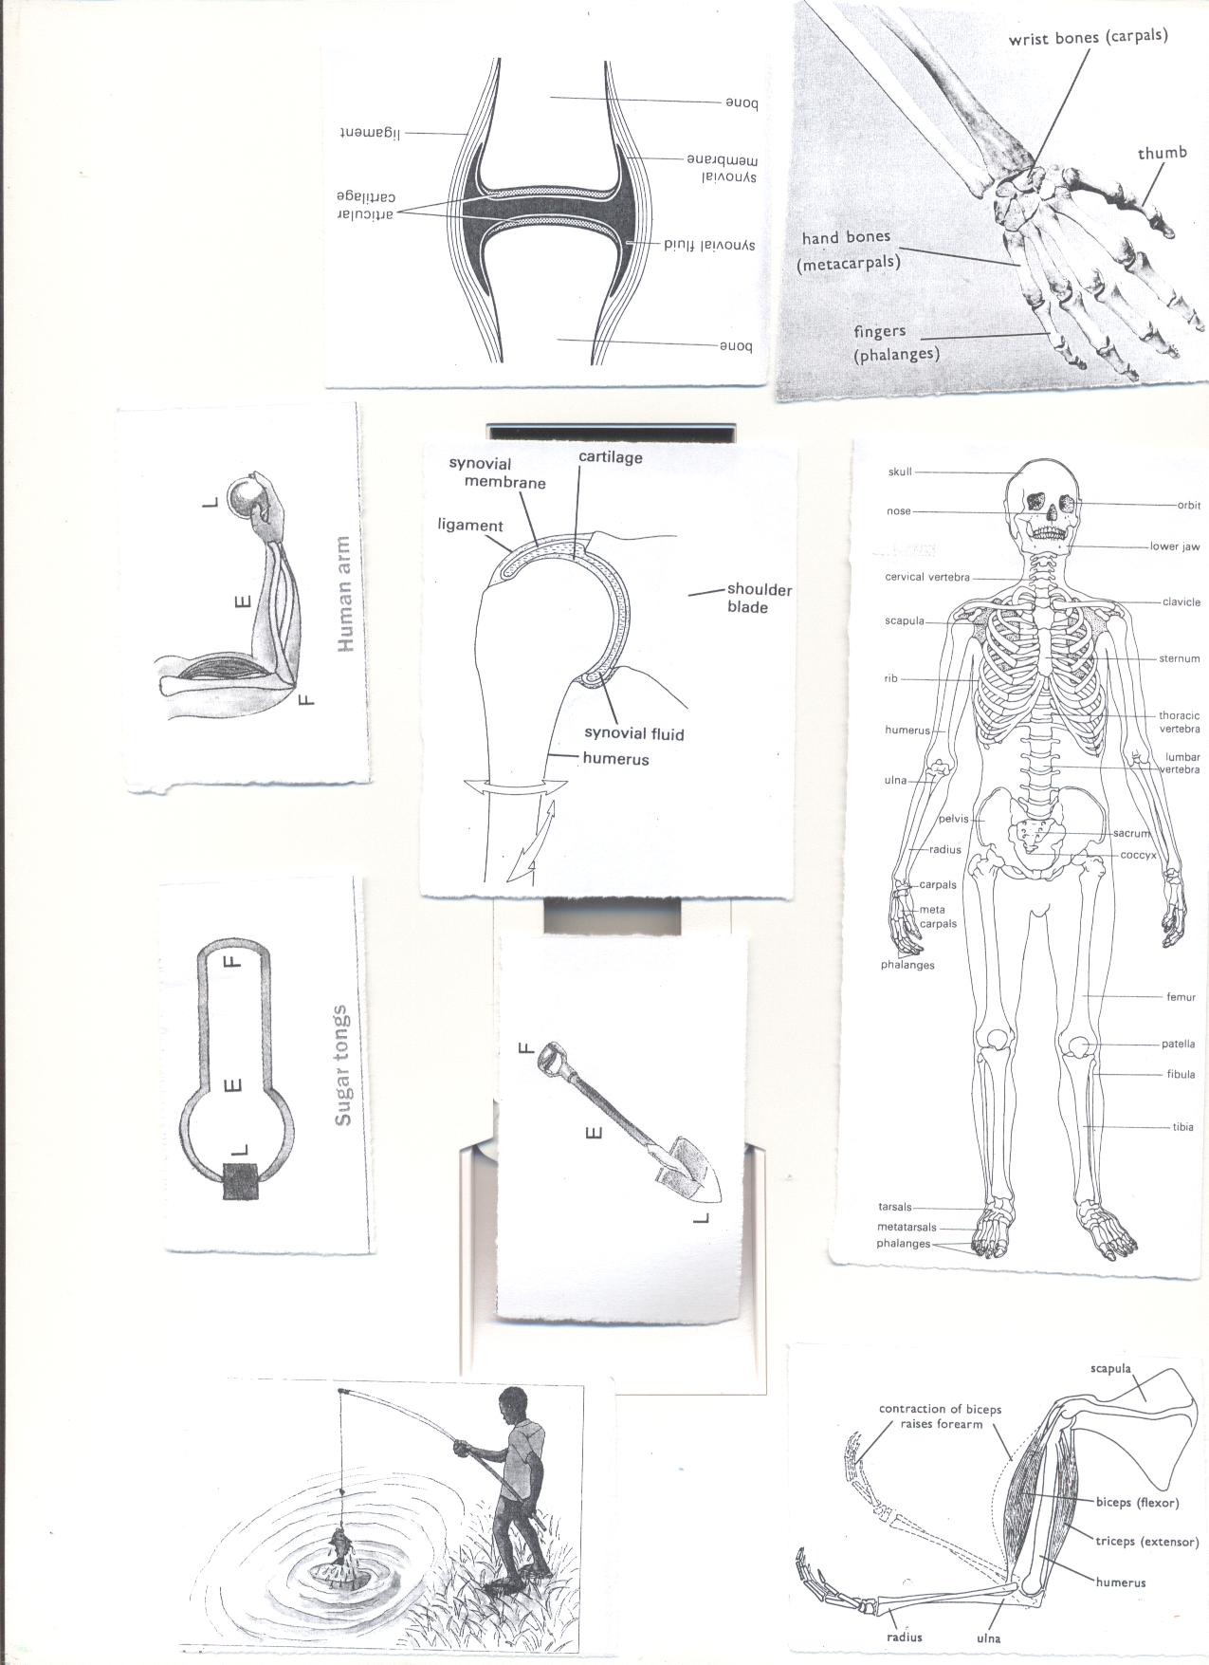

**Importance of joints in the body**

* Joints aid movement in the body
* Joints enable us to nod our heads.

**IMMOVABLE JOINTS**

**1. What is an immovable joint?**

Immovable joint is a type of joint which do not allow movement in the body.

**Example of an immovable joint**

-The suture joints of the skull

**Diagram showing the structure of suture joints of the skull**

**ACTIVITY**

1. **How are joints important to a boy of 4 years?**
2. **What is a joint?**
3. **Write down one way joints are similar to muscles.**
4. **Write down any one example of a hinge joint.**
5. **Why is a shoulder joint said to be a movable joint?**
6. **State the substance in the human body that helps to reduce friction.**

**MUSCLES**

**1. What is a muscle?**

A muscle is an elastic bundle of flesh under the skin that is attached to bones.

A muscle is a special elastic tissue that contracts and relaxes to produce movement.

**TYPES OF MUSCLES**

There are two types of muscles namely;

* Voluntary muscles
* Involuntary muscles

1. **Voluntary muscles / skeletal muscles**

Voluntary muscles are muscles whose action is normally controlled by an individual's will.

* Voluntary muscles are muscles whose movement can be controlled

1. **Examples of voluntary muscles.**

* Biceps (flexor) muscles of the hand which connects the scapula and the radius
* Triceps (extensor) muscles of the hand which connects the scapula the Humerus and ulna.

**Involuntary muscles or smooth muscles**

Involuntary muscles are muscles whose movement is not under individual’s will.

* Involuntary muscles are muscles whose movement is automatic (cannot be controlled by an individual)

**Examples of involuntary muscles;**

* + Cardiac muscles of the heart.
  + Muscles of the eye lids.
  + Muscles of the stomach and intestines
  + Muscles of the blood vessels.
  + Muscles of the excretory system

**Antagonistic muscles**

**What are antagonistic muscles?**

Antagonistic muscles are muscles that work in pairs but have an opposite effect to each other.

* Antagonistic muscles are muscles that work in pairs but in opposite direction.

**Example of antagonistic muscles**

* Biceps (flexor) and triceps (extensor)



**Activity**

1. **What is a muscle?**
2. **State the two types of muscles in our bodies.**
3. **Why the triceps and biceps are called antagonistic muscles?**
4. **How are muscles useful in our bodies?**
5. **Cite any one disorder to the body muscle.**

**DISORDERS OF THE MUSCULAR AND SKELETAL SYSTEM**

* Fractures
* Sprain
* Strains
* Dislocation
* Cuts
* Spinabifida-The spinal cord does not form properly.

**DISEASES OF THE MUSCULAR SKELETAL SYSTEM**

1. **Polio (poliomyelitis)**

Polio is caused by **a virus** passed out by an infected person’s faeces.

**How is polio spread from an infected person to another**?

* Polio is spread through drinking contaminated water
* Polio is spread through eating contaminated food
* Polio is spread through swimming in dirty water.

**Signs and symptoms of poliomyelitis**

* Paralysis of the limbs
* Weaknesses of the bones
* Fever

**How can poliomyelitis be prevented and controlled in the community?**

* By immunization with polio vaccine through drops in the mouth
* By boiling water for drinking
* By proper use of latrines
* Washing hands with soap and clean water before and after eating food

**Note; polio affects bones especially limbs. Polio is water borne disease that affects the skeleton.**

1. **TUBERCULOSIS OF THE SPINES**

Tuberculosis is caused by bacterium called mycobacterium tuberculosis of the spine.

* The bacterium was first discovered by a scientist called **Robert Koch in 1882.**

**How is the bacterium that spread tuberculosis spread?**

* The bacterium is spread through air
* Long lasting painful backache
* Paralysis of the legs or failure to walk
* Pain in the while walking

**How can tuberculosis of the spine be prevented or controlled?**

* By treating of the infected person
* By immunization with **BCG** vaccine on the right upper arm at birth
* By drinking boiled or pasteurized milk
* By isolating the infected person

1. **TETANUS**

Tetanus is caused by bacteria found in the soil

**How do bacteria that cause tetanus enter the body?**

* The bacteria enter through fresh cuts or wound
* In babies the bacteria enter through the umbilical cord if it’s cut with dirty or unsterilized instruments like razorblade.
* Tetanus attacks muscles making them stiff and breathing also becomes difficult.

**Signs and symptoms of tetanus**

* Stiff muscles all over the body
* The baby stops sucking mother’s breasts
* Spasms when touched.

**Prevention and control of tetanus**

* Early immunization with **DPT** vaccine on the left upper thigh
* Treating the infected person
* Put on shoes while walking
* Keeps sharp skin piercing objects out of children’s reach

1. **RICKETS**

Rickets is a deficiency disease caused by lack of enough foods containing vitamin D, Calcium and phosphorous in the diet.

* Rickets affects the bones especially during pregnancy.
* In adults, rickets can cause common fractures.

**Signs and symptoms of rickets**

* Oxbow legs
* Knock knee legs
* Weak bones and poor teeth

**Control and prevention of rickets**

-Eating food containing vitamin D, Calcium and phosphorous.

**Other diseases of the muscular skeletal system**

* **Arthritis**

**-**pain, Stiffness and swelling of joints

* **Scurvy**

**Scurvy is** caused by lack of ascorbic acid (vitamin C) in the diet.

* **Osteoporosis** is caused by low level of calcium in the body.

**State five importance of regular physical exercises to the body**

* Physical body exercises strengthen the heart muscles
* Regular physical exercises reduce the risk of heart diseases like heart attack, high and low blood pressure etc.
* Regular physical exercises reduce level of fats in the body.
* Digestion of food is carried out faster and quickly.
* Physical exercises make the heart to pump more blood to the muscles in the body.
* Regular physical exercises make joints become more flexible and reduce the chances of injury.

**POSTURE**

Posture is a way a person positions his or her body when sitting, standing or walking.

* Posture is a way one positions his or her body in whatever he or she does.

**The correct sitting Posture**

* Sit up straight on the chair.
* Place both feet on the floor.
* Put all your weight on both bottoms.
* Do not tighten your ankles and knees.

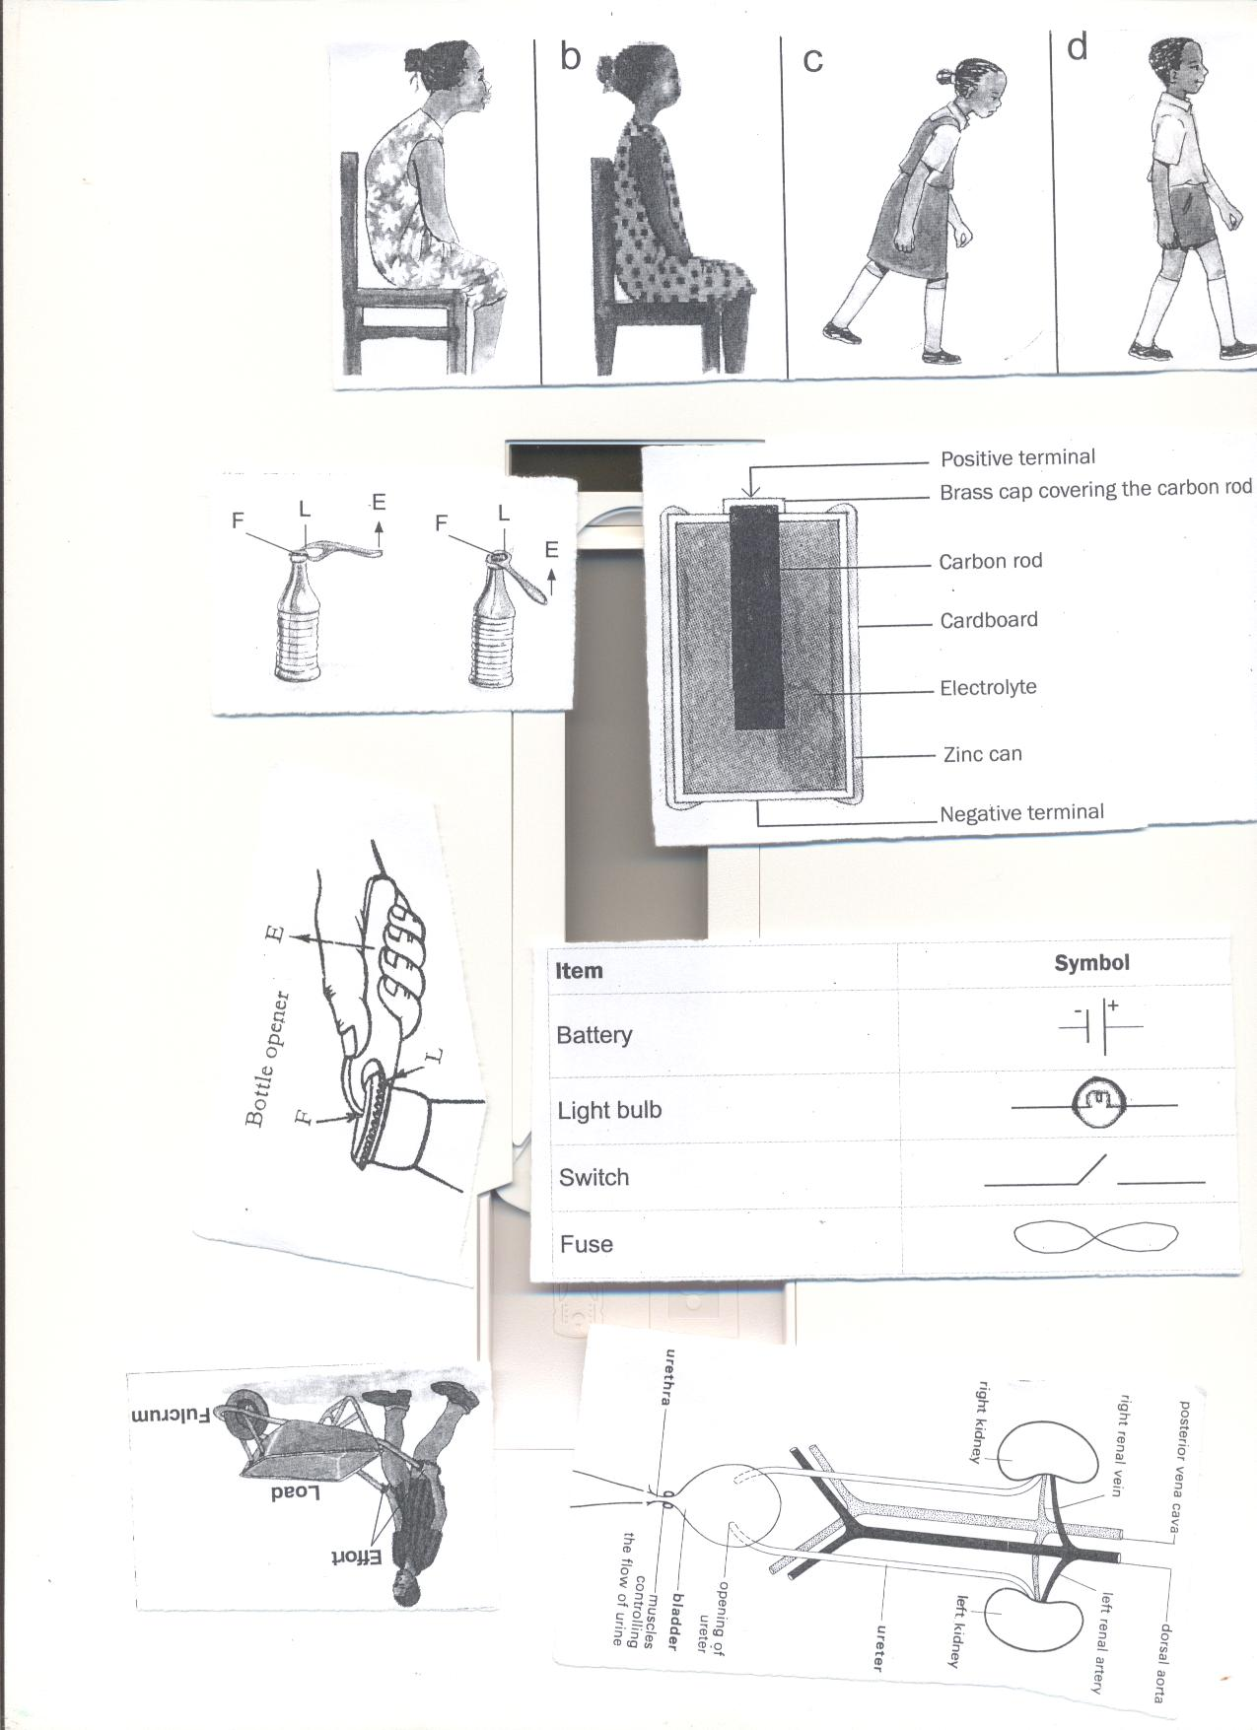

**Importance of correct posture**

* Correct posture prevents body aches
* Correct posture prevents bones bending (bones deformation)

**HEALTH HABITS THAT HELP TO MAINTAIN PROPER FUNCTIONING OF THE MUSCULAR –SKELETAL SYSTEM**

* Eating a balanced diet
* Doing regular physical body exercises
* Early immunization of children against diseases like tuberculosis, polio and tetanus
* Boiling water for drinking
* Ensure proper body posture

**TOPICAL QUESTIONS**

1**. Which class of food is necessary for proper growth of bones?**

**2. Write down one example of each of the following**

**a) Skeletal muscles b) Smooth muscles**

**3. What is the functional difference between ligaments and tendons?**

**4State one disorder to each of the following**

1. **Ligaments b) tendons.**

**5. Which part of the skeleton protects the following?**

**a) Brain b) tendons**

**6. State one health habit that can keep one’s skeleton in a healthy working condition.**

**TOPIC 2: ELECTRICITY AND MAGNETISM**

**VOCABULARY**

* **Electricity**
* **Fuse**
* **Circuit**
* **Switch**
* **Insulator**
* **Conductors**
* **Short circuit**
* **Magnet**
* **Electro – magnet**
* **Device**
* **Magnetism**
* **Dynamo**

**ELECTRICITY**

1. **What is electricity?**

Electricity is a form of energy produced due to the presence of charges in the body.

**TYPES OF ELECTRICITY**

1. **Mention two types of electricity**

* Current electricity
* Static electricity

**CURRENT ELECTRICITY**   
**(a) What is current electricity?**

Current electricity is the type of electricity where electrons flow through good conductors.  
**The diagram showing the flow of current/ electricity/convectional current**

**Note.** Current/electricity flow from positive terminal to negative terminal  
  
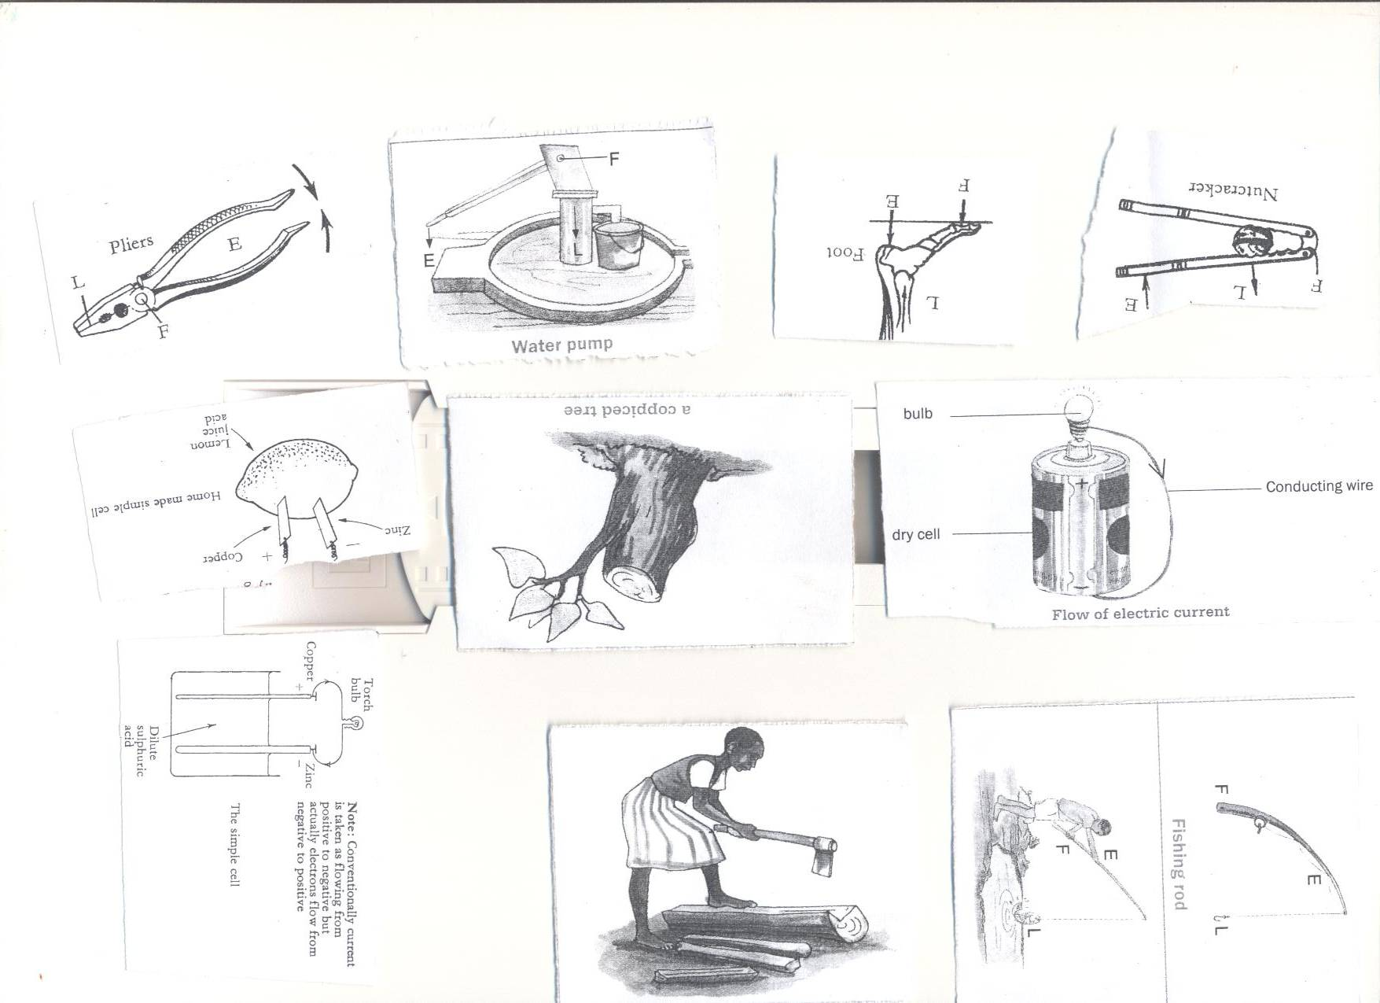

**The diagram showing the flow of electrons**

**Note.** Electrons flow from negative terminal to positive terminal.  
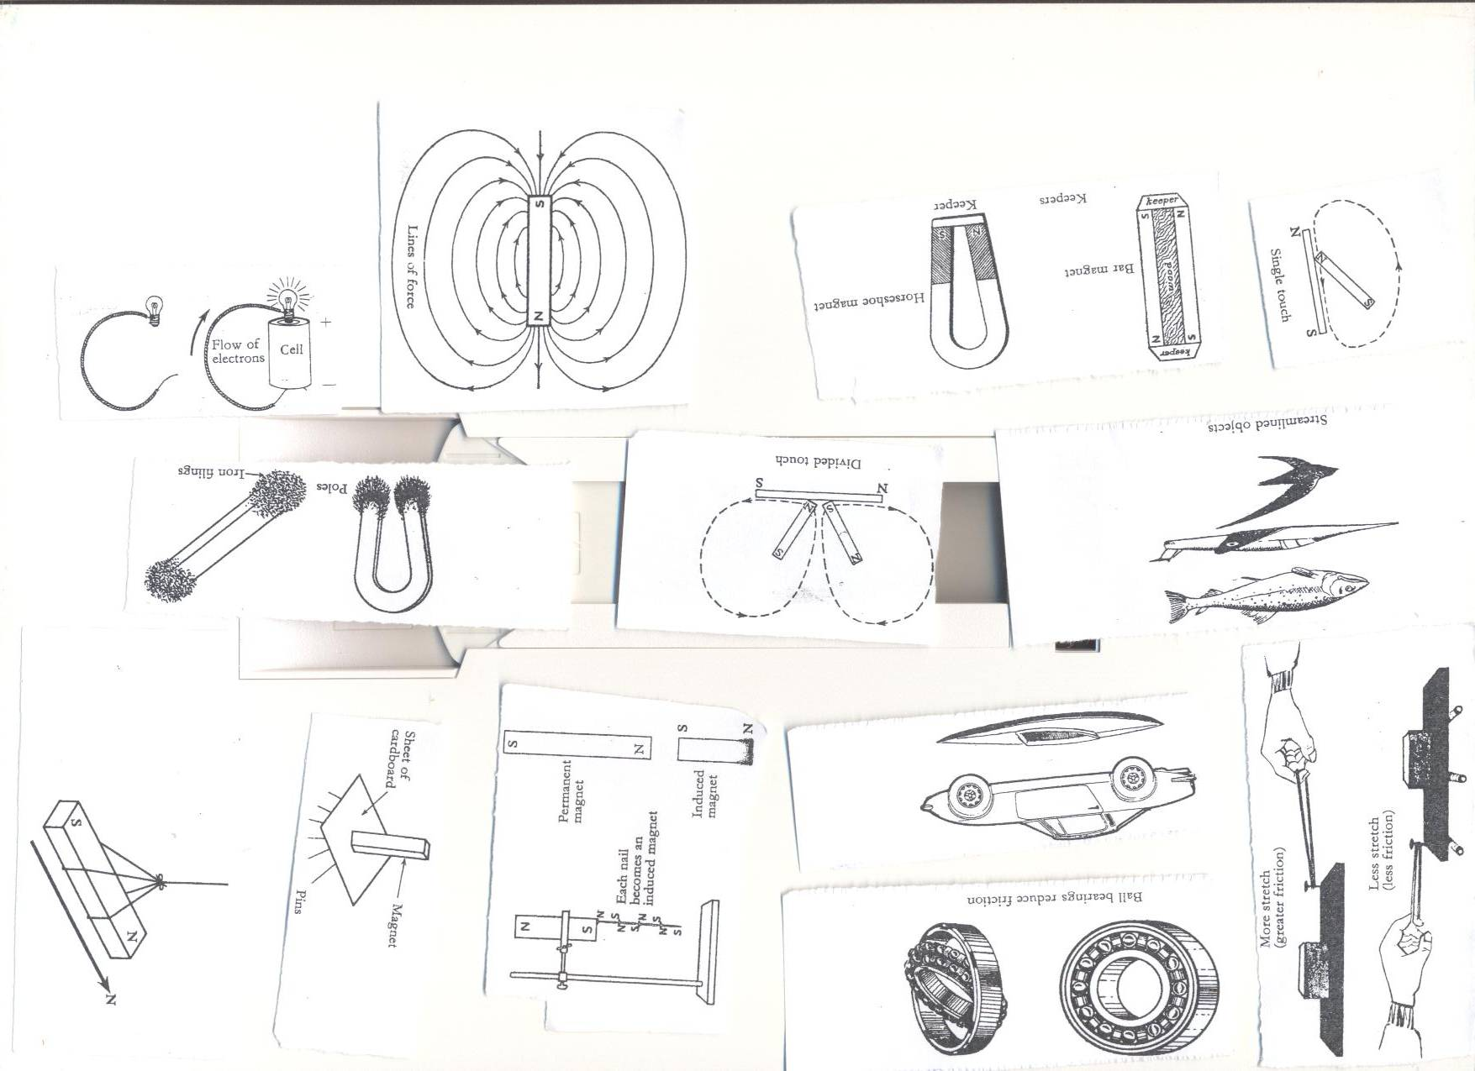

**TYPES OF CURRENT ELECTRICITY**

1. **DIRECT CURRENT ELECTRICITY(DC)**

Direct current electricity is the type of electricity in which electrons flow in only one direction that is from the source to the appliance.

* Direct current electricity can be stored but cannot be stepped up and down.

**Sources of direct current electricity**

* Chemical batteries(accumulators)
* Dry cells
* Simple /wet cells

1. **ALTERNATING CURRENT ELECTRICITY(AC)**

Alternating current electricity is the type of current electricity in which electrons flow in two (both) directions from the source to the appliance that is forward and backward.

* Alternating current electricity can be stored in form of direct current and it can be step up and down.

**SOURCES OF ELECTRICITY**

Sources of electricity are materials or things that can be used to generate electricity.

**Sources of electricity**

* The sun
* Fast flowing or running water
* Fossil fuels like petroleum, coal and natural gas
* Wind
* Hot springs
* Electric cells like dry cells, simple wet cells, chemical batteries, and phone batteries.

**SOURCE S OF ALTERNATING CURRENT ELECTRICITY**

1. **Hydro electricity**

Hydro electricity is produced from the power of fast flowing water turning turbines at a dam.

* At a power station, **potential energy** of water in the reservoir changes to **kinetic** **energy** of the fast flowing water turning the turbines connected to the generators that produce electricity.

1. **Thermal electricity**

Thermal electricity is produced from burning fossil fuels such as petroleum, coal etc.that contains chemical energy.

1. **Solar electricity**

Solar electricity isproduced from the sun.

* Solar cells (panels) are used to trap light from the sun and stored in solar batteries.
* Solar cells change solar electricity to electric energy

1. **Nuclear/atomic electricity**

Atomic or nuclear energy is produced from splitting of uranium mineral in a nuclear power stations**.**

* The splitting atoms produce a lot of heat used to boil water to produce steam that turns turbines.

1. **Geo thermal electricity**

Geothermal energy is produced by steam from hot springs.

**QUESTION**

1. Write down the types of electricity
2. State any two forms of electricity
3. Draw a diagram to show flow of electricity
4. What type of electricity is commonly used by most urban areas in Uganda?

**ELECTRIC CELLS**

1. **What is an electric cell?**

An electric cell is a device that stores and produces electricity as a result of chemical reaction.

**TYPES OF CELLS**

1. **Give two types of electric cells**
2. Primary cells
3. Secondary cells
4. **PRIMARY CELL**
5. **What are primary cells?**

Primary cells are cells that cannot be recharged once used up or exhausted.

* Primary cells change stored chemical energy to electric energy

1. **Give two examples of primary cells**

* Dry cells
* Simple cells or wet cells

1. **THE DRY CELL**

A dry cell is an improved version of simple or wet cells.

Dry cells have a capacity of producing a voltage of 1.5volts when it is still new and the voltage keep on reducing as one uses it.

* Dry cells store chemical energy which is converted to electricity when the circuit is complete.

**Structure or parts of a dry cell**



**FUNCTION OF EACH PART OF A DRY CELL**

1. **Brass cap**

Brass cap is thepositive terminal and contactor of electricity in a dry

1. **pitch or top seal**

Pitch or top seal prevents ammonium chloride jelly from drying up.

1. **Ammonium chloride jelly**

Ammonium chloride jelly helps in the transfer of electrons

* Ammonium chloride absorbs the hydrogen

**Note.** Ammonium chloride paste is an electrolyte in a dry cell

**What is an electrolyte?**

An electrolyte is a liquid conductor of electricity

* Electrolyte reduces the internal resistance of the cell.

1. Manganese IV oxide prevents the buildup of hydrogen oxide around the carbon rod.
2. **Manganese IV oxide**

* Manganese IV oxide is a depolarizing agent
* Depolarization leads to the leaking of cells when exhausted.

1. **Carbon rod**

Carbon rod is a non- metallic conductor of electricity found in dry cells.

* Carbon rod is made from graphite.

1. **Zinc can**

Zinc can is a container in which the dry cell content is put and it is negative terminal.

1. **Insulating top seal**

Insulating top seal prevents the jelly from drying up.  
**N.B**: I. A dry cell has voltage of **1.5 volts**The energy needed to push an electric current through a electric circuit is called **voltage.**

Voltage is measured in **volts.**

A dry cell stores **chemical energy** which is later changed to **electric energy**.

**Advantages of using dry cells**

* Dry cells are portable that is easy to transport
* Dry cells are affordable

**Disadvantages of using dry cells**

* Dry cells are not rechargeable
* Dry cells have low current that cannot run strong machines

**CALCULATING VOLTAGE**

**Example one**. Juliet’s radio uses **seven** dry cells.

How many volts are needed if she is to use it to listen to news?

Solution:

**1 dry cell= 1.5 volts**

**7 dry cells= ?**

**7dry cells X 1.5 Volts.**

**=10.5 volts**

**Example 2.** A Panasonic radio cassette uses 12 volts, how many dry cells does the radio need to operate.

**Example 3.** One torch uses 6 dry cells. Calculate the voltage of the torch.

**ACTIVITY**

1. **A sony television remote uses 4.5volts. How many dry cells does it need to operate?**
2. **A radio cassette player uses 24 dry cells, calculate the voltage of the radio.**
3. **A clock uses 9volts, how many pairs dry cells does it need to function?**
4. **A flat iron uses 195volts, how many dry cells does one need to iron the handkerchief.**

**SECONDARY CELLS**

**What is secondary cell?**

Secondary cells are cells that can be recharged once exhausted.

**Examples of secondary cells**

* Car battery (accumulators)
* Telephone batteries
* Nickel cadium alkaline

**CONDUCTORS OF ELECTRICITY**

**What are conductors of electricity?**

Conductors of electricity are materials that allow electricity to pass through them easily.

**Examples of conductors of electricity**

* Metals like; silver, copper, aluminum, tungsten Iron, copper, tin, zinc, lead, brass.
* Materials like; spoons, pair of compasses, razor blades etc.
* Undistilled (impure) water from rivers, lakes, springs and wells.
* Carbon {non-metallic conductors
* Salty solutions like sodium chloride, all acids
* Wet woods

1. **Why is a distilled water not good conductor of electricity?**

* Distilled water does not contain mineral salts
* Distilled water does not have free ions

1. **Silver is the best conductor of electricity, why is it not used to make overhead electric cables?**

* Silver is very expensive
* Silver is heavy

1. **Why is aluminum common used to make to make utensils like saucepans?**

* Aluminum is cheap
* Aluminum has a low density.
* Aluminum does not rust

**INSULATORS OF ELECTRICITY**

1. **What are insulators of electricity?**

Insulators of electricity are materials that do not allow electricity to pass through them easily.

**Examples of insulators**

* Rubber
* Plastic
* Dry wood,
* Dry paper
* Dry cloth
* Air
* Porcelain
* Glass

**Importance of insulators**

* Insulators are used to insulate flat irons, frying pans to prevent electric shocks.
* Insulators prevent conductors from meeting to cause short circuits.
* Insulators like sweaters keep our body warm by absorbing and retaining heat in the body.
* Insulators like feathers keep birds warm.

**ELECTRIC CIRCUIT**

1. **What is an electric circuit?**

An electric circuit is a path through which an electric current flows.

1. **What is an electric current?**

An electric current is the flow of electrons

**Components of an electric circuit**

* A switch
* An electric bulb
* A conductor or conducting (wire)
* Dry cells(Battery)
* Fuse
* Ammeter

**Diagrams showing simple Electric circuit**

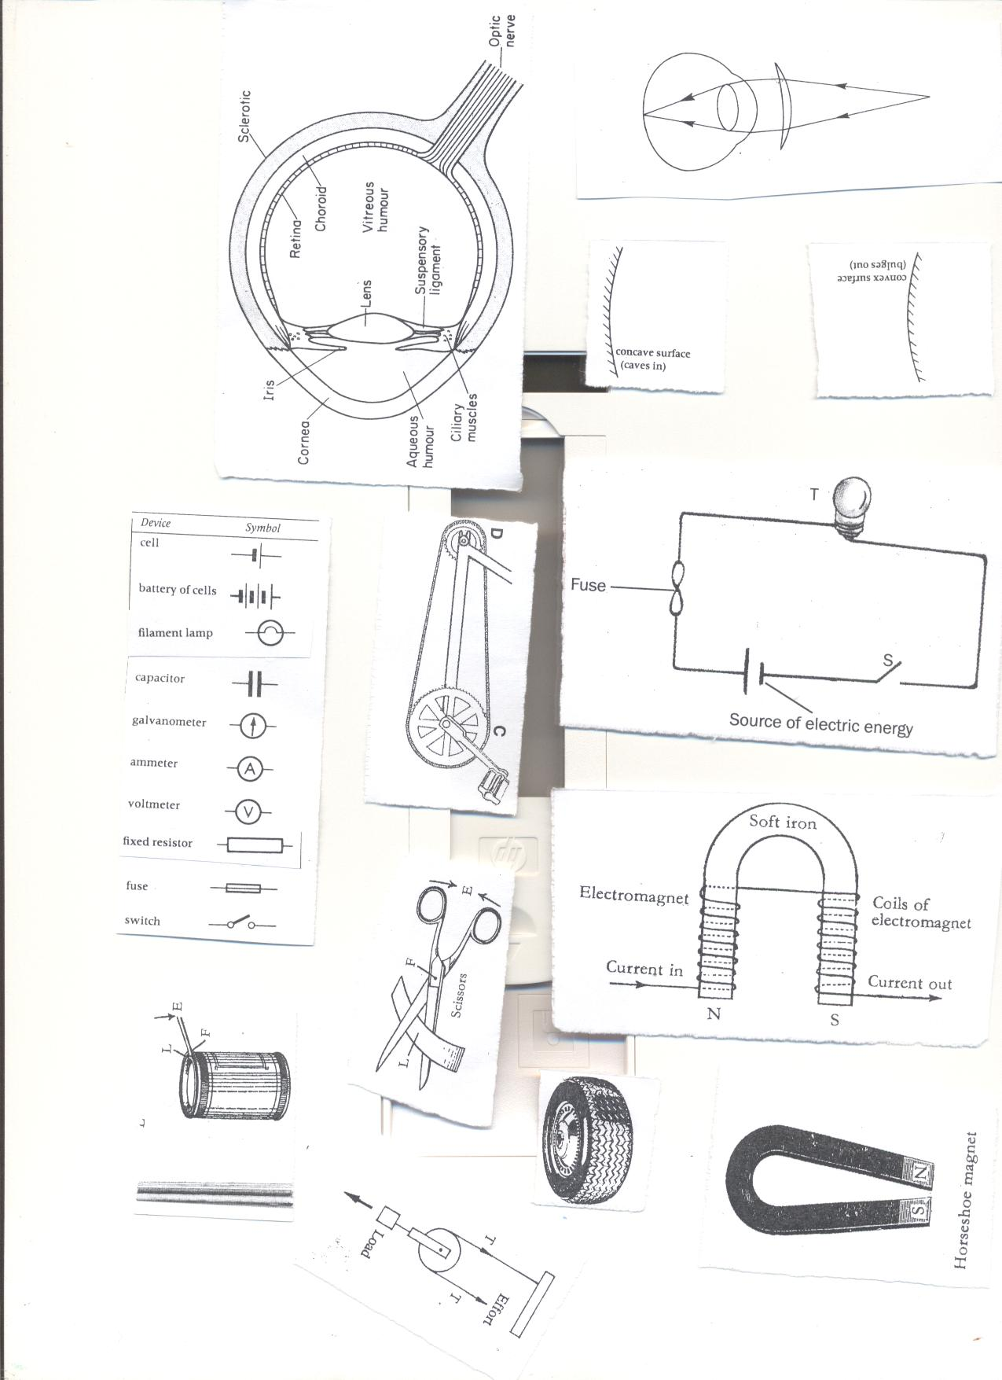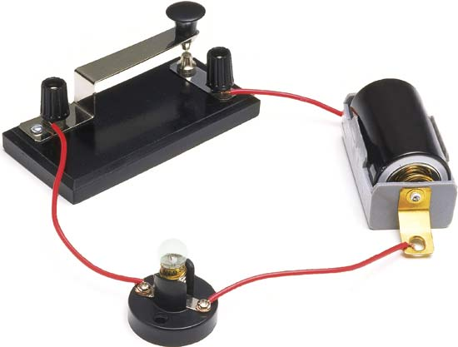

**Function of uses of parts of an electric circuit**

|  |  |
| --- | --- |
| 1. **Switch** | The switch breaks and completes the circuit at the users wish |
| 1. **Battery/dry cell** | Dry cells store **chemical energy** and change it to **electric energy** when the circuit is complete. |
| 1. **Conducting wire** | Conducting wires transmits electric energy through the circuit to the appliance. |
| 1. **Fuse** | A fuse is the safety device breaks the circuit when there is too much flow of current.   * Fuse is made from a thin wire (alloy) of tin and lead with a low melting point.  1. **What is an alloy?**   An alloy is a mixture of two or more metals.   1. **Give four importance of alloys.**  * Alloys make metals harder. * Alloys lower the melting points of metals * Alloys make wear and tear of metals difficult |
| 1. **Electric bulb:** | Electric bulb produces heat and light when the circuit is complete.   * Electric bulb changes electric energy to heat and light energy.   Ammeter is used to measure electric current in an electric circuit |
| 1. **Voltmeter** | Voltmeter is used to measure the electromotive force in a circuit |

1. **Of what value is a fuse in an electric circuit?**

The fuse protects the electric appliances from damage in case of too much flow of current in the circuit

1. **How does a fuse work?**

A fuse works by melting and breaking the circuits in case of too much flow of current.

1. **Give three reasons why a fuse may melt or break.**

* Overloading of the circuit
* When there is a short circuit
* When there is high voltage
* When the wires are weak or old

1. **Mention two advantages of a fuse in the circuit**

* A fuse reduces the risk of electric fires
* A fuse protects the delicate electric appliances from damage by melting and breaking the circuit the circuit in case of too much flow of current.

1. **Which energy change takes place in an electric bulb when the circuit is complete?**

Electric energy changes to heat and light energy

1. **State two forms of energy produce by the electric bulbs when the circuit is complete.**

* Heat energy
* Light energy

1. **Give three reasons why an electric bulb may stop producing light in a circuit**

* When the filament blows or burns out.
* When the dry cells are used up or exhausted
* When the fuse melts or blows

1. **Give four reasons why an electric bulb may not work or give light in a circuit**

* When the circuit is incomplete
* When the dry cells are poorly arranged
* When the dry cells are exhausted
* When the conducting wires are broken or poorly arranged

**Symbols used in an electric circuit.**





**SHORT CIRCUITS**

1. **What is short a circuit?**

A short circuit is a path of electricity with low resistance towards the flow of current through a circuit.

A short circuit is the path of electricity with low resistance between two terminals of a battery.

**Note; 1**. A short circuit occurs when current bypass the appliance that is supposed to use the electric energy.

1. A short circuit is mainly caused when two naked (uninsulated) wires carrying electricity come in contact.

**CAUSES OF SHORT CIRCUIT**

* Poor wiring when installing electricity in buildings
* Pushing metallic objects into electric sockets or adapters
* When bare electric wires get into contact
* Wrong connection of wires in electric equipment like radios, TVs, flat irons etc.
* Overloading of the sockets
* Use of uninsulated or naked wires when wiring building

**DANGERS/EFFECTS OF SHORT CIRCUIT**

* Short circuits lead to destruction damage of electrical equipment
* Short circuit leads to an outbreak of fires in a house, aero planes, computers, motor vehicles etc.
* Short circuits lead to electric shock death (electrocution) of people and animals.

**HOW TO PREVENT SHORT CIRCUITS**

* Proper insulation of electric wires
* Installation of electricity in houses should be done by experts only (registered technicians)
* Repair of faulty electric appliances should be done by expert technicians only.
* Avoid pushing metallic objects into the sockets or adapters or electric appliances.
* By replacing damaged or old wires immediately.

**Diagram showing a short circuit**

**THE ELECTRIC BULB**

**What is an electric bulb?**

An electric bulb is an electric appliance that changes electricity to heat and light energy.

**Parts of an electric bulb**

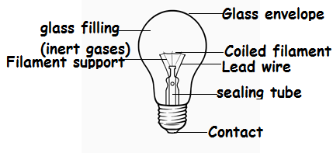

**Function or uses of the parts of an electric bulb**

1. **Glass envelope**

Glass envelope holds a mixture of nitrogen and inert gases to prevent the evaporation of the gases.

* The gases enable tungsten to burn at a higher temperature
* The glass is transparent to allow light to pass through it.

1. **What are inert gases/**

Inert gases are gases that do not undergo chemical reactions under a set of given conditions**.**

1. **Give four examples of inert gases.**

* Argon
* Helium
* Neon
* Krypton
* Xenon

1. **Coiled filament:**

Coiled filament produces light by changing **electric energy** to **heat and light energy.**

* Coiled filament is made of **tungsten** from a mineral called **wolfram.**

1. **Why is the filament of an electric bulb coiled?**

To increase electrical resistance to produce more heat and light energy

1. **Give two reasons why tungsten is used to make an electric bulb filament.**

* Tungsten has high melting point
* Tungsten has a very high resistance on electricity.

**Adaptation of the filament for its function**

* Electric filament has a high melting point.
* Electric filament is coiled to increase electric resistance

1. **Sealing tube**

Sealing tube enables air to be removed from the bulb and this prevents the filament from combining with oxygen.

1. **Supporting glass tube**

Supporting glass tube holds the filament in position.

1. **Lead wire**

Lead wires take electricity to the filament.

1. **Conducting wire**

Conducting wire transmits or conducts electricity to the filament.

1. **Contact**

Contact allows electricity into the bulb.

1. **Insulating material**

Insulating material separates the conducting wires.

**ACTIVITY**

1. **Why is a filament of an electric bulb coiled?**
2. **State any component of a circuit that uses an alloy.**
3. **Which gas is commonly used in electric bulbs?**
4. **Give one reason why the glass of a bulb is transparent?**
5. **Which mineral is used for making electric filament?**
6. **Study the diagram below carefully and use it to answer questions that follow**
7. **Name the above electric appliance.**
8. **Name two gases that can be used in part marked A**
9. **Why is part marked B coiled?**
10. **State the energy change that takes place in the above appliance.**
11. **Identify two forms of energy produced by the above appliance.**
12. **Why is part marked A made of transparent glass?**
13. **Explain why part marked B is made of tungsten but not copper.**

**THE TORCH/FLASH LIGHT**

A torch works on the principle that electricity travels in a complete circuit.

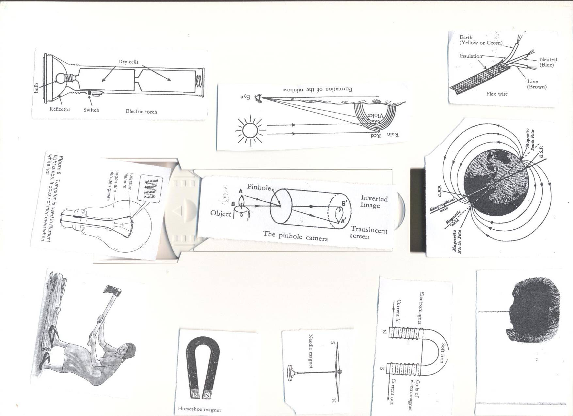

**Uses of parts of a torch**

1. **Reflector**

Reflector directs light into **a diverging** beam of light.

1. **Bulb**
2. Bulb produces light

* Bulb changes electricity to heat and light energy.

1. **Dry cells**

Dry cells produce and stores electricity.

1. **Transparent glass**

Transparent glass protects the bulb and reflector.

* Transparent glass allow light to pass through it.

1. **Switch**

The switch breaks and completes the circuit at the users wish.  
**(f) Cover and springs**

The cover keeps the dry cells tightly together.

* The springs complete the circuit.

1. **State five reasons why a torch can fail to work**

* When the dry cells are poorly arranged
* When the dry cells are exhausted
* When the torch has a rusted part
* When the circuit is incomplete

1. **Give two reasons why the torch may start working properly and later stops.**

* When the bulb blows
* When the dry cells are exhausted or used up.

**DEVICES CONNECTED TO ELECTRICITY**

* Generators
* Dynamos
* Electric motors
* Transformers

1. **GENERATORS**

Generators produce sound by changing mechanical energy inform of kinetic energy into electric energy.

Generators produce alternating electricity.

**HOW CAN GENERATORS BE MADE TO PRODUCE MORE ELECTRICITY?**

* By increasing the number of turns of wire in the coils
* By increasing the speed of rotation
* By increasing the magnetic fields

1. **DYNAMOS**

Dynamos produce electricity by changing **mechanical energy** into **electric energy.**

* An example of a dynamo is in bicycles and bigger ones are found in vehicles
* Dynamos in vehicles are used for charging batteries.
* A dynamo is a device which converts **mechanical energy** into **electrical energy.**  
  A dynamo uses **a permanent magnet** and a coil of wires on **electro magnets**
* During the turning, the **mechanical energy** is turned into **electric energy**

**Diagram showing a bicycle dynamo**

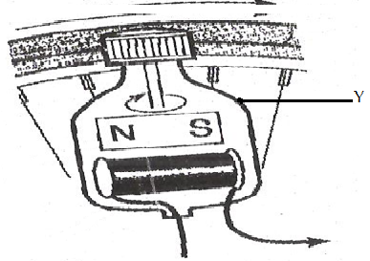

1. **ELECTRIC MOTORS**

Electric motors are the reverse of the generators and dynamos

* Electric motors produce electricity by changing electric energy to mechanical energy.

1. **State three uses of electric motors in our daily life.**

* Electric motors are used in lifts, trains, ships and some boats.
* Electric motors are used to start car engines
* Electric motors are used in some radios (cassette players)

1. **Give three uses of generator and dynamos.**

* Generators are used for emergency in case power goes off in schools and hospitals.
* Generators and dynamos provide energy for cooking.
* Generators and dynamos provide electricity.

1. **Transformer**

A transformer is an electric device that steps down or up the voltage of electricity.

The main function of transformers is to step or down the voltage of alternating current electricity.

**STATIC ELECTRICITY**

Static electricity is the type of electricity where there is no flow of electrons.

* Static electricity is produced by friction between insulators rubbed against each other.
* Static electricity involves two charges that is negative and positive charges.
* Positive charges are attracted by negative charges while negative charges are repelled by negative charges.
* In nature static electricity can be seen when lightning occurs.
* **LIGHTNING**

What is lightning?

Lightning is a sudden flow of charges from a huge spark of a cloud that has become charged.

* Lightning is static electricity in nature caused when clouds become heavily charged by friction.
* When a positively charged cloud meets a negatively charged cloud, a huge spark is formed and may pass to the ground.
* During the passage of lightning, the surrounding air is heated strongly, expands suddenly and contracts causing vibration and produce sound called **thunder.**

**Note; lightning is seen before thunder because light travels faster than sound.**

**Advantage of lightning**

* Lightning fixes nitrogen into the soil.
* Lightning converts air in the atmosphere into nitrates for plants to use.

**Disadvantages of lightning**

* Lightning can strike and damage buildings.
* Lightning can cause fires.
* Lightning can strike people and animals to death.

**PREVENTION OF DANGERS OR EFFECTS CAUSED BY LIGHTNING**

* Avoid sitting or seeking for shelter under tall trees when it is raining.
* By installing lightning conductors on buildings
* Always wear rubber shoes
* Always put off all electric appliances when it is raining.
* Avoid swimming in open water during rain.

1. **What are lightning conductors?**

Lightning conductors are pieces of metals which are placed in buildings and are made to connect metal plate underground.

* Spikes or pointed ends of the metals are placed above the building to attract charges.

1. Why are aluminum and copper used as lightning conductors?

Aluminum and copper are conductors

**Diagram showing the house with lightning conductor**

**How lightning conductors reduce risks to the building.**

Lightning provide route for electrons to pass into the ground without damaging the building.  
**Differences between static electricity and current electricity**

|  |  |  |
| --- | --- | --- |
|  | **Static** | **Current** |
| 1 | Static electricity takes place in insulators. | Current electricity takes place in conductors. |
| **2** | In static electricity the charge is on the surface. | In current electricity the charge is inside the conductor. |
| 3 | In static electricity the charge does not flow. | In current electricity charge flows through the conductor from one place to another. |
| 4 | Protons (+) and electrons (-) are both necessary for this type of electricity. | Only electrons flow in current electricity. |

**USES OF ELECTRICITY IN OIUR DAILY LIFE**

* Electricity is used for ironing clothes
* Electricity is used for cooking
* Electricity is used for operating machines
* Electricity is used for lighting
* Electricity is used for protection or security fences
* Electricity is used for heating.

**ADVANTAGES OF USING ELECTRICITY**

* Electricity is fast or quick
* Electricity is easy to use
* Electricity is clean
* Electricity is environmental friendly

**State two ways in which the use of electricity is environmentally friendly**

* Electricity does not pollute the environment
* Electricity makes work faster and simpler

**DANGERS OF ELECTRICITY**

* Electricity can shock and kill people
* Electricity can burn the properly

**Safety precautions in handling electricity and electrical appliances**

* Never touch a switch with wet hands
* Avoid over loading the socket.
* Avoid repairing the appliance when not trained.
* Avoid pushing metallic objects into sockets.
* Never open anything that uses electricity if not an expert.
* Never touch an electric wire that has fallen from an electric pole.
* Never take shelter under tall trees during thunderstorm.
* Report to **Uganda Electricity Distribution Company Limited (UEDCL)** currently **UMEME** if there is any broken cables or hunging wires.

**Topical questions**

1. **Why electricity is called a form of energy?**
2. **Give any one way in which electricity can prevent deforestation.**
3. **Why is it important to properly handle electric appliances?**
4. **Draw a symbol of an electric bulb.**
5. **Suggest any one way in which we can prevent our electric appliances from being destroyed by electricity.**
6. **State any one difference between conductors and insulators.**
7. **Why are electric wires carrying current from the source raised some meters high from the ground?**
8. **Cite any one disadvantage of using electricity in the environment**
9. **Draw a diagram to show the flow of current.**
10. **Cite any one danger of lightning to the environment.**
11. **State the static electricity in nature.**
12. **Briefly explain how to overcome the dangers caused by short circuits in the environment.**
13. **Why is the filament of an electric bulb coiled?**
14. **How is a fuse important in an electric circuit?**

**MAGNETISM**

**VOCABULARY**

* **Magnet**
* **Magnetic materials**
* **Non- magnetic materials**
* **Magnetism**
* **Magnetic fields**
* **Magnetic lines of force**
* **Magnetization**
* **Demagnetization**

1. **Magnets**:

A magnet is a piece of metal that has the ability to attract other magnetic materials.

1. **Magnetic materials:**

Magnetic materials are materials that can be attracted by a magnet.

**Examples of magnetic materials**

* Iron (most common magnetic substances)
* Nickel
* Cobalt
* Steel

1. **Non- magnetic materials**

Non- magnetic materials are materials that cannot be attracted by magnets

**Examples of non- magnetic substances**

* Dry wood
* Plastic
* Lead
* Glass
* Cloth
* Copper
* Paper
* Aluminum
* Brass

**Examples of metals that are non- magnetic materials**

* Aluminum
* Copper
* Gold
* Silver

1. **Poles of a magnet**

Poles of a magnet are the ends of a magnet i.e**. North Pole** and **South Pole**

1. **Magnetism**

Magnetism is the ability of a magnet to attract or repel other magnetic materials

Or, magnetism is the force in magnet which enables it to attract or repel other magnetic materials.

1. **Magnetic field**

A magnetic field is the area/region around a magnet in which it attracts of repels other magnetic materials

1. **Magnetic lines of force**

Magnetic lines of force are the lines around a magnet through forces of magnetism runs from North Pole to South Pole

1. **Magnetization**

Magnetization is a method/ way of making a magnet.

1. **Demagnetization**

Demagnetization is the ways of making a magnet lose its magnetism.

**PROPERTIES OF A MAGNET**

1. **A freely suspended bar magnet by a piece of thread will always rest pointing in the North to South direction.**

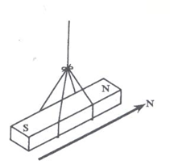

**Note:** This property is used to make compasses that show directions. Pilots, soldiers, navigators and tourists use this property to find direction.

1. **Like poles of magnets repel each other.**

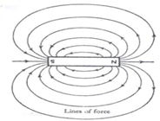

1. **Unlike poles of magnets attract each other.**

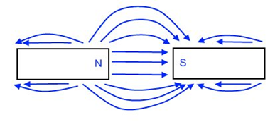

1. **Magnets are strongest at the poles(The poles are the strongest part of a magnet).**

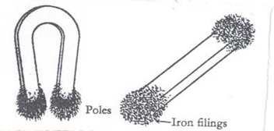

**Magnets have magnetic fields around them.**

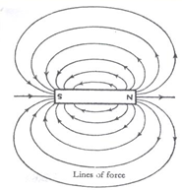

1. **Magnetism passes through non- magnetic materials like wood and paper.**

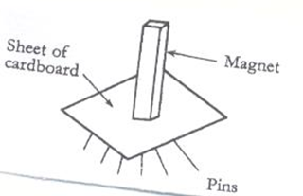

1. **When a bar magnet is broken into pieces, each piece becomes independent.**

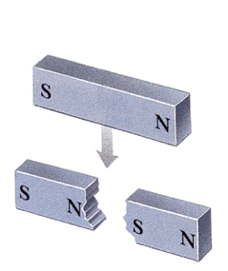

1. Magnets become weaker with age.

**NB**. Magnets can be prevented from losing their magnetism or becoming weak by: keeping them using iron keepers as **shown below**.

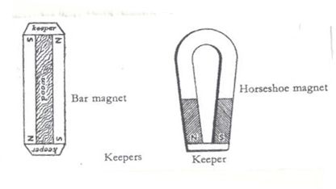

**Types of magnets**

There are two main types of magnets namely;

* Natural magnets
* Artificial magnets

a**) Natural magnets**

Natural magnets don’t lose magnetism.

**Examples of natural magnets**

1. **The Earth.**

The earth is a huge natural magnet because it has both North and South pole.

* The earth has a weak magnetic field that is why we don’t feel it.

An illustration of the earth

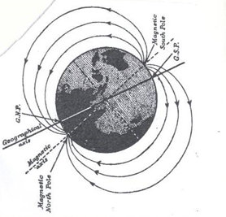

1. **Lodestone/magnetite**

* Lodestone is a magnetic ore which occurs naturally in the earth.
* Lodestone was discovered near the ancient city of magnesia in Asia currently called Malaysia.
* Lodestone has North and South Pole when it rests.

An illustration of lodestone

1. **Artificial magnets**   
   Artificial magnets are magnets made by people from steel and other strong magnetic alloys.

Artificial magnets are divided into two namely;  
1. Permanent magnets

1. Temporary magnets

**Permanent magnets**

Permanent magnets are magnets which retain their magnetism for long even after the source has been removed.

Permanent magnets keep their magnetism for long provided they are carefully stored and handled

**Examples of artificial (permanent) magnets and their shapes**

1. **Bar magnet**

A bar magnet is a bar of uniform cross section.

* 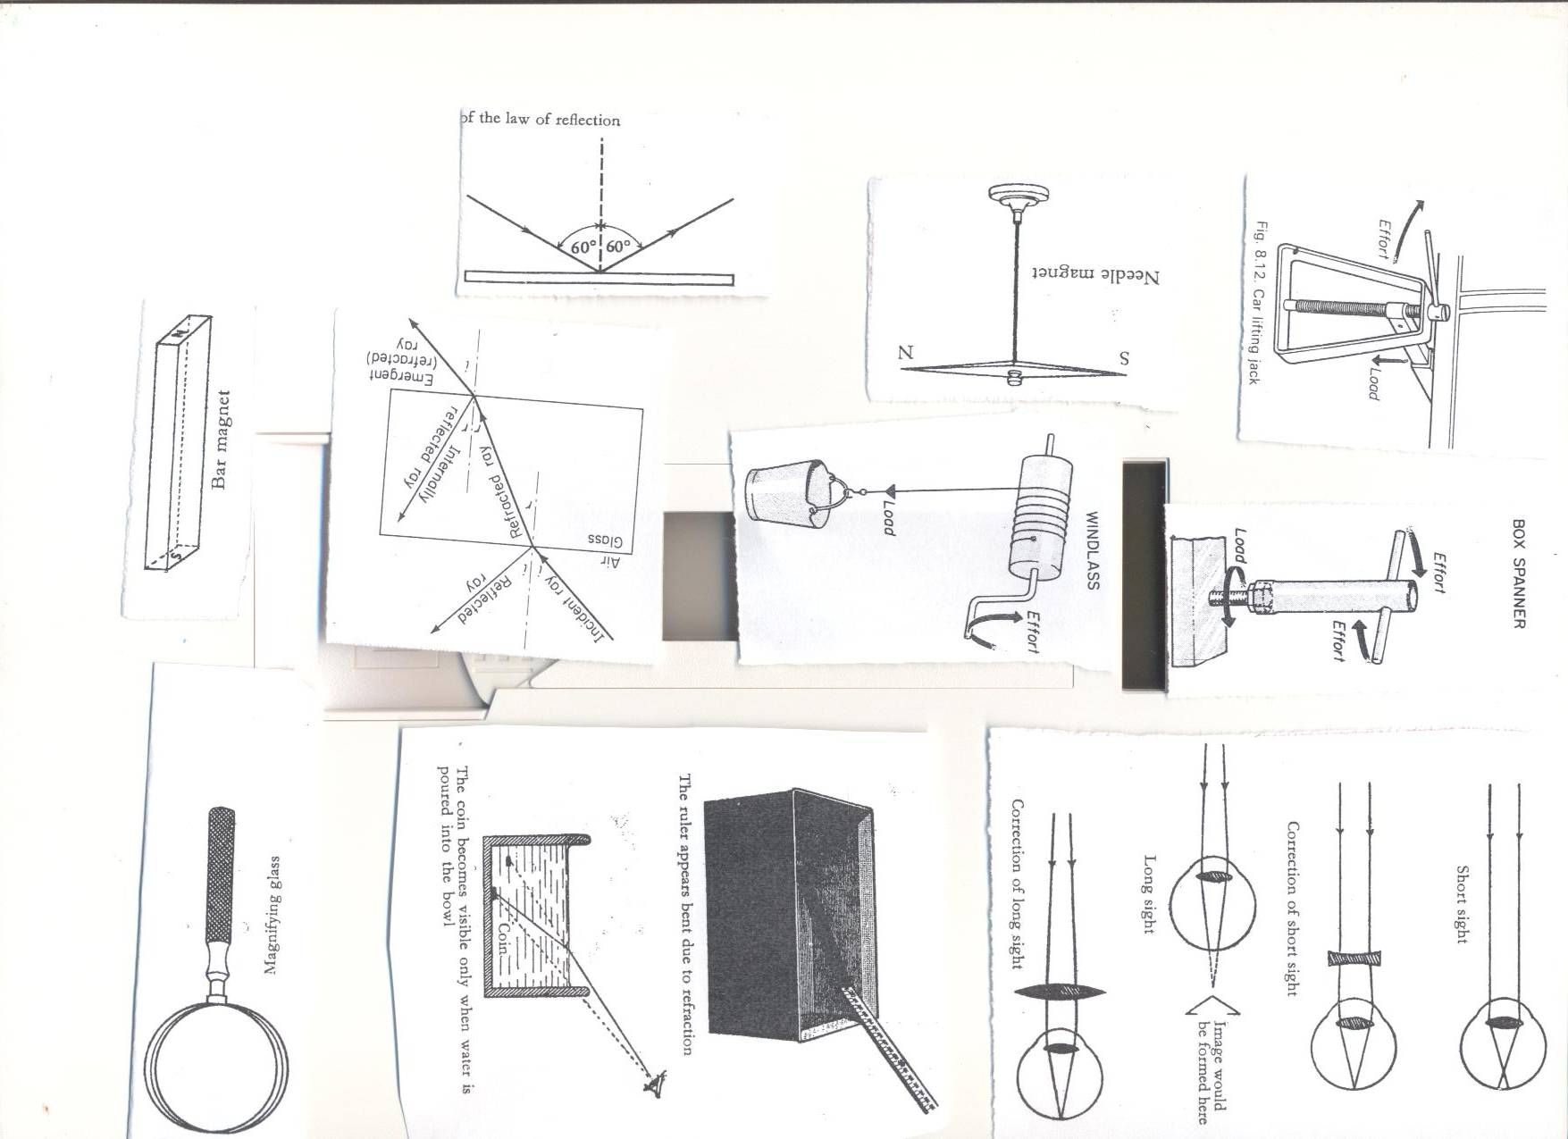A bar magnet may be rectangular or circular.

**An illustration of a bar magnet**

**An illustration of cylindrical magnets**

1. **A Horse shoe magnet**.

A horse shoe magnet is u shape.

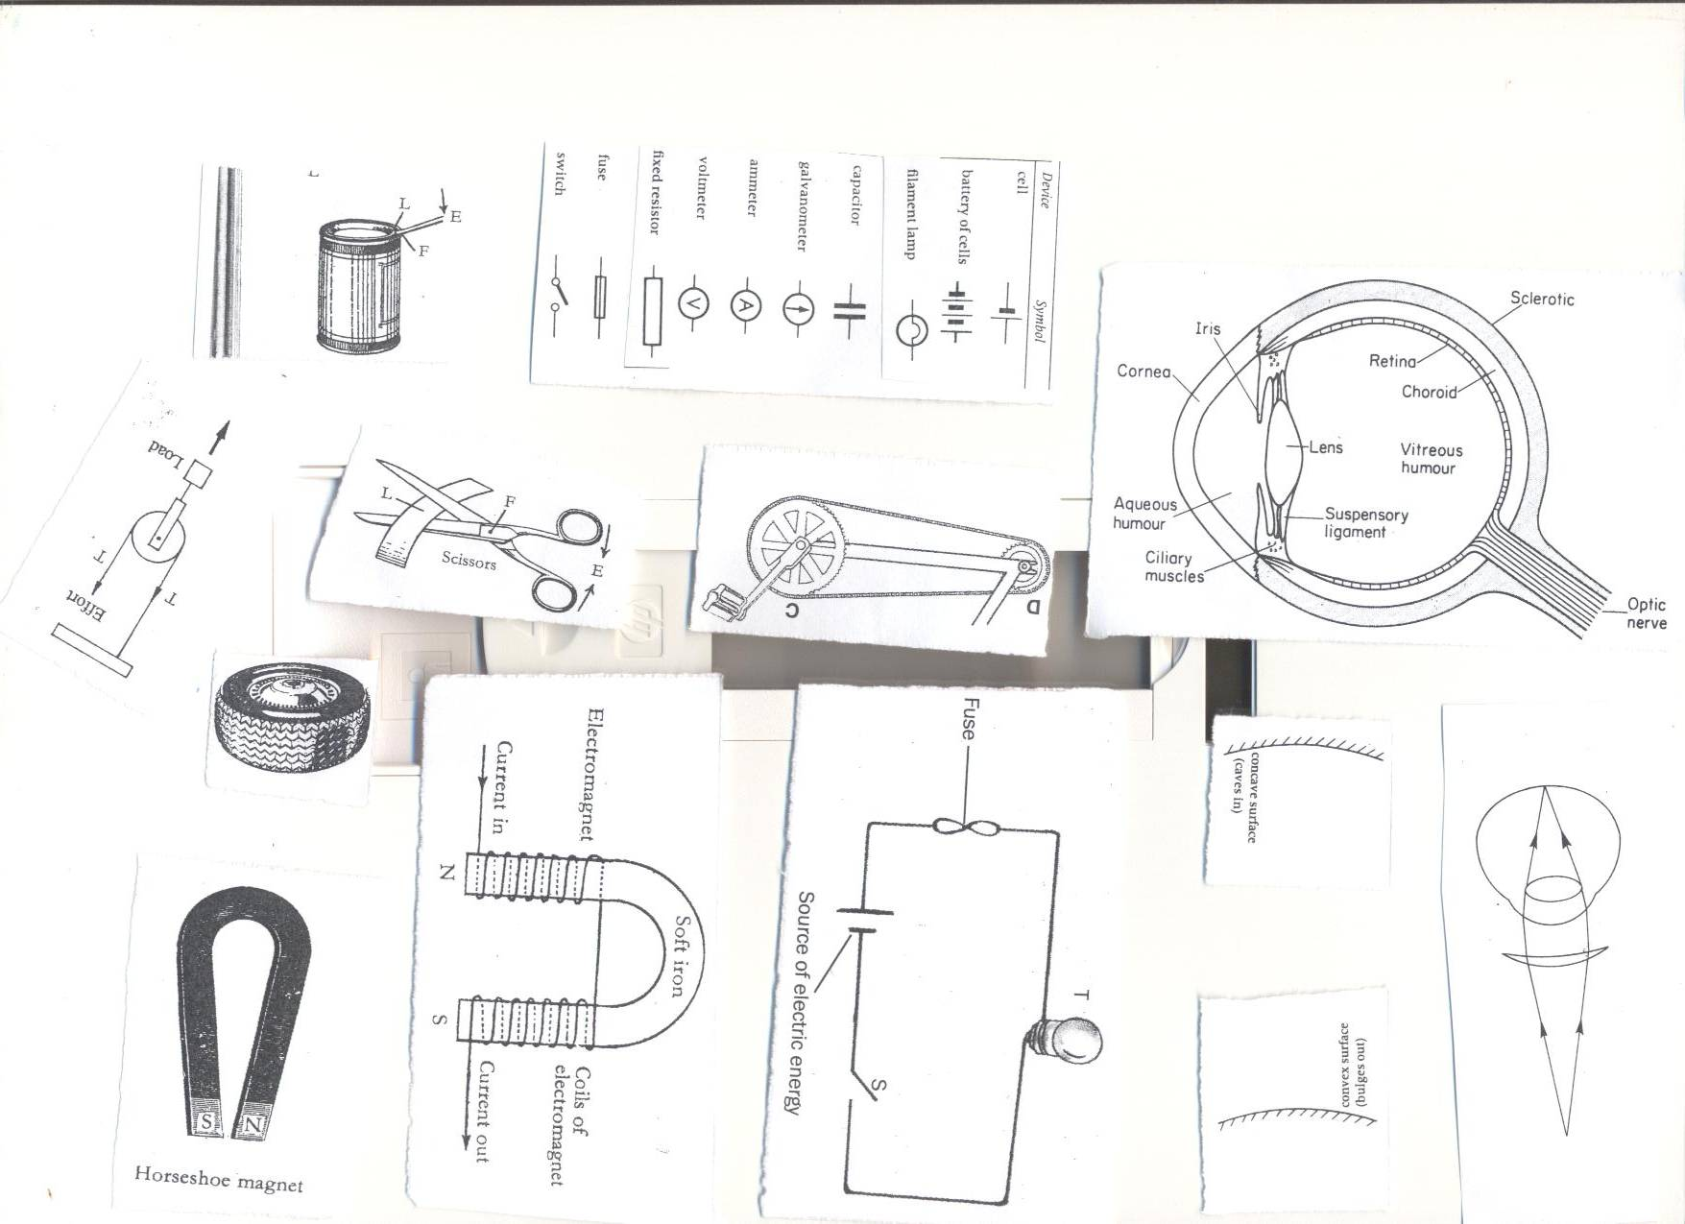

1. **Needle magnet/magnetic needle**

A compass needle is a thin magnet pointed at both ends and balanced at its centre.

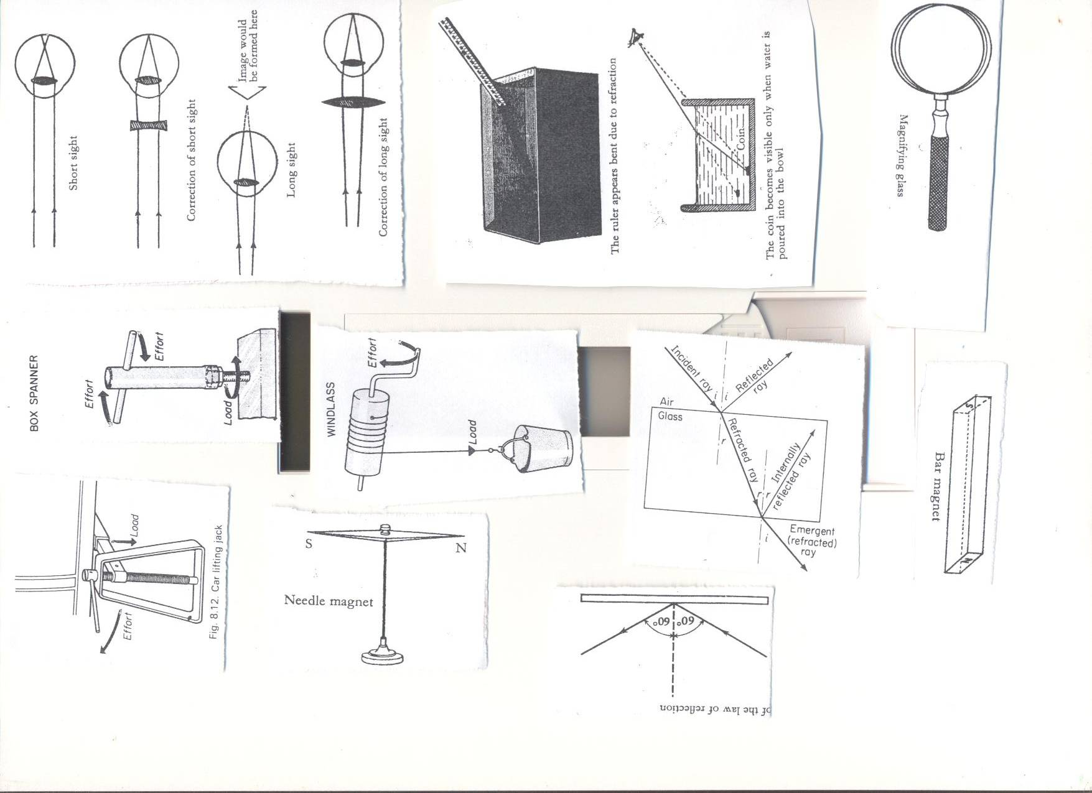

**TEMPORARY MAGNETS:**

Temporary magnets are magnets which lose their magnetism easily as soon as electricity making them magnetized is withdrawn.

**Example of a temporary magnet**

Electromagnet

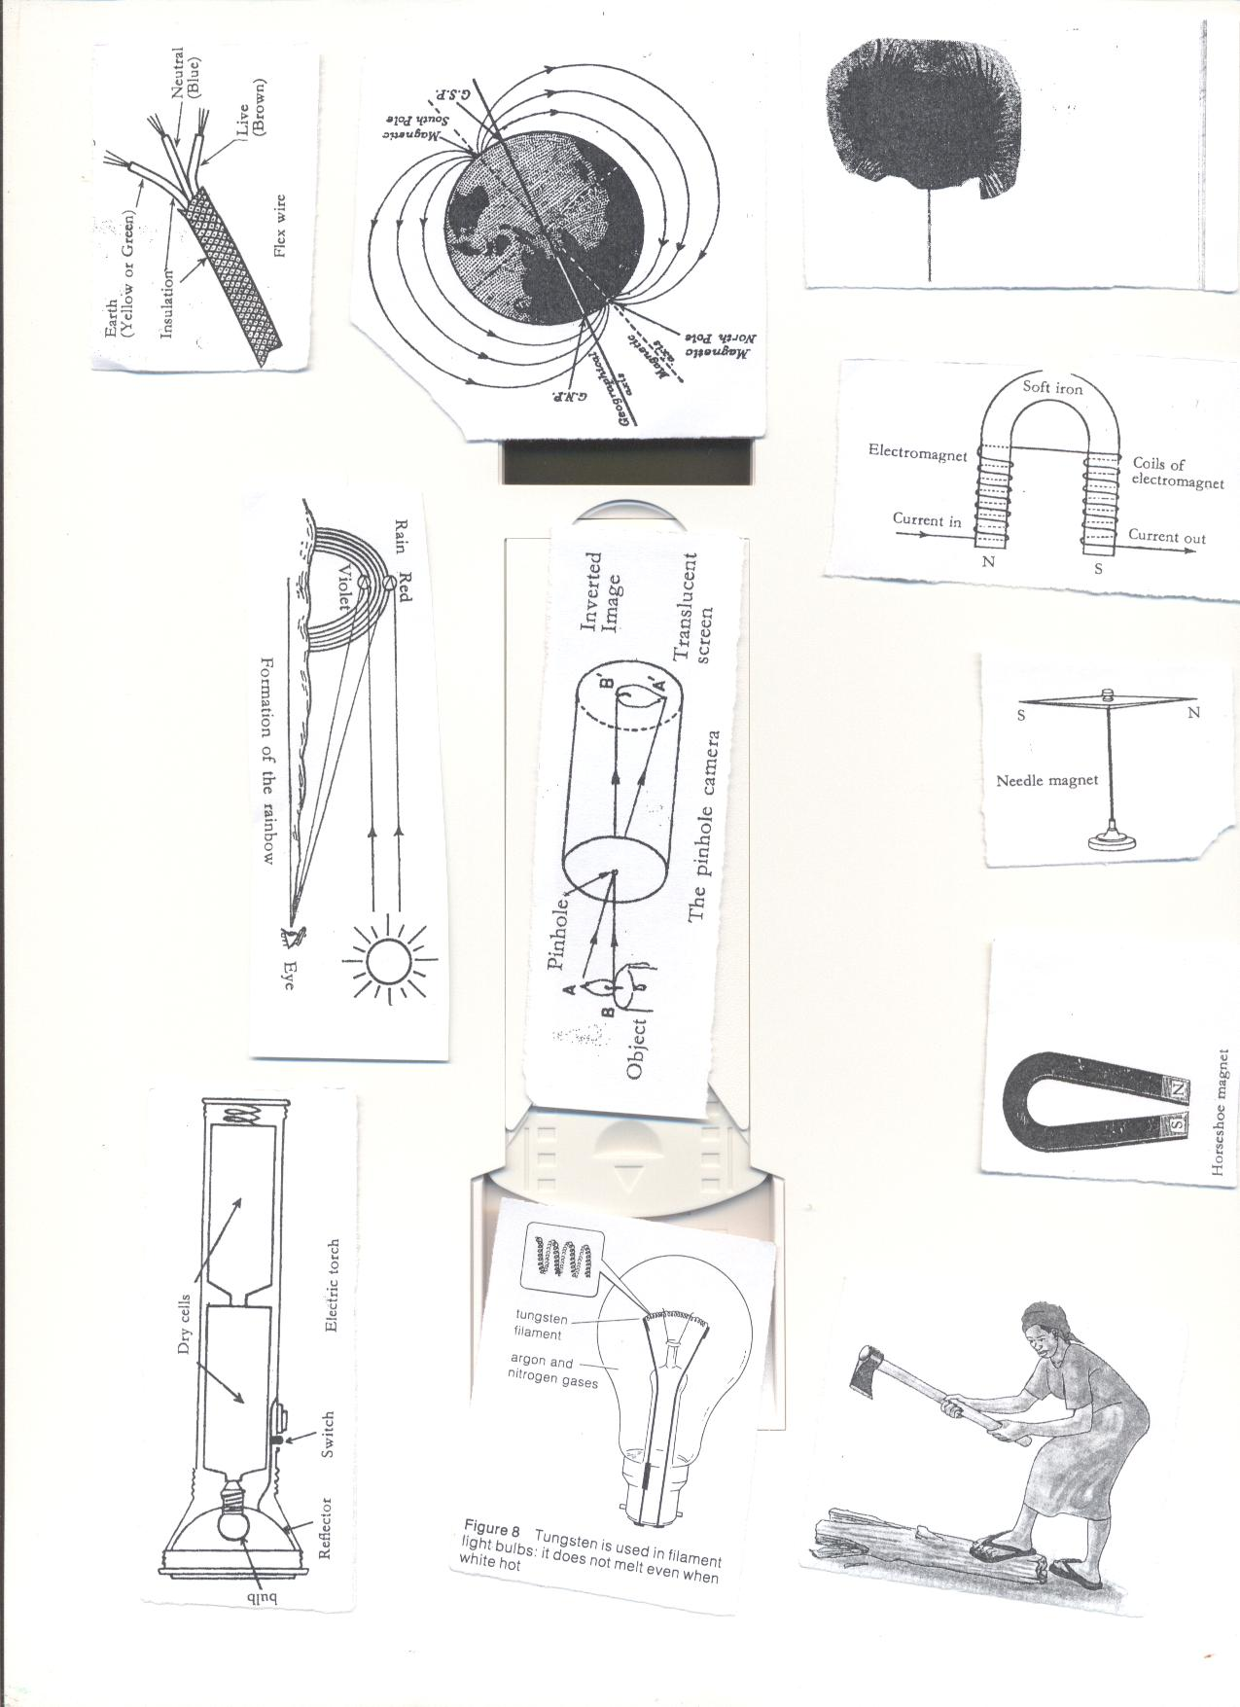

**Laws of magnets**

The law of magnet states that like poles of magnets repel each other while unlike poles attracts each other.

**What is magnetic field?**  
A magnetic field is the area around the magnet in which it can attract other magnetic materials.

**Properties of magnetic fields**

* The lines of forces of magnetism do not intersect with each other.
* A line of force is continuous; it starts from the North Pole and ends at the South Pole.
* There is no line of force within the magnet itself

**MAGNETIZATION**

Magnetization is ways or methods of making magnet.

Mention the four methods of making magnets.

* Single touch method
* Double touch method
* Induction method
* Electrical method

1. **STROKING BY SINGLE TOUCH METHOD.**

Stroking or single touch method is done by stroking magnetic materials with a magnet in the same direction with the same pole of the magnet.

Note. **The end after the stroke becomes the opposite pole of the magnet being used.**

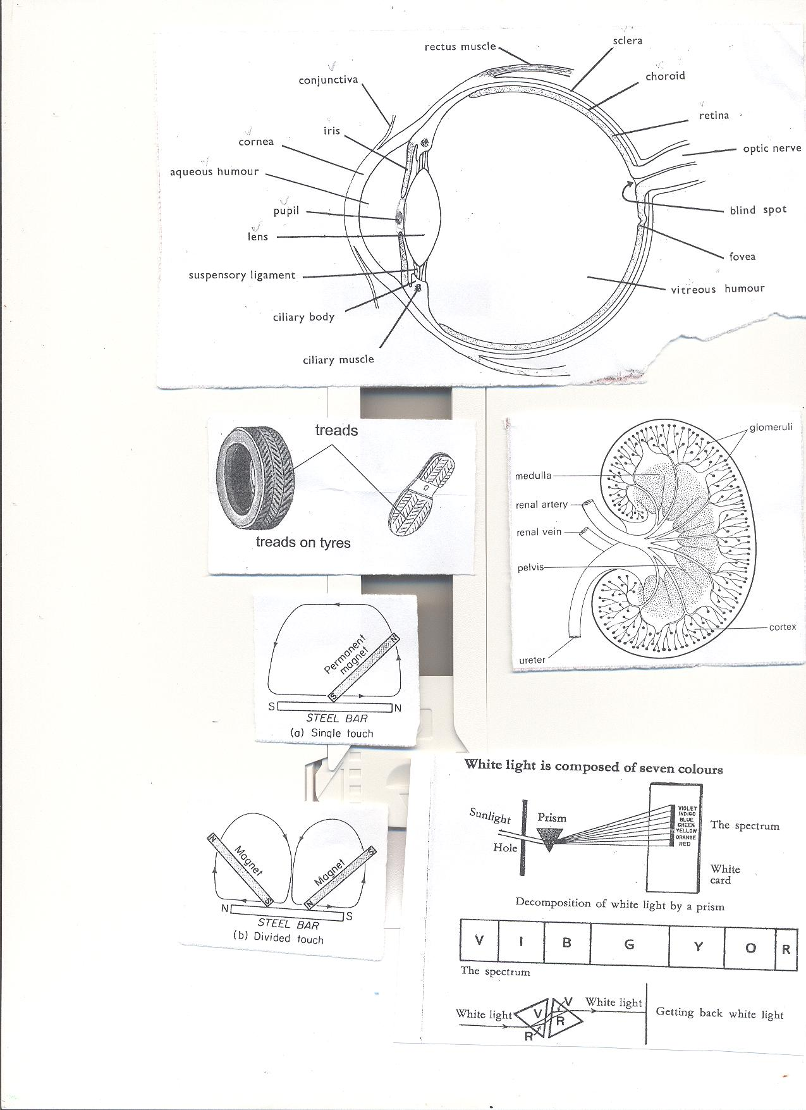

1. **STROKING BY DOUBLE/DIVIDED TOUCH METHOD.**

Double touch method is the method done by stroking using two bar magnets.

Unlike poles and opposite direction must be kept and followed, opposite poles are produced at the end.



1. **BY INDUCTION.**

**Induction method is done by attaching a magnetic material like steel bar on a permanent magnet.**

* A magnetic object becomes magnetized by induction when it is nearer or contact with a magnet.
* Unlike poles are immediately formed to the ends of the new magnet.
* 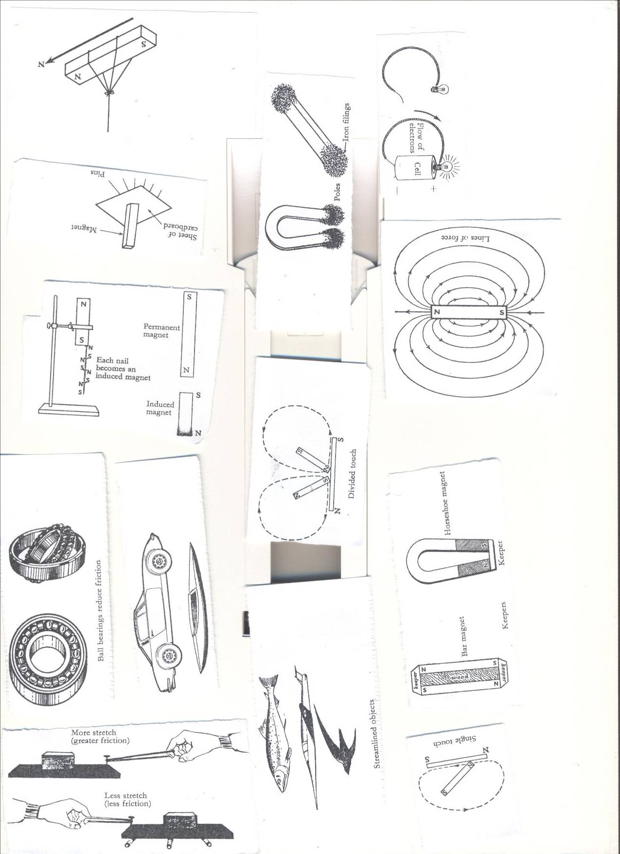A magnet made by induction is called **induced method.**

1. **BY ELECTRICAL METHOD.**  
   Electrical method is a method of making magnets using electricity.

* A magnet made by using electricity is **electro- magnet.**
* Electrical method is done by placing steel or iron in coils of wire called solenoid and a electric wire pass through them.

**An illustration of a electrical magnet.**

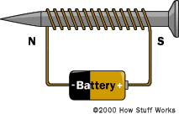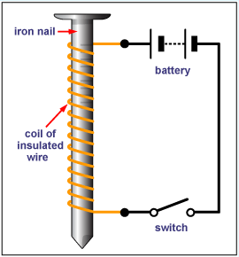

**Electro magnets are made stronger by;**

* By increasing the coils around the soft iron
* By increasing the voltage (electrical strength)

**Determining the poles an electromagnet**

1. **The direction of flow of current.**

* Looking at it from either end;
* If current flows in an **anticlockwise** way through the solenoid, the pole is **North (N)**
* If current flows in **a clockwise** way through the solenoid, the pole is **South(S).**

**ii. Using the right hand grip rule.**

* Grasp the solenoid in the **right hand** with **thumb pointing in the direction of current.**
* The thumb points to **the North Pole.**

**Demagnetizing magnets**

* Demagnetization is the ways making a magnet lose its magnetism.
* Demagnetization is the ways of weakening or destroying a magnet.  
  **Ways of demagnetizing a magnet**
* Hammering/hitting strongly.
* Strong heating.
* Leaving a magnet in an east-west direction for a very long time.
* By keeping the magnets with like poles together.
* By passing an **alternating current** through a magnet.
* Leaving it to rust.

**Uses of magnets in modern world of work**

* Magnets are used in compasses by sailors, pilots and explorers.
* Electromagnets are used in industries to collect heavy scrap iron.
* An electric bell is also built on the principle of magnets.
* Magnets are used in telecommunication devices.
* Electric motors which produce electricity use magnets.
* Magnets are used in loud speakers.
* Magnets are used on doors of fridges.

**Appliances that use electricity**

* Flat irons
* Heaters
* Driers
* Washing machines
* Electric fans
* Cooker

**Appliances that use magnetism**

* Magnetic compasses
* Magnetic tapes  
  **Appliances that use both electricity and magnetism.**.
* Fridges.
* Radios
* Televisions
* Mobile phones
* Electric bells

**AN ELECTRIC BELL**

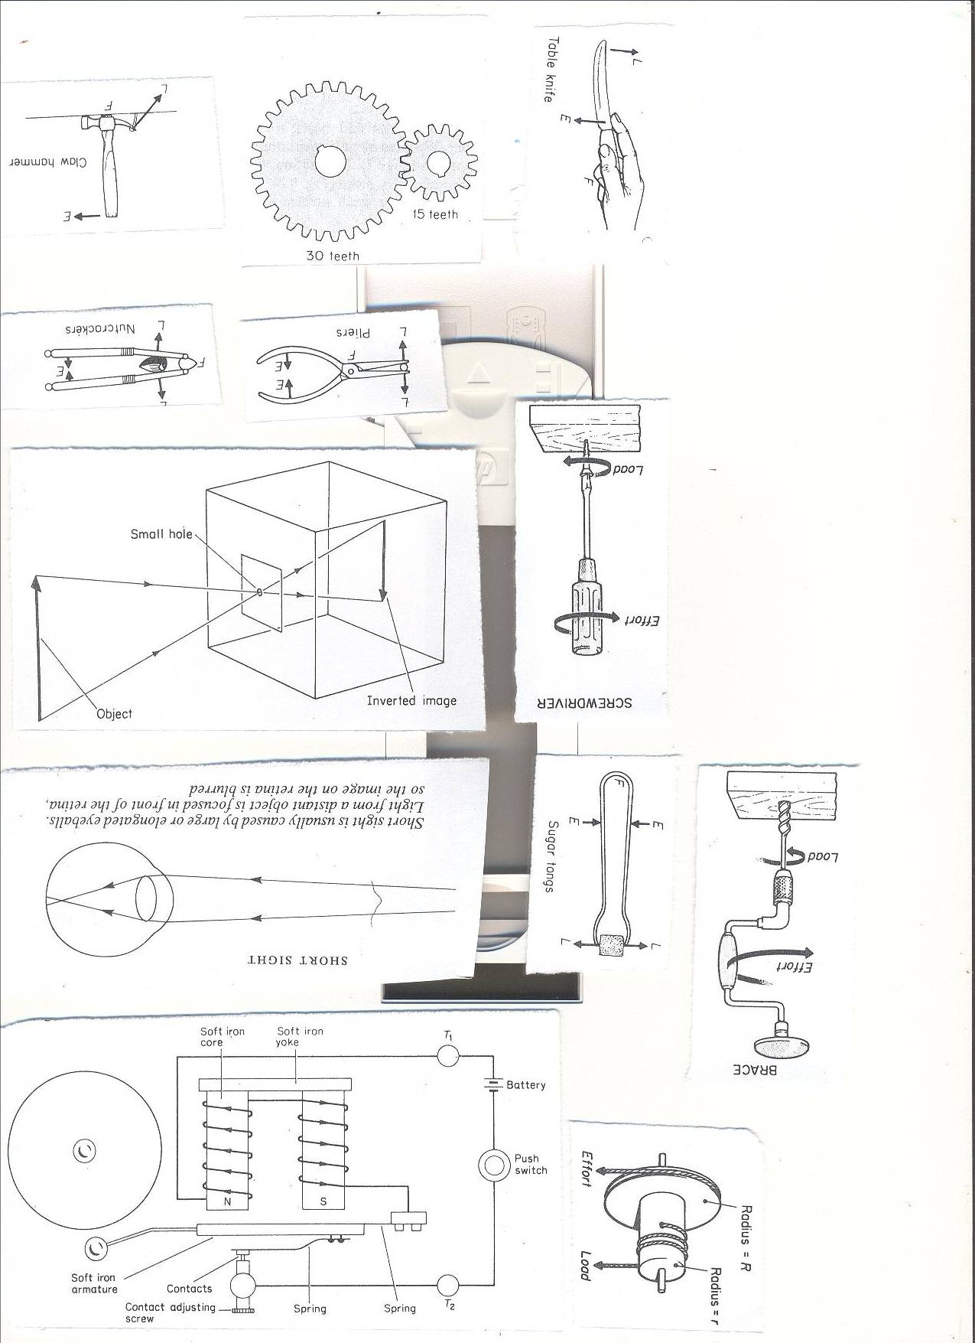

**FUNCTION OF THE PARTS OF AN ELECTRIC BELL**

1. **Switch.**

A switch breaks and completes the circuit.

1. **Batteries**

Batteries produce electricity.

1. **Soft iron bar**

Soft iron bar gets attached to the electromagnet to move the hammer.

1. **The hammer.**

The hammer hits the gong.

1. **The gong.**

The gong produces sound when hit by the hammer.

1. **The steel springs.**

The steel springs break the circle in order to demagnetize the electromagnet.

**HOW THE ELECTRIC BELL WORKS.**

**When the switch is closed, current flows and the u-shaped soft iron bar gets magnetized.**

* When the contact is made the soft iron becomes magnetized.
* It pulls the soft iron strip with the hammer.
* The hammer hits the gong producing sound.
* When the strip is pulled the soft iron loses its magnetism and the contact is broken because current is not flowing.

**Topical questions**

1. How is magnetism different from magnets?
2. State the any one law of magnetism
3. How are magnets important to the following?
4. Doctors b) pilots c) teachers
5. Cite one item that uses both magnets and electricity.
6. How are magnets found in radios important?
7. In four sentences, briefly explain how an electric bell works.
8. Write the term AC in full.
9. What is the importance of the hammer found on an electro magnet?
10. State one way of making magnets.
11. In which one way can a p7 child make a magnet lose its magnetism?
12. Briefly explain how strong heating a magnet can make it lose its magnetism.

TOPIC 3:ENERGY RESOURCES IN THE ENVIRONMENT**.**

**Mental work**

1. What is environment?

2. Identify five components of environment?

3. What are renewable resources?

4. Cite **four** examples of renewable resources.

5. Why are minerals referred to as non- renewable resources?

6. Cite any **three** examples of resources got from non -living things.

7. Give **two** ways in which the following are used as a resource in the environment.

a) Sun

b) Soil

c) Water

d) Wind

f) Animals

g) Plants

8. Fossils are remains from plants and animals that have been buried in the soil millions of years ago. Give **two** examples of plants and animal remains which form fossils.

9. a) what is fossil fuel?

b) Cite **four** products got from petroleum

c) What is fuel?

d) Give **four** examples of fuel.

10. a)Sustainable use of resources refers to the use of resources sparingly or wisely to prevent depletion. Mention **four** ways of sustainable use of resources in the environment.

b) Which energy change takes place in wood?

c) How do energy saving stoves conserve the environment?

**VOCABULARY**

* **Resource**
* **Hydro electricity**
* **Energy resource**
* **Sustainable use of resources**
* **Tidal**
* **Fossil fuel**
* **Coal**
* **Bio gas**
* **Bio fuel**
* **Wood fuel**

**ENERGY RESOURCE**  
1. **What are energy resources?**

An energy resource are materials in the environment that provide useful energy to people.

2. **Mention six sources of energy resources in the environment**.

* Animals
* Plants
* Water
* Sun
* Wind
* Fossils like petroleum, coal, natural gas etc.

**TYPES OF ENERGY RESOURCES IN THE ENVIRONMENT.**  
a) Renewable energy resources

Renewable energy resources are resources that can be replaced naturally when used up.

**Examples of renewable energy resources**

* Sun
* water
* Wind
* Plants.
* Animals

2**. Non- renewable resources**

Non- renewable resources are resources that cannot be replaced when used up.

**Examples of non -renewable energy resources**

- Minerals like coal uranium

- Fossil fuels like petroleum or crude oil, coal and natural gas

**(A) THE SUN AS A MAJOR SOURCE OF ENERGY IN THE ENVIRONMENT(SOLAR ENERGY)**  
The sun is the main source of heat and light as a form of energy on earth.

Sun’s heat is used in the production of solar electricity using solar panels.  
**Importance of the sun to people and environment**

* Heat from the sun is used to generate solar electricity.
* The sun helps in rain formation by heating water bodies to cause evaporation.
* Heat from the sun is used to preserve our harvested crops by sun drying.
* Sunlight energy enables the human skin to make vitamin D
* Heat from sun enables people to disinfect beddings by killing the parasites and germs.
* Light from the sun enables us to see properly.
* Sunlight from the sun enables plants to make food called starch.
* Heat from sun dries our clothes.

**USES OF SOLAR ELECTRICITY AS AN ENERGY RESOURCE**

* Solar electricity is used for cooking
* Solar electricity is used to run or operate machines
* Solar electricity is used to sterilize medical equipment
* Solar energy is used for heating water
* Solar electricity is used in solar dryer for drying harvested crops

**Diagram showing solar cooker**

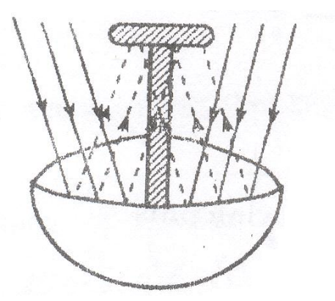

**EXERCISE**

1. **Name the major source of heat and light on earth.**
2. **What do we call the cells that converts heat from the sun into solar energy?**
3. **Give any two natural sources of energy in the environment.**
4. **What is the role of the sun during rain formation?**
5. **Mention any two equipment that use solar electricity**
6. **State any one use of solar electricity in our daily life**
7. **Give two advantages of using solar electricity over thermal electricity.**
8. **Why are solar panels made using black materials?**
9. **How does the sun drying preserve cereal crops?**
10. **Why is water regarded as an energy resource?**

**ENERGY RESOURCES FROM WATER (HYDRO ELECTRICITY, STEAM ENGINES AND TIDAL ENERGY)**

Water contains a lot of energy that people can use for different purposes.

* Water enables people to get the following forms of energy.

A**) HYDRO ELECTRICITY**

Hydro Electricity is the form of electricity produced by the power of fast flowing water at a fall of high level.

* Waterfalls in the reservoir contains potential energy that is changed to kinetic energy.
* Kinetic energy turns the turbines connected to a generator with powerful magnetic field and a coil of wire turning it and Hydro electricity is produced.

**Diagram showing how Hydro Electricity is generated at a dam**

**Advantages of using hydro electricity as an energy**

* Hydro electricity is renewable through water cycle
* Hydroelectricity is the cheapest source of electricity
* Hydro electricity does not pollute the environment

**B) STEAM ENGINES**

Steam is water in gaseous state

* Steam is got when water boil and begin to evaporate with kinetic energy that can be used to turn turbines of generators to power steam engines.
* Steam possess kinetic energy, this is why the lid of a saucepan or kettle is thrown off when boiling water.

**Uses of steam as an energy resource**

* Steam is used for generating electricity
* Steam is used for running engines of steam train, propellers and boat.
* Steam is used for heating and warming food and houses
* Steam can be used to cook food and steam bath.

**(C)TIDAL ENERGY**

Tidal energy is the form of energy got from water tides on the sea shores.

-Tides are periodic rise and fall of the level of water in large water bodies.

-The tides are caused by gravitational interaction between the earth and the moon.

**Importance of water as an energy resource to people and environment**

* Fast running water at a fall turns turbines to produce HEP.
* Water is used to cool machines in industries.
* Water is used for bathing and drinking.
* Tidal energy is used to produce electricity.

**EXERCISE**

**1. Mention four crops preserved by sun drying.**

**4. Mention two non- living energy resources found in your community.**

**5. Why is water regarded as energy resources?**

**6. Cite two living renewable resources in the environment.**

**7. State the difference between renewable energy resources and non -renewable energy resources.**

**8. Give three ways how water is used as an energy resource?**

**9. State the difference between air and wind.**

**10. Give three uses of carbon dioxide in the environment.**

C) **ENERGY RESOURCES FROM FOSSIL FUELS (PETROLEUM AND COAL)**

a) **What are fossils?**

Fossils are remains of plants and animals that were buried in the millions of years ago.

1. **What are fossil fuels?**

Fossil fuels are remains of plants and animals that were buried in the soil millions of years ago and can be burnt to produce heat and light energy.

1. **What are fuels?**

Fuels are substances that can be burnt to produce heat and light energy

1. **Write down four examples of fuels**

**Examples of fossils fuels.**

* Petroleum
* Coal
* Natural gas

**PETROLEUM//CRUDE OIL**.

Petroleum is a thick, dark sticky fossil formed from animal remains that were buried many years ago.

* Petroleum or Crude oil is mined in an impure form and separated in the **refineries** by the process called **fractional distillation**.

1. What is distillation?

Distillation is the process of boiling liquid to form vapour and the cooling of the vapour to obtain liquid.

1. What is fractional distillation?

Fractional distillation is the process of separating two liquids by distillation, the distillate being collected as a fraction which boil at different temperatures.

**Examples of petroleum product used as fuel**

* Petrol
* Diesel
* Jet ( aviation) fuel
* Paraffin/kerosene
* Natural ga

**Other petroleum products**

* Polythene bags
* Detergent
* Vaseline
* Fertilizers
* Paints
* Lubricating oil
* Tar
* dye

**Importance of petroleum products**

* Petroleum products are used to generate power that can run machines and vehicles.
* Petroleum products are burnt to produce heat and light.

1. **COAL.**

Coal is a fossil fuel dug from underground that was formed from plant remains.

**Importance of coal**

* Coal is used as fuel in steam engines.
* Coal is burnt to produce thermal electricity
* Coal used to make tar for surfacing roads.

**Other products from coal**

* Paints
* fertilizers
* perfumes.
* **NATURAL GAS**

During the formation of petroleum or coal, a gas is formed above called natural gas.

This gas can be tapped after drilling the gas is the put under a lot of pressure and it is liquefied.

* The gas is stored in cylinders.
* The gas is used for lighting, cooking, heating and refrigeration

**Uses of uranium**

* Uranium is used to make atomic bombs.
* Uranium is used as fuel in nuclear powered sub marines.
* Uranium is burnt to produce atomic electricity.

**EXERCISE**

1. **Give any one example of non-renewable energy resource**
2. **Why is coal and petroleum referred to as fossil fuel?**
3. **Why does clay made charcoal stoves use less charcoal than metallic one?**
4. **How are petroleum and coal used as an energy resource?**
5. **Why is the use of plastic as a resource being discouraged by NEMA?**
6. **Give any one way in which petrol in car is similar to food in human being.**
7. **Mention any three ways how animals depend on non- living things in the environment.**

**ENERGY RESOURCES FROM WIND**

1. State the difference between wind and air
2. Mention four components of air.

**HOW WIND IS USED AS AN ENERGY RESOURCE**

* Wind is used to turn wind mills to generate electricity
* Wind is used for winnowing harvested crops
* Used to turn wind mills to produce electricity.
* Wind is used for sailing boats
* Wind is used for flying kites.

**Diagram showing a windmill**

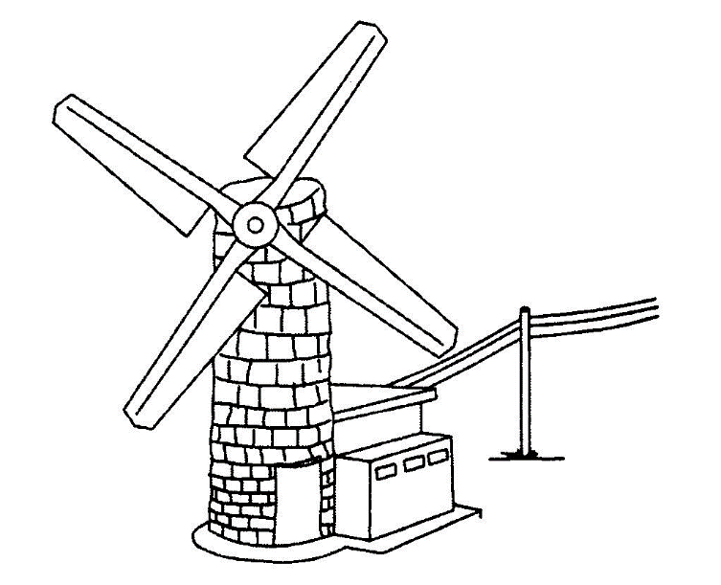

**ENERGY RESOURCES FROM ANIMALS**

People use animal products as a source of energy.

* Food is the major source of energy from animals
* The form of energy stored in animal meat is called chemical change.

**How animals are used as an energy resource**.

* Animals like oxen are used for ploughing land.
* Some animals like the donkeys, horse and camels are used for transport.
* Some animals like oxen, donkey ,horse and camel are used to pull carts

**ENERGY RESOURCES FROM PLANTS (BIO FUEL, WOOD FUEL, FOOD AND BIOGAS).**

People use plants in different ways to get energy. Energy resources from plants include;

**Energy resources from plants include;**

* Wood fuel-charcoal

-Firewood

-briquettes

* Biofuel like biogas (methane gas) and biodiesel from vegetable oil.

-Briquettes.

Briquettes are products that are made by pressing saw dust or other plant re sidues like coffee husks, maize husks and rice husks to produce fuel.

1. **Charcoal**

Charcoal is a product of wood made by incomplete burning of wood under limited supply of oxygen.

* This is done by burying the logs of wood in the soil to control oxygen supply

**Diagram showing charcoal burning**

**Biogas production from plants**

1. **What is biogas?**  
   Biogas is a methane gas that is produced from the rotting organic matter.
2. What is a biomass?

Biomass is the amount of living material found in an area.

The waste plant materials

* Cow dung and urine
* Plant materials.
* Kitchen refuse (wastes)

**Steps of making biogas digester**

* The plant and animal materials are put into an air-tight container called a biogas digester to ferment.
* The decomposition of plant and animal wastes in biogas digester is called anaerobic decomposition because it takes place in the absence of oxygen.
* During fermentation by an aerobic bacteria, methane or biogas is formed.
* When the gas formation stops, the remains (bio slurry) can be used as manure.

**Structure of Biogas digester**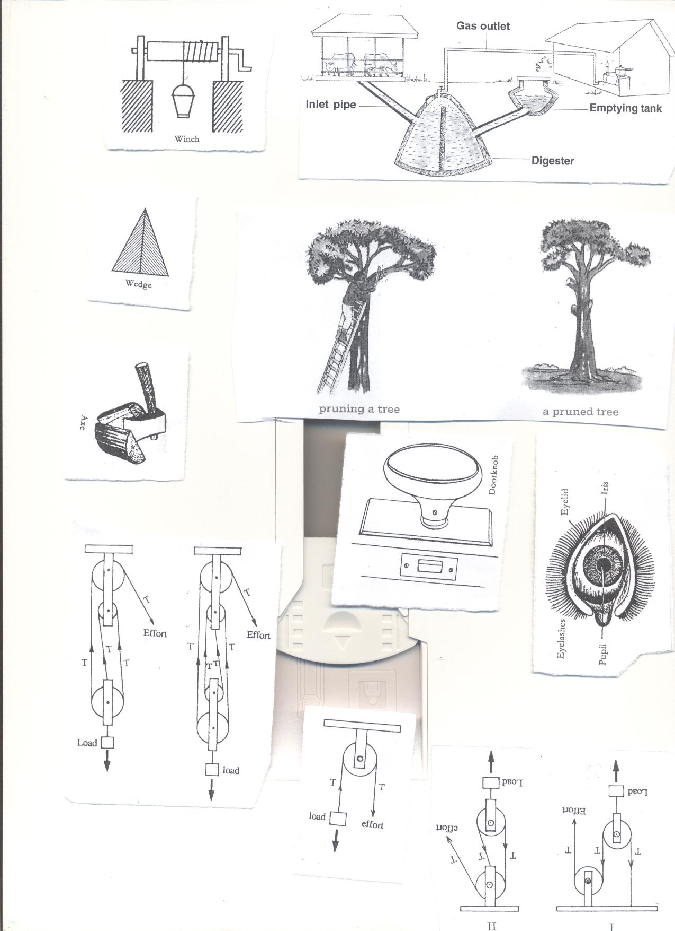

**Uses of the parts**

1. **Inle**t

An inlet is used for inserting in plants and animal matter**.**

1. **Inlet pipe**

Inlet pipe allows plant and animal matter into the digester.

1. **Outlet**

Outlet is used for removing old used up matter to the garden.

1. **Emptying tank**

Emptying tank is where used up matter is collected before it is taken to the garden.

1. **Biogas tube**

Biogas tube traps biogas and takes it to the heating or lighting equipment.  
**Uses of biogas**

* Biogas is used for cooking.
* Biogas is used for lighting.
* Biogas is used for heating.  
  **Advantages of using biogas**
* Biogas is cheaper alternative source of energy than natural gas
* Biogas materials are readily available in the environment.
* Biogas bio slurry provide organic fertilizers.
* Biogas production improves home hygiene.
* Biogas does not pollute environment.

**CONSERVATION OF ENERGY RESOURCES IN THE ENVIRONMENT**

**What is energy resource conservation?**

Conservation of energy resource is the protection of energy resources in the environment for future use**.**

**Ways of conserving energy resources from plants**

* By practising afforestation.
* By practising agro forestry**.**
* By using alternative sources of energy for cooking.
* By using energy saving stoves.
* By practising re afforestation.

**Ways of conserving energy resources from animals.**

* Gazetting game parks and reserves.
* Bunning the illegal hunting and killing of wild animals.
* Proper feeding of animals.
* Bunning the buying and selling of wild life products.
* Treating the sick animals.

**SAMPLE TOPICAL EXERCISE**

1. **Name the fuel got through burning wood in a limited supply of oxygen**
2. **State one advantage of animal transport over transport by vehicles.**
3. **How is biogas digester important in biogas production?**
4. **What is the advantage of using biogas over thermal electricity**
5. **How do energy saving stoves conserve the environment?**
6. **Why is biogas digester tightly sealed during biogas production**
7. **Why do local leaders encourage their people to plant trees?**
8. **Give two uses of charcoal and firewood as energy resources.**
9. **State two ways school buildings are protected from strong wind.**
10. **Mention any two examples of animals used for transport.**
11. **State the role of bacteria in biogas production.**
12. **How can cutting down of forest affect the production of HEP?**
13. **Give any two ways in which wind is dangerous to people.**
14. **How does covering of food during cooking save fuel?**
15. **State the importance of the solid residue to a farmer after the production of biogas.**
16. **What term is used to refer to the turning of biomass into useful energy?**
17. **The diagram below shows a biogas digester, use it to answer the questions that follow.**

a)**What name is given to part x?**

**b Identify the process which helps in the formation of biogas in part x.**

**c )How is respiration in container x of bacteria differ normal respiration?**

**D )What advantage does biogas have over thermal energy?**

**e) Name any two materials used in part marked x?**

**f )Give any one use of the item got from the above diagram in our daily life.**

1. **Mention any one advantage of using biogas over using firewood.**

**15 .How is a biogas digester important in the production of biogas?**

**16 . Cite any one thing used in the making of biogas.**

1. **Write down any three ways how animals depend on non living things in the environment.**

**18 .In what way can a farmer use the residue left after making bio gas.**

**19. State any two uses of biogas to human beings.**

**20. Why is wind said to be a form of energy?**

**21 .How does use of biogas contribute towards the control of environmental degradation?**

**22. What danger caused when biogas containers are kept near the reach of young children.**

**23. Name any three natural sources of energy.**

**24. How do we call the cell use to change the heat from the sun into electric energy?**

**25a) In which way does the use of biogas conserve the environment.**

**b) Apart from running windmills, give two other ways wind is used as an energy resources.**

**TOPIC 4: FRICTION AND SIMPLE MACHINES**

**VOCABULARY**

* **Friction Force**
* **Nuisance**
* **Moments**
* **Mechanical advantage**
* **Wedges**
* **Inclined Plane**
* **Axles**
* **Screws**

**FRICTION**

1. **What is friction?**

Friction is the force that opposes movement between two objects or surfaces.

* Friction is the force which prevents movement between two surfaces.

1. **What is force**?

Force is the pull or push exerted on an object.

Force is measured in Newton **(1kgf =10N).**

Types of forces

|  |  |
| --- | --- |
| * Frictional force | Frictional force is the force which opposes motion between two surfaces or objects. |
| * Gravitational force | Gravitational force is the that pulls objects to the Centre of the earth |
| * Buoyancy force | Buoyancy force is the force that makes object weigh less when placed in water |
| * Inertia force | Inertia force is the force which have the tendency of the body to remain in its state of rest or uniform motion |

**TYPES OF FRICTION**

1. **Static friction**:

Static friction is found in objects which are fixed in one position.

1. **Sliding or rolling friction**:

Sliding friction is the type of friction found in moving objects.

1. **Viscosity friction**:

Viscosity is the type of friction which occurs in liquids and gases.

**Properties of friction**

* There is more friction with rough surfaces than with smooth or slippery ones.
* The greater the load, the greater the friction force (weight increases friction)
* Whenever friction occurs heat is produced.

**FRICTION AS A USEFUL FORCE IN OUR DAILY LIFE (ADVANTAGES OF FRICTION)**

* Friction enables us to produce static electricity
* Friction enables moving vehicles, bicycles to brake or stop.
* Friction enables us to write using pens, chalk etc.
* Friction is used in sharpening objects or tools like knives, axes, panga etc.
* Friction is used for walking or movement.
* Friction enables us to light match sticks.
* Friction enabled early man to discover fire

**FRICTION AS A NUISANCE FORCE (DISADVANTAGES OF FRICTION)**

* Friction causes wear and tear of things e.g. shoe soles, parts of engines
* Friction delays work as it makes us use a lot of force.
* Friction produces unnecessary heat and noise squeaking of the door when it’s being opened
* Friction reduces the efficiency of the machine
* Friction reduces the speed of movement
* Friction makes one use a lot of energy

**How to increase friction**

* Making smooth surfaces rough

**Ways of making surfaces rough**

1. Putting treads on vehicle tyres / on shoe soles.
2. Putting spikes on sports boots
3. Putting grips on handles of bicycles, motorcycles
4. By tarmacking the roads
5. By pouring murram on roads

**Diagrams showing how friction is increased on rough surfaces**

|  |  |
| --- | --- |
|  |  |
|  |  |

**HOW FRICTION CAN BE REDUCED.**

* **Using rollers**.

Rollersdecrease areas of contact between moving parts.



* **Using ball bearings**

Ball bearing are round metallic balls they reduce friction by keeping moving parts separated.

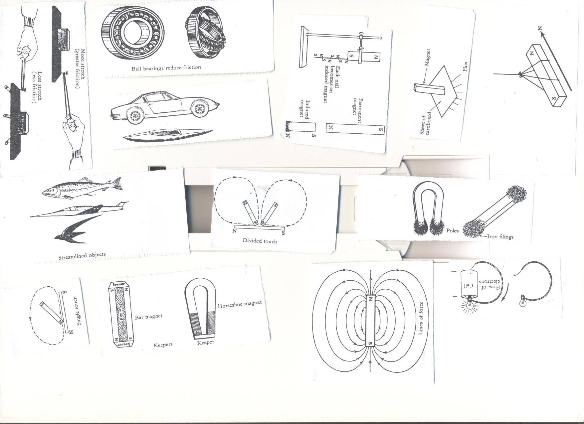

* **By lubricating the moving parts of machines using grease and oil**
* Lubrication reduces contacts between moving parts of machines
* Oil and grease are referred to as **lubricants**.
* **Streamlining objects like birds, aero planes, cars and fish**

**diagrams showing streamlined objects**

|  |  |
| --- | --- |
| **Aero plane** | **Vehicle** |
|  |  |
| **Fish** | **birds** |
|  |  |
| **Boats** |  |
|  |  |

**Exercise**

1**. Name the force that makes objects fall on the ground**

**2. Give two ways in which friction can be increased in a slippery road.**

**3. How is friction useful to a P.7child calculating Mathematics numbers on the chalk board?**

**4. Write down any two advantages of friction in our daily lives**

**5. Why is friction said to be a nuisance force?**

**6. Why are some objects stream lined?**

**7. a) Which type of mechanical energy is possessed by the body;**

1. **In motion.**
2. **at rest**

**b) Why do people sitted in a bus tend to bend backward when the bus starts?**

**c) Which force tends to push objects towards the surface of a liquid?**

1. **State any two items that are stream lined?**
2. **How is friction reduced in the joints?**
3. **John pulls a load of 50kg over a set of metal rollers. Peter pulls another load of the same weight along the ground. Use the diagrams below to answer the questions that follow.**

**a) Explain why one of the two uses less force.**

**b) What is the advantage of pouring sand on slippery roads?**

**c) What force makes a pencil reduce in length as one writes?**

**d) Name any one form of energy produced by the force when one writes.**

**11a). whenever Mariam opens or closes her door, the hinges make noise. What causes the noise?**

**b) Give two advice you can give to Mari am to overcome the noise.**

**c) Give one way in which the above force is useful to a person riding a bicycle.**

**12a) State the difference between friction and buoyancy force.**

**b) What is the difference between inertia in motion and inertia at rest?**

**C) Give any one form of energy produced as a carpenter drives a nail into wood with a hammer.**

**SIMPLE MACHINES**

**1. What is a machine?**  
A machine is a device that simplifies work.

**2. How do machines simplify work?**

* By changing the direction of force
* By reducing the effort required to do work
* By increasing the speed of doing work  
  **TYPES OF MACHINES**
* Simple machines
* Complex machines

**(A) Complex machine**  
1. **What are complex machines?**

A complex machine is a machine that is made up of many parts and simplifies work.

**Examples of complex machines**

* Tractor
* Bicycle
* Sewing machine
* Car
* Aero plane
* Sewing machines

**SIMPLE MACHINES**

1. **What is a simple machine?**

Simple machine is a device that is made up of few parts and simplifies work.  
**Examples of simple machines**

|  |  |  |  |  |  |
| --- | --- | --- | --- | --- | --- |
| A hoe | See saw | Claw hammer | Nut cracker. | Human arm. | Nut cracker. |
| A wheel barrow | Pincers. | Water pump | Sugar tongs. | Spade. | Sugar tongs. |
| A pair of scissors | Crow bar. | Bottle opener | Fishing rod | Ladder. | Stairs. |

**CLASSES OF SIMPLE MACHINES**

* Levers
* Inclined planes/slope
* Wedges
* Screws
* Wheel and axle
* Pulleys  
  **LEVERS**

1. What is a lever?

A lever is a stiff rod that turns on a fixed point called a pivot or fulcrum

**Parts of a lever**

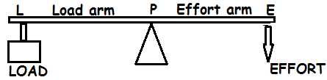  
**(a) Effort**

Effort is the force exerted on a machine to overcome the load  
**(b) Load / resistance**

Load is the weight of the body to be lifted.

**(c) Fulcrum or Pivot**

Pivot is the turning point of a machine.  
**(d) Load arm**

Lord arm is the distance between the fulcrum and the load.  
**(e) Effort arm**

Effort armis the distance between the fulcrum and the effort.

**Classification of levers**

1. **How are levers classified?**

Levers are classified according to the position and arrangement of load fulcrum and effort

1. **How are the classes of levers determined?**

Classes of levers are determined basing on the force that lies between other two.

**CLASSES OF LEVERS**  
There are three classes of levers depending on the position of the fulcrum **(F)**, Load **(L)** and effort **(E)**   
**FIRST CLASS LEVERS**

1. **What is a first class lever?**

First class lever is where fulcrum/pivot is between the load and effort.

* In first class lever, the effort arm is longer than the load arm.
* The longer the effort arm, the smaller the effort applied.  
  **The advantage of the first class lever is that less effort is used.**  
  **Examples of simple machine under first class levers**

|  |  |  |  |
| --- | --- | --- | --- |
| 1 | See saw | 5 | Crow bar |
|  | C:\Documents and Settings\Kirinya\Desktop\stepu\order form 3 016.jpg |  | C:\Documents and Settings\Kirinya\Desktop\stepu\order form 3 016.jpg |
| 2 | Pincers | 6 | Pliers |
|  | C:\Documents and Settings\Kirinya\Desktop\stepu\order form 3 016.jpg |  | C:\Documents and Settings\Kirinya\Desktop\stepu\order form 3 015.jpg |
| 3 | Claw hammer | 7 | Water pump |
|  | C:\Documents and Settings\Kirinya\Desktop\stepu\order form 3 012.jpg |  | C:\Documents and Settings\Kirinya\Desktop\stepu\order form 3 015.jpg |
| 4 | Scissors | 8 | Lid opener |
|  | C:\Documents and Settings\Kirinya\Desktop\stepu\order form 3 007.jpg |  | C:\Documents and Settings\Kirinya\Desktop\stepu\order form 3 007.jpg |
| 9 | Scales |  | 10.Beam balance |
|  | C:\Documents and Settings\Kirinya\Desktop\stepu\order form 3 016.jpg |  | C:\Users\ONGOM PETER\Desktop\SCIE DIAGRAM\Scie diagram\beam balance.png |

**How do first class levers simplify work?**

-By reducing the load arm and increasing effort arm less effort is used.

-Load and effort move in different direction

**EXERCISE**

1. **Name the turning point of a machine.**
2. **Why is a pair of scissors referred to as a simple machine?**
3. **The diagram below shows a claw hammer. Use it to answer the question that follow.**

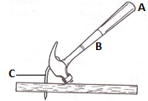

**Show on the diagram above, the position of the pivot using an arrow and letter P.**

1. **Which class of lever is shown above?**
2. **Why is it easier to pull the nail from A than from B?**
3. **The diagram below shows a simple lever system. Use it to answer question 4,5and 6.**

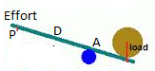

1. **Show on the diagram with an arrow the direction of movement of the effort at P as the load is being lifted.**
2. **At which of the two points D and P shown on the diagram less effort be used to lift the load.**
3. **Give a reason for your answer in 5 above**

**Why are pliers classified under first class lever?**

**The diagram below shows a simple machine. Use it to answer the questions 17 and 18.**

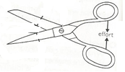

1. **To which class of lever does the machine above belong?**
2. **Use an arrow and letter F show the position of the pivot on the above diagram**

**Daniel and Patel sat on a see-saw as shown in the diagram below. Use it to answer the question that follow.**

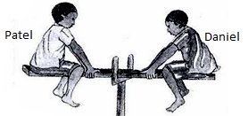

1. **Why is Daniel nearer to the fulcrum than Patel?**

**SECOND CLASS LEVER**

* **What is a second class lever?**  
  Second class lever is where the load is between the **fulcrum** and **effort.**  
  The fulcrum and the effort are on either side. **(FLE OR ELF**)
* The load is closer to the fulcrum than the effort
* The effort applied is smaller compared to the load.  
  First and second class levers are referred to as force multipliers

**Examples of machine under second class levers**

* Wheelbarrow
* Bottle opener
* Nut cracker
* Human foot
* Paper cutter

|  |  |  |  |  |
| --- | --- | --- | --- | --- |
| 1 | Wheel barrow | 3 | Human Foot | |
|  | C:\Documents and Settings\Kirinya\Desktop\stepu\order form 3 014.jpg |  | | C:\Documents and Settings\Kirinya\Desktop\stepu\order form 3 015.jpg |
| 2 | Nut cracker | 4 | Bottle opener | |
|  | C:\Documents and Settings\Kirinya\Desktop\stepu\order form 3 015.jpg |  | C:\Documents and Settings\Kirinya\Desktop\stepu\order form 3 014.jpg | |

**Questions**

1. Write down any **two** examples of each of the following.

a)First class lever b) second class lever

1. State any **one** advantage of using first class lever?
2. Draw any **two** devices in first class lever.
3. How are machines important in life?
4. State any **two** ways in which machines are able to improve on the efficiency of a machine.

**THIRD CLASS LEVERS**

1. **What is third class lever?**

Third class lever is where the effort is between fulcrum and load.  
-The fulcrum and the load are on the either side. **(FEL OR PEL**)

The effort is closer to the pivot than the load  
The effort used is greater than the load.  
Third class levers are referred to distance multipliers.

The advantage of using this class is that the effort moves through a shorter distance  
**Examples of machines under third class levers**

* Sugar tongs
* Fishing road
* Human arm
* Tweezers
* Spade and hoe in use

|  |  |  |  |
| --- | --- | --- | --- |
| 1 | Sugar tongs | 3 | Fishing rod. |
|  | **C:\Documents and Settings\Kirinya\Desktop\stepu\order form 3 012.jpg** |  | C:\Documents and Settings\Kirinya\Desktop\stepu\order form 3 015.jpg |
| 2 | Human arm.  C:\Documents and Settings\Kirinya\Desktop\stepu\order form 3 012.jpg | 4 | Spade.  C:\Documents and Settings\Kirinya\Desktop\stepu\order form 3 013.jpg |
| 5 | Table knife 6. Tweezers | | |
|  | C:\Documents and Settings\Kirinya\Desktop\stepu\order form 3 004.jpghttp://shop.nouveaubeautygroup.com/media/catalog/product/cache/1/thumbnail/650x650/9df78eab33525d08d6e5fb8d27136e95/h/d/hdbrows_tweezers_1.jpg | | |

**N.B** The formula PLE or FLE can help to determine the class of lever

**EXERCISE**

1. State the difference between first class lever and second class lever?
2. A boy of weight **200N** lifts a bag to **4.5m** above the ground. Calculate the work he did.
3. How do simple machines simplify work?
4. Why is it difficult to write on an oily paper?
5. To which class of levers does a wheelbarrow belong?
6. Calculate work done by Lubega who pushed a wheelbarrow of mass **60kg** through a distance of **20m**.
7. The diagram below shows a machine, to which class of simple machine does the machine shown above belong.

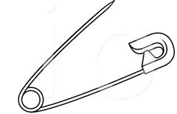

1. How can friction be reduced in the moving parts of machines?
2. State any one use of screws as a simple machine.
3. **Study the diagram of a pulley below and use it to answer questions 17 and 18.**

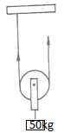

Name the type of pulley shown on the diagram above

1. State one use of such pulleys at a construction site.
2. How useful is the law of lever to businessmen in your community?
3. What is a lever?
4. Which force enables a rubber to remove pencil marks on a paper?
5. Why do cars take long to stop in marrum roads than tarmac ones when brakes are applied?

**The diagram below of a simple machine. Use it to answer question that 27 and 28.**

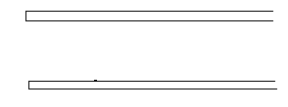

1. Indicate with letter **E** the position of the effort.
2. Which class of lever is the above machine?
3. How does friction affect a hoe?
4. Give that the mechanical advantage of a machine is **4** and the load to be lifted is **480N.**Find the effort needed to lift the load.
5. How do first class levers simplify work?
6. In terms of machines, how is the hammer similar to pairs of scissors
7. Give a reason why a spade is classified as a third class lever.
8. Give one example of third class lever?
9. If the effort of **20kgf** is required to lift a load of **40kgf**.Find the mechanical advantage.
10. Give the use of an axe as a simple machine.
11. What name is given to the space between fulcrum and the effort?

**The principle of moments (The law of the lever)**

1. **What is moment?**

Moment is the turning effect of a force about a point

Force acting on the left of the pivot tends to turn it anticlockwise while force on the right of the pivot tends to turn it clockwise.

**2. State the principle or law of moments**  
The principle of moments states that load force multiplied by the load arm is equal to the effort force multiplied by the effort arm.

OR. The principle of moments states that clock wise moments are always equal to anti-clock wise moments.

Formula; Load

**APPLICATION OF PRINCIPLE OF MOMENTS  
Examples one**

1. A man weighs 60 kgf. He sits 1.5 metres from the fulcrum of the see saw. How far from the fulcrum will the boy whose weight is 30 kgf sit in order to balance the man.  
   Let the man be the effort and the boy be the load.  
   Let the load be x metres.

X 1.5m

MAN

BOY

Load x Load arm = Effort x effort arm.  
30Kgf x X =60kgf x 1.5m  
30x = 90  
 30 30  
x =3 metres  
2. A boy weighing 60kgf sits 2 metres away from the fulcrum of the see saw.  
A girl sits on the other side at a distance of 3 metres from the fulcrum in order to balance the see saw. Find the weight of the girl.

2m 3m

60Kgf

X kgf

Let the boy be the effort and the girl the load.  
Let the girl’s weight be y  
Then, Load x Load arm=Effort x Effort arm  
 y x 3m =60Kgf x 2 metres.  
3y =120  
 3 3  
 y = 40kgf  
3. A weight of 120 grams at a distance 3cm from the fulcrum is balanced by a weight of 30g on the other side. Find the distance from the 30kg weight to the fulcrum.

Take 120kgf as the effort and 30kg as the load.  
Let y be the distance of the load from the fulcrum.  
Then Load x load arm=Effort x Effort arm.  
 30 x y =120gf x 3cm  
30y = 360  
 30 30  
 y =12cm

**4.**Using a see-saw shown below, find the length of the wooden plank AB.

A 2m B

3kgf

5kgf

**1. Find the value of X**

4m 2m X m

5kgf

15kgf

10kgf

**Find the weight at X**

4cm 2cm 3c m

5kgf

15kgf

**X**

1. Find the weight at X

3m 2m 2m 4m

30g

40g

**X**

25g

**EXERCISE**

1. **The lever in the diagram below is balancing use it to answer the questions that follow**.

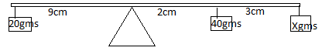

1. Calculate the value of X**.(2Marks)**
2. Why is the lever above said to belong to first class lever?
3. Give one example of a device in the second class levers.
4. (a) What is a machine?

(b) Name **two** types of machines

(c)To which group of machines does an axe belong?

1. (a) Which term describes the stiff or rigid rod that turns freely at the fulcrum?

(b) Give any **one** example of;

(i) First class lever

1. (ii) Levers of third class
2. **The diagram below shows a wheelbarrow. Use it to answer the questions that follow.**

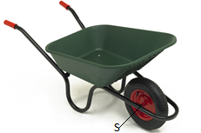

1. To which class of levers does the wheelbarrow belong?
2. Give a reason for your answer in (a) above.
3. With an arrow and letter **E** show the position of effort.
4. Mention any other tool that belongs to the same class as a wheelbarrow.
5. **The diagram below shows a boy getting water from the pump**.

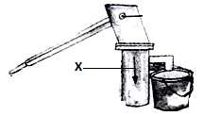

(a) Mark on the diagram of water pump with letter **E** the position of the effort.

(b) What does part mark **X** represents?

1. What change would the boy experience if he moved his hands to position **B**?

(d)If the effort is **20N** and the load is **80kg**.What is the mechanical advantage of the pump?

1. Why are wheelbarrows grouped under second class lever? **Study the diagram below and use it to answer the questions that follow**.

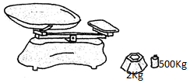

(a) Name the simple machine shown above.

(b) State the **basic unit** for mass used when measuring using the above simple machine.

(c)To which class of lever does the above machine belongs?

1. (d)Name any **one** item that can be measured using the above machine. **The diagram below shows the human arm holding a stone. Use it to answer the questions that follow.**

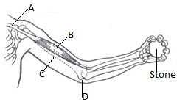

(a) Which muscle act as the effort in order to lift the stone?

(b) What kind of movement is possible at each of the following points?

(i) Joint **A**

(ii) Joint **D**

1. Which class of lever is represented by the diagram above? **Pearl** who weighs **40kgf** sits **9metres** from the Pivot and is balancing with **Judith** who weighs **60kgf**.How far is **Pearl** from **Judith**. Begin with a sketch **(4 Marks)**
2. **Study the water pump below and use it to answer the question that follow.**

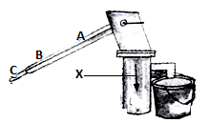

(a) Which of the three positions **A, B** and **C** requires;

(i) Less effort

(ii) More effort

(b) Which class of lever does the water pump above belong?

(c) If the effort is **20N** and load is **100N**, what is the mechanical advantage of the pump?

1. **The diagram below shows two loads balancing on a see-saw. Use it to answer the questions that follow**.

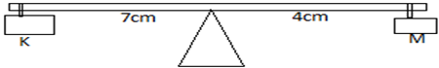

(a) Which load is heavier?

(b) Give a reason to support your answer in **(a)** above

(c)To which class of lever does a see-saw belong?

1. Use letter **A** to show the pivot.
2. Mention any **two** types of machines found in the following:

(a) Wheelbarrow

(b) A pair of scissors

**13. The diagrams below show simple machines. Use it to answer the questions that follow.**

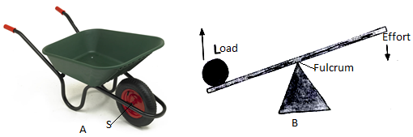

1. Name the machine marked with letter **A**.
2. State the class of lever to which each of the above machines.

(i)Machine **A**

(ii) Machine **B**

1. Give any **one** example of a machine which works in the same way as machine marked with letter **A**.

**THE INCLINED PLANE (SLOPE)**

1. **What is an inclined plane?**

An inclined plane is slanting surface connecting the lower level to the higher level

* An inclined plane makes it easier to lift heavy loads by enabling the person to apply less effort over a longer distance.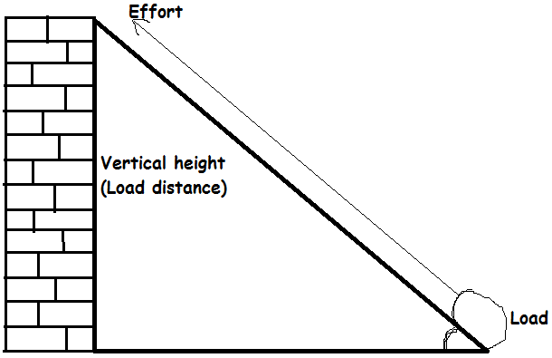

**Examples of inclined planes**

* Winding roads
* Stair cases (steps)
* Ladder leaning against the wall
* Ramp or a plank of wood

**Diagrams showing inclined planes**

|  |  |  |  |
| --- | --- | --- | --- |
|  | C:\Documents and Settings\Kirinya\Desktop\stepu\order form 3 010.jpg |  | C:\Documents and Settings\Kirinya\Desktop\stepu\order form 3 012.jpg |
| 2 | Stairs/ steps. | 4 | Ladder leaning against the wall |
|  | C:\Documents and Settings\Kirinya\Desktop\stepu\order form 3 010.jpg |  | C:\Documents and Settings\Kirinya\Desktop\stepu\order form 3 006.jpg |

**Importance of an inclined plane**

* Inclined planes are used for loading and off-loading heavy loads to higher level like in lorries
* Inclined planes are used for climbing tall buildings like pyramids,skyscramppers
* Inclined planes enable people to use less effort when lifting heavy loads.
* Inclined planes are used by builders to carry materials to higher levels.
* Inclined planes is used to lift logs by lumber jack
* Inclined planes enables vehicles to ascend or climb steep hills

**CALCULATION OF WORK DONE AND MECHANICAL ADVANTAGE IN INCLINED PLANES.**

**Example one**  
John used a slope to raise a load of 60kgf from the ground to the higher level as shown below.  
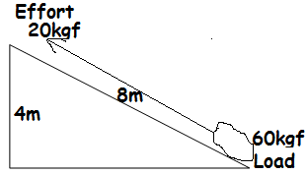  
(a) What distance does load and effort move?

1. load
2. effort

(b) Calculate the mechanical advantage of the machine

(c) Calculate work done by the man  
**WEDGES**

1. **What is a wedge?**

A wedge is a simple machine used for cutting, splitting and piercing.

Wedges are also known as double inclined plane/slope.

1. **How do wedges simplify work?**

By concentrating forces at the cutting point

1. **Why are wedges called doubled inclined planes**?

Wedges have two sloping surfaces

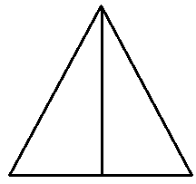

**Examples of wedges**

* Knife
* Axe
* Needle
* Razorblade
* Panga
* Safety pin
* Bullet
* nail

|  |  |  |  |
| --- | --- | --- | --- |
| **1** | Knife edge. | **5** | Axe bladder |
|  | C:\Documents and Settings\Kirinya\Desktop\stepu\order form 3 004.jpg |  | C:\Documents and Settings\Kirinya\Desktop\stepu\order form 3 011.jpg |
| **2** | Hoe | **6** | Razor blade |
|  | http://www.easydigging.com/images-new/home-grape-hoe.jpg |  | [http://t2.gstatic.com/images?q=tbn:ANd9GcTIE6EoqmU1uhn6oT3YYz7krE0IbWL1xY3_rCxkvI_eKjLOa1ctsHbPGZbI](http://www.google.com/imgres?imgurl=http://lunyole.webonary.org/wp-content/uploads/bantu/images/original/razor.png&imgrefurl=http://lunyole.webonary.org/?s=razor%20blade&partialsearch=1&usg=__BNcddsRX0bAoxj2PKoF09yyTX98=&h=1131&w=1351&sz=15&hl=en&start=20&zoom=1&tbnid=ZP5O7exX4QMmRM:&tbnh=126&tbnw=150&ei=fwYNUbGVNseKhQet3YHgDQ&prev=/search?q=razor+blade&um=1&hl=en&gbv=2&tbm=isch&um=1&itbs=1) |
| **3** | Nail. | **7** | Needle. |
| **4** | http://image.made-in-china.com/4f0j00VCLEmPsfsYgG/Iron-Nail.jpg |  | **[http://adaptstudio.ca/blog/uploaded_images/needle-769303.png](http://adaptstudio.ca/blog/uploaded_images/needle-769308.png)** |
|  | Safety pin  C:\Users\ONGOM PETER\Desktop\SCIE DIAGRAM\Scie diagram\safety pin.png | | |

**USES OF WEDGES**

* Wedges are used for splitting logs or wood
* Wedges is used for cutting trees
* wedges are used for sewing
* Wedges are used for digging
* Wedges are used by medical workers to carry out surgical operation
* Wedges are used by health workers to inject drugs in people

**SCREWS**

1. **What are screws?**

Screws are inclined planes wound around a rod

Screws give a large mechanical advantage that enable users to apply very little effort to do the work

**DIAGRAM SHOWING A SCREW**

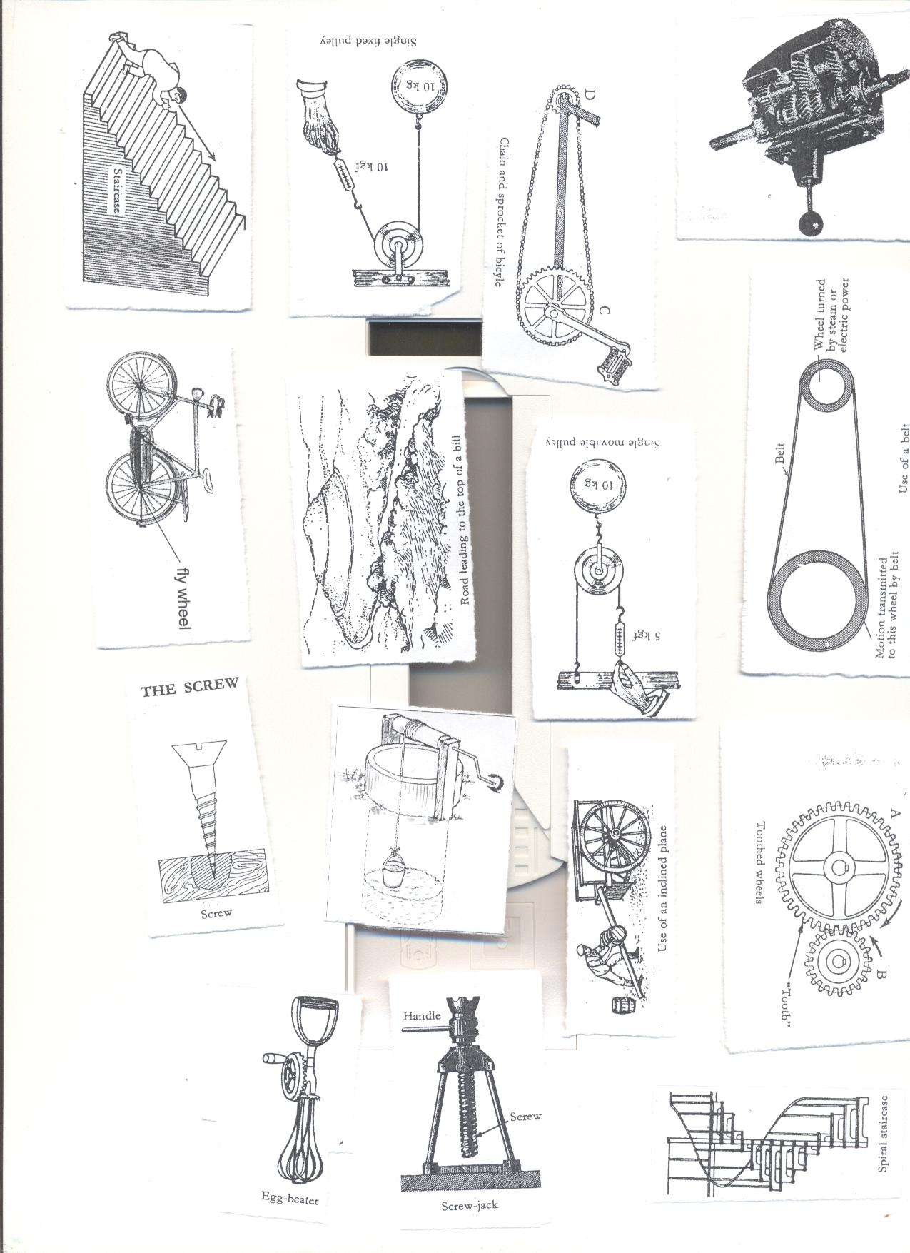

**Examples of screws**

* A car jack
* Bolts
* Nuts
* Bottle lids
* Spiral stair cases
* Screw nail engineering vice

**USES OF SCREW**

* Screws are used for lifting very heavy things e.g. screw jack
* Screws make movement up stairs easier e.g. using a spiral stair case
* Screws are used to fasten and loosen things together.
* Screws are used to drill holes in wood and metal  
  **EXAMPLES OF SCREWS**

|  |  |  |  |
| --- | --- | --- | --- |
| **1** | Spiral staircase | **3** | Screw jack |
|  | **C:\Documents and Settings\Kirinya\Desktop\stepu\order form 3 010.jpg** |  | C:\Documents and Settings\Kirinya\Desktop\stepu\order form 3 012.jpg |
| **2** | Screw nails |  |  |
|  | C:\Documents and Settings\Kirinya\Desktop\stepu\order form 3 012.jpg |  |

**WHEEL AND AXLE**

1. **What is a wheel and axle?**

Wheel and axle is a simple machine consisting of two rotating wheels fixed together.

Wheel and axle is a simple machine consisting of a circular wheel and a shaft called axle attached to the centre of the wheel

1. **What is an axle?**

An axle is a rod passed through a wheel that rotates or turns  
The wheel rotates on an axle.  
**Examples of devices that use wheels and axles**

* Steering wheel
* Door knobs
* Pedal wheels and bicycle chains
* Egg beater
* Screw drivers
* Brace
* Windlass/winch
* Handles of bicycles

|  |  |  |  |
| --- | --- | --- | --- |
| **1** | Door Knobs | **5** | Pedal wheels |
|  | C:\Documents and Settings\Kirinya\Desktop\stepu\order form 3 011.jpg |  | C:\Documents and Settings\Kirinya\Desktop\stepu\order form 3 007.jpg |
| **2** | steering wheel | **6** | Egg beaters |
|  | C:\Documents and Settings\Kirinya\Desktop\stepu\order form 3 012.jpg |  | C:\Documents and Settings\Kirinya\Desktop\stepu\order form 3 010.jpg |
| **3** | Screw drivers | **7** | Brace |
|  | C:\Documents and Settings\Kirinya\Desktop\stepu\order form 3 012.jpg |  | C:\Documents and Settings\Kirinya\Desktop\stepu\order form 3 004.jpg |
| **4** | Windlass  C:\Documents and Settings\Kirinya\Desktop\stepu\order form 3 005.jpg |  | Handles of a bicycle.  http://www.benluiindia.com/cycle_imgs/handles-a,b2.jpg |

**APPLICATION OF WHEEL AND AXLE IN OUR DAILY LIFE/USES OF WHEEL AND AXLE**

* Wheel and axle is used for drawing water from underground tanks using windlass/winch.
* Wheel and axle is used for driving vehicles e.g. car steering wheel
* wheel and axle is used for drilling holes in wooden materials using the brace
* Wheel and axle is used to open and close the doors e.g. door knobs
* wheel and axle is used for turning screws to fix things together using a screw jack, screw drivers
* Wheel and axle is used in loosening the screws.
* Wheel and axle preparing eggs for frying using egg beaters.

**EXERCISE**

1. **Give any two examples of each of the following:**
2. **Wheels and axles**
3. **screws**
4. **How are screws important to people?**
5. **Give any two uses of screws.**
6. **Give any two examples of screws.**
7. **How are inclined planes important to human beings?**
8. **To which group of simple machine does a surgical blade belong?**

**GEARWHEELS/COG WHEELS OR TOOTHED WHEELS**

**1. What are gear wheels?**  
A gearwheel is a special form of the wheel with teeth around the edges.  
-The teeth interlock with the teeth of another gear wheel.

-If teethed wheels are connected with chains belts, they move in the same direction.

-As one wheel rotates, it turns the other but they move in opposite direction.



**Examples of machines that use gear wheels**

* Watches
* gear boxes
* radio cassette decks
* digital video disc player
* Electric toys
* Bulldozers
* Bicycles
* Motor cycles

1. **What are the advantages of using gear wheels?**

* Gear wheels multiply the force
* Gear wheels change the direction of rotation
* Gear wheels multiply the speed of rotation.
* Gear wheels can slow the speed of rotation

**DRIVE BELTS**  
*A driver bell transmits motion from one wheel to another*

*Both wheels move in the same direction*

*When one turns it causes the other one to turn.*

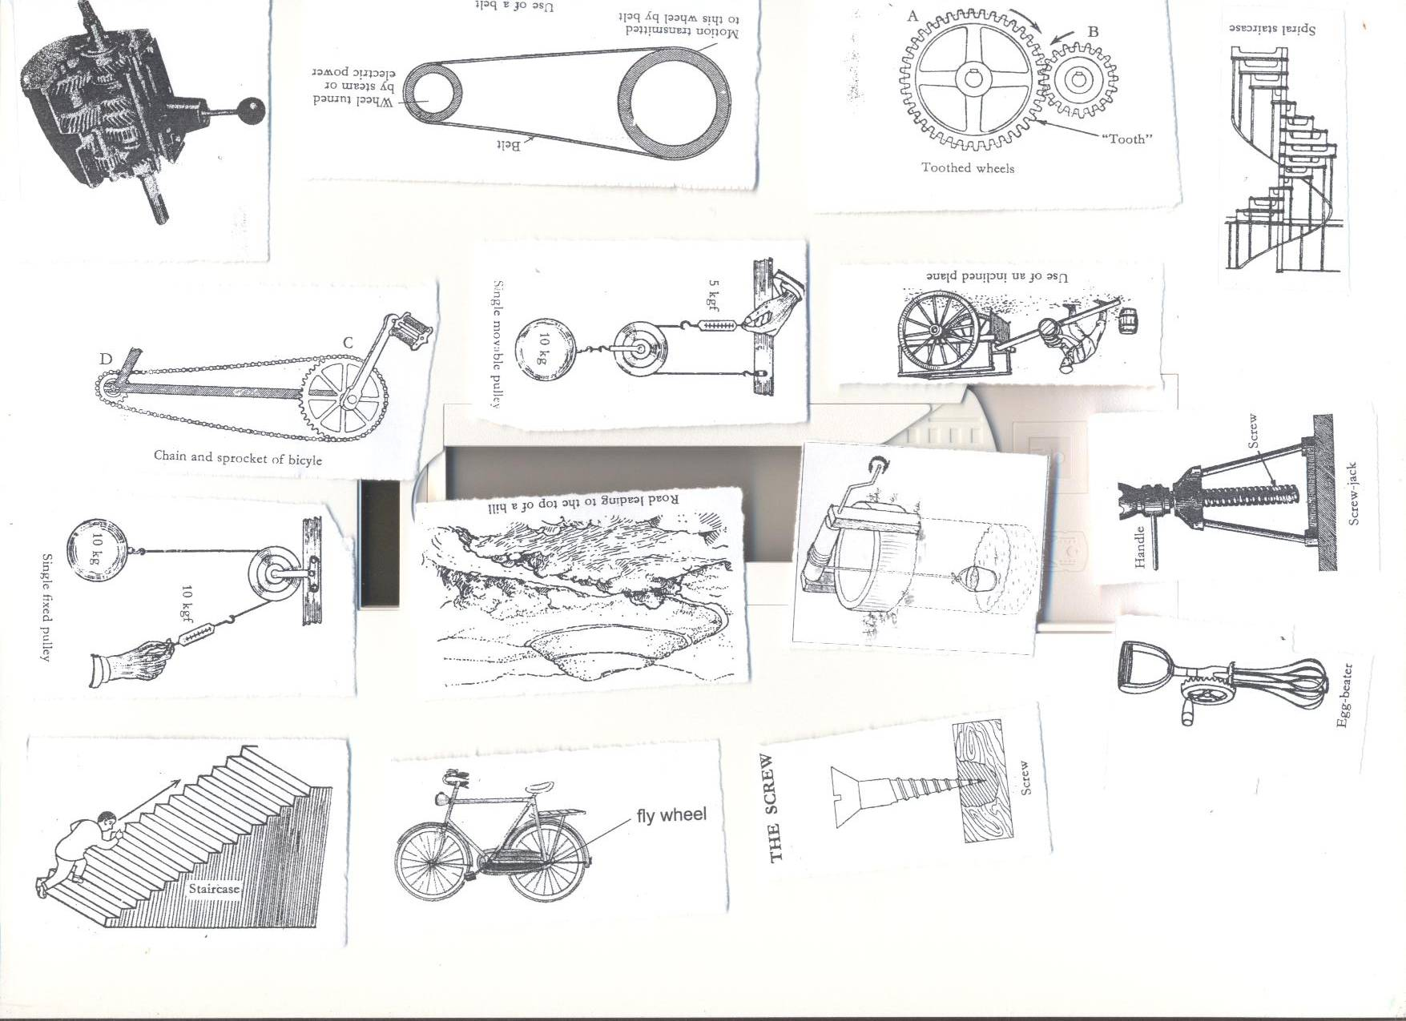  
If A has 30teeth and B has 15 teeth, how many rotations does B make in one revolution?  
30divided by 15  
=2 turns.

**What are the uses of gear wheels and belt drives?**

-Gear wheels can be used to change direction of rotation that is reverse in vehicles

-Gear wheels can be used to multiply the effort

-Drive belts transmit motion from one wheel to another

-Belt drives are used in factories and industries to transmit and transport different manufactured products e.g. bottling lines of soda and beers.

Questions

1. Give any two types of pulleys.
2. How are pulleys important at school?
3. Calculate the Mechanical Advantage of a machine that needs an effort of 20kg to overcome a load of 60 kg.
4. State one difference between a single fixed pulley and a single movable pulley.

Cite any two importance of the rope on a pulley.

**PULLEYS**

1. **What is a pulley?**  
   A pulley is a wheel with grooved rim that rotates freely about an axle through a Centre.  
   -A rope or chain passes over the pulley and is prevented from slipping by the grooved

The frame which holds the pulley is called block

**TYPES OF PULLEYS**  
1. Single fixed pulley  
2. Single movable pulley  
3. Block and Tackle system.

**SINGLE FIXED PULLEY**

Single movable pulley is the type of pulley where the block is attached to the frame and only the wheel moves.

* In single movable pulley the distance moved by the load is equal to the distance moved by the load is the same as the distance moved by the load.
* The effort applied is equal to the load.
* Single fixed pulley changes the direction of force by applying the down ward force, work becomes easier.  
  The M.A of a single fixed pulley is one (1)

**Diagrams showing single movable pulley**

**Examples of single fixed pulley**

* Flag pole (hoisting a flag)
* Towing vehicles

**Advantages of using single fixed pulley**

* Single fixed pulley changes the direction of the force
* Single fixed pulley is easily operated from below by pulling it downwards; it’s easier to raise the load.

**Worked example on single fixed pulley**

**Example one**;  
If a load of 30kgf is to be raised using a single fixed pulley, find the effort needed  
M.A =1  
L=30kgf  
E=??  
M.A = load/Effort  
 1 = 30/E  
E x 1 = 30  
 E = 30kgf.

**SINGLE MOVABLE PULLEY**  
Single movable pulley is the type of pulley where the whole pulley block moves along the rope.

* Single movable pulley is supported on two ropes.  
  The rope is pulled up wards.  
  The pulley moves with the load.  
  Each of the ropes share a half of the effort needed.  
  The rope moves twice as far as the load.
* Single fixed pulley does not change direction of the force, both load and effort move in the same direction.  
  The M.A advantage of single movable pulley is 2 (two)

-Effort applied is half the load force. (It reduces the effort needed)

Qn.**Why doesn’t movable pulley change the direction of force**?

Single fixed pulley doesn’t change direction because there are two sections of rope which support the pulley and this gives M.A of 2 reducing the force by half the weight of the load

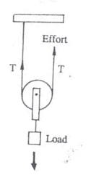

**Example**. If a load of 30kgf is to be raised using a single movable pulley, Find the effort needed.  
M.A = 2  
L = 30kgf  
E =??  
M.A = L/E  
 2 = 30/E  
2 x E = 30  
2E = 30  
 2 2  
 =15kgf.

**DIFFERENCES BETWEEN FIXED AND MOVABLE PULLEY**

|  |  |
| --- | --- |
| **Fixed pulley** | **Movable pulley** |
| Work is done faster | Work is slower |
| Change direction of force | No change of in direction of force |
| Force used is equal to the load. | Effort applied is half the load force. |

**BLOCK AND TACKLE SYSTEM**

**Block and pulley is the type of pulley which consists of two or more pulleys in each block according to the mechanical advantage required**  
-Block and tackle does work more easily because it is a combination of both fixed and movable pulleys.  
-Block and tackle changes direction of force.  
Block and tackle reduces effort needed.  
The ratio of load to Effort is determined by the number of pulleys.

-The mechanical advantage of a block and tackle is determined by the number of pulley (wheels) in the block.

.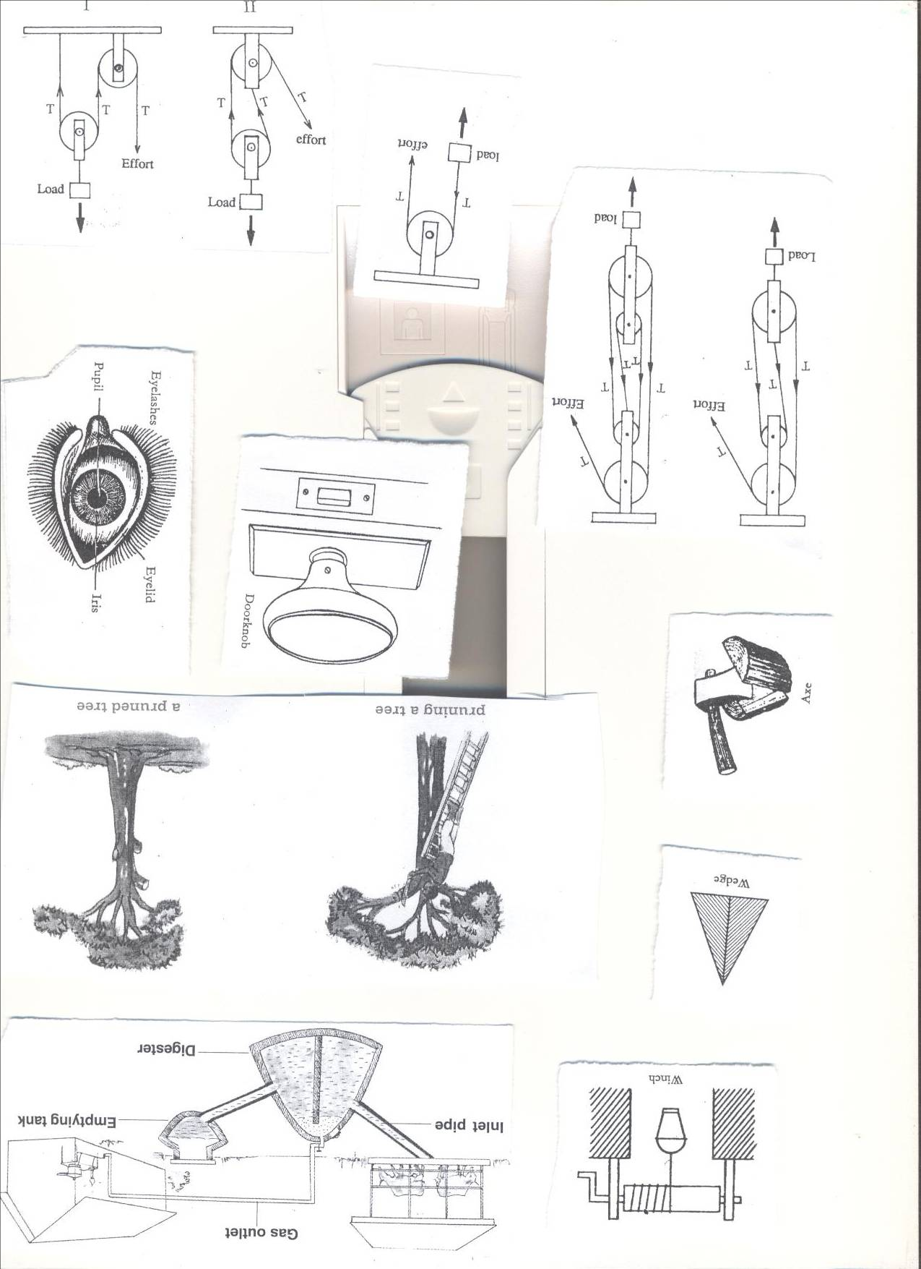

**IMPORTANCE OF PULLEYS**

* Pulley is used in lifting objects from the lower level to higher level
* Pulley is used in lifting heavy loads during building
* Pulley is used in off-loading heavy vehicles.
* Pulley is used in towing vehicles.
* Pulleys are used to raise flags on the poles.
* Pulleys are used to move window curtains

**5: THE EXCRETORY SYSTEM**

**VOCABULARY**

* **Excretion**
* **Ureter**
* **Urinary system**
* **Wastes**

1. **What is excretory system?**

Excretory system is a group of organs that deals with the removal of metabolic waste products from the body.

1. **Give two important roles played by excretory organs in our body.**

* Excretory system removes metabolic wastes from the body.
* Excretory system regulate water and salt balance in the body.

1. **What is excretion?**

Excretion is the removal of metabolic wastes from the body.

OR: Excretion is the process of removing harmful products from the body as soon as they exceed certain concentration.

1. **What is metabolism?**

Metabolism is the chemical reaction that take place in the body cells

1. **Give four examples of excretory products from the body.**

* Carbon dioxide
* Water
* Sweat
* Nitrogenous compound like urea, uric acid, lactic acid

**Major excretory organs and the products they remove from the body.**

|  |  |
| --- | --- |
| **Excretory organs** | **Excretory products** |
| The skin | Sweat (water, salt, lactic acid, urea |
| The kidneys | Urine (water, salt, urea, uric acid, ammonia) |
| The lungs | Carbon dioxide  Water vapour |
| Liver | Bile pigments |

**Activity.**

1. **Name two body organs that gets rid of waste materials from the body.**
2. **Name the human body system which eliminates wastes from the body.**
3. **What is the importance of the excretory system to people?**
4. **State the difference between excretion and egestion.**
5. **Give any one good health habits that facilitates the removal of waste products from the body.**
6. **Defecation is the removal of undigested food materials from the alimentary canal. Why is faeces not a waste product?**
7. **Apart from water, name any other product of sweat**
8. **Name any one by product of respiration.**
9. **Match the list of items in A with those in B correctly.**

**Respiration**

**Absorption of air**

**Conception**

**Absorption of food**

**Oviduct**

**Villi**

**Body cells**

**Alveoli**

1. **Write down four components of urine**
2. **Write down four examples of nitrogenous compound**
3. **Match list P to list Q correctly**

**Kidneys eliminates sweat**

**Brain regulates the amount of water**

**Liver controls body actions**

**Skin regulates sugar levels in the body**

**THE HUMAN SKIN**

The skin is the largest external organ of the human body.

The skin consists of two major layers namely;

* epidermis
* dermis

**STRUCTURE OF THE SKIN.**

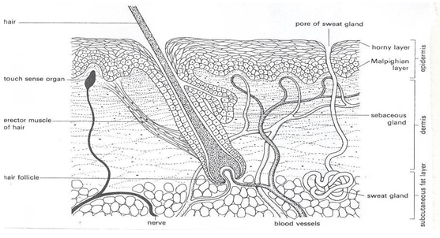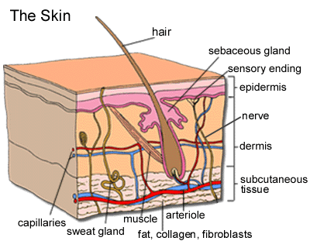

**The skin is made up of two main layers namely;**

* **Epidermis**
* **Dermis**

**EPIDERMIS**

Epidermis is the outer layer of the skin that is consist of three sub layers.

1. **The cornified layer**

* Cornified layer is made of dead cells that form tough outer surface of the skin which provide resistance to damage and bacterial invasion.
* Cornified layer reduces water loss by evaporation.

1. **The granular layer**

The granular layer contains living cells and produce new cells which die continuously to form the cornified layer.

1. **The malpighian layer**

The Malpighian layer contains living cells that produce a dark pigment called melanin that determine the skin and hair colour and protects it from ultraviolet rays.

* A total lack of melanin leads to a condition called **albinism.**
* A person suffering from the condition is called an **albino**
* Nails on the fingers and toes are made of hard by **keratin**

**DERMIS.**  
Dermis is the inner layer of the skin.  
**PARTS OF THE DERMIS.**

* Sweat glands
* Sebaceous glands
* hair
* Sweat pore
* Sweat duct
* Hair follicle
* Erector muscles
* Capillaries
* Nerves
* Subcutaneous fat

**Uses of some parts of the inner skin.**

1. **Sweat glands**

Sweat glands produce sweat

* Sweat glands absorbs sweat from blood.

1. **Sebaceous glands**

Sebaceous oily gland produces an oily substance called sebum that keeps the skin water proof and elastic.

* Sebum is also antibacterial in nature.

1. **Hairs**

Hairs keep the body warm.

1. **Sweat pore**

Sweat pore lets out sweat from the body

1. **Sweat duct**
2. Sweat duct is an opening that lead sweat to the surface of the skin.
3. **Hair follicle**

Hair follicle is a deep pit of granular and Malpighian layer cells that multiply to build hair.

1. **Capillaries**

Capillaries supply food and oxygen to the skin and removes excretory products.

* Capillaries also help in temperature control.

1. **Erector muscle**

Erector muscles keep the hair standing and trap the air around the skin that act as an insulator to heat loss.

1. **Nerves**

Nerves transmit impulses for pain, touch, heat, pressure, cold etc.

1. **Subcutaneous fat**

Subcutaneous fat are layers beneath the skin.

* Subcutaneous fat contains fat cells that prevent heat loss from the body.

**FUNCTIONS OF HUMAN SKIN.**

* Skin protects the body against germ invasion and ultraviolet rays.
* Skin is a sense organ for feeling, touch, pain, heat, cold etc.
* The skin excretes salts, water and urea (sweat)from the body
* The skin stores fat for keeping the body warm.
* The skin produce vitamin D whenever exposed to the sun.
* The skin regulates the body temperature.

**How does the skin regulate body temperature on a hot day?**

* By sweating.

Sweat glands produce more sweat through which heat is lost by evaporation and the body cools down

* The blood vessels vasodilate or widen to allow more blood to flow near the surface of the skin and heat is lost by radiation
* Body hairs lie flat so that hair current takes away heat from the body.

**How does the skin regulate body temperature on cold days?**

* Sweating stops
* The blood vessel narrows (Vasoconstriction) to reduce the flow of blood to the surface of the skin to limit heat loss by radiation.
* The body hairs stand or erect to trap air around the skin which acts as heat insulator to heat loss.
* Shivering occurs to produce heat by contracting muscles in the body.
* Production of goose pimples in man.

**Diseases of the human skin.**

|  |  |
| --- | --- |
| **Disease** | **Cause** |
| 1. Ringworm | Fungi |
| 1. Athlete’s foot | Fungi |
| 1. Leprosy | Bacteria |
| 1. Boils | Bacteria |
| 1. Impetigo | Bacteria |
| 1. Measles | Virus |
| 1. Chicken pox | Virus |
| 1. Scabies | Itch mite |
| 1. Pellagra | Lack of enough Vitamin B3 in the diet |
| 1. Scurvy | Lack of enough Vitamin C in the diet |
| 1. Skin cancer | Use of strong chemicals and expose to strong rays from the sun. |
| 1. Syphilis | Bacteria(treponema pallidum) |
| 1. Eczema |  |
| 1. Tuberculosis of the skin | Bacteria |

1. **How is ringworm spread from one person to another?**

* By sharing clothes, basin, beddings, comb and towels with an infected person.
* Through direct body contact with an infected person.

1. **Goreti has the following signs, itching of the skin, round patches on the bare skin, hair falls off the head and peeling of the skin. Which skin diseases is Goreti suffering from?**

Goreti is suffering from ringworm

1. **What advise can you give Goreti to prevent the above disease given in question 2 above?**

* I would advise Goreti to maintain her personal hygiene
* I would advise Goreti to wash and iron her clothes
* I would advise Goreti to avoid sharing clothes, towels, beddings and combs with an infected person.

1. **How is athlete’s foot spread from one person to another?**

By sharing shoes and stockings with an infected person.

1. **How can athlete’s foot be controlled?**

* Regular washing of shoes and stockings
* Regular changing of stocks and shoes
* Avoid wearing tight shoes that may squeeze the toes together.
* Wash foot clean and dry the before wearing shoes.
* Disinfect shoes and stockings

1. **How is scabies spread from one person to another?**

* Through direct body contact with an infected person
* Through sharing clothes with an infected person

1. Which skin disease has the following signs; **severe itching of the body at night**, **rashes on the skin and irritation and watery swellings on the skin.**

**Scabies**

1. **How can the above disease be controlled?**

* By bathing every day with clean water, soap and sponge.
* Avoid sharing clothes, beddings, basins, sponges and towels.

**DISORDERS OF THE HUMAN SKIN.**

* Albinism: Lack of colour in the skin.
* Burns.
* Scalds
* Cuts and wounds
* Pimples
* Corns (caused by wearing tight shoes)

**HOW TO CARE FOR THE HUMAN SKIN.**

* Eating foods rich in a balanced diet.
* Carrying out regular physical exercises.
* Wash the body with clean warm water and soap.
* Smear the body with Vaseline to make it soft.
* Wear clean and loose clothes to allow free circulation of air around the body.
* Avoid sharing clothes towels, basins and sponges.
* Wash and iron clothes before wearing them.
* Do not bleach your skin.
* Avoid playing with sharp cutting materials.

**EXERCISE**

1. **Name two major layers of the skin**
2. **Name the bacterial disease that affects both the skin and the skeleton**
3. **Name the sexually transmitted disease of the skin**
4. **State the similarity between ringworm and athlete’s foot**
5. **How is sweating in humans similar to panting in dogs?**
6. **What is the importance of evaporation of sweat in our bodies?**
7. **State the importance of whiskers to animals like cats**
8. **How does shivering on cold days keep the body warm?**
9. **How can you as a p.7 child care for your skin?**
10. **How is the function of hairs in human beings different from that of whiskers in cats?**
11. **By what process does sweat disappear from a person doing vigorous activity?**
12. **State the similarity between human skin and kidneys**
13. **What is the importance of bathing using a soap?**
14. **What is the effect of playing on a compound with so many broken bottles?**
15. **(a)Name the childhood immunisable disease that affects the skin**
16. **At what is the vaccine against the disease mentioned in 15(a) above given?**
17. **Give a reason for your answer in question 15(b) above**
18. **(a) write down two reasons why you bath**
19. **Give two materials used for bathing**
20. **Identify the parts of the skin that perform the following functions**
21. **Produces sebum to keep the skin moist and water proof**
22. **Produces sweat**
23. **Lets out sweat**
24. **Enables the skin to feel pain when pricked by a nail**
25. **Write down two activities that affect the proper functioning of the skin**

**THE HUMAN URINARY SYSTEM**

1. **What is urinary system?**

Urinary system is a group of organs that produces and remove urine from the body.

1. **What is urine?**

Urine is a transparent yellow fluid made up of nitrogenous compound wastes like excess water, excess salts, urea, lactic acid, ammonia etc.

1. **Write down three major organs of the urinary system**

* The kidneys
* Ureters
* Urinary bladder.

**THE KIDNEYS**

The kidneys are reddish brown bean shaped organs at the back of the abdominal cavity beneath the liver on the right and the spleen on the left.

The outermost layer of the kidney is called **cortex**, the middle is called **medulla** and the Centre of the kidney is a cavity called **pelvis.**

**Name three regions of the kidneys**

* **Cortex**
* **Medulla**
* **pelvis**

**The structure of the urinary system in the human body**

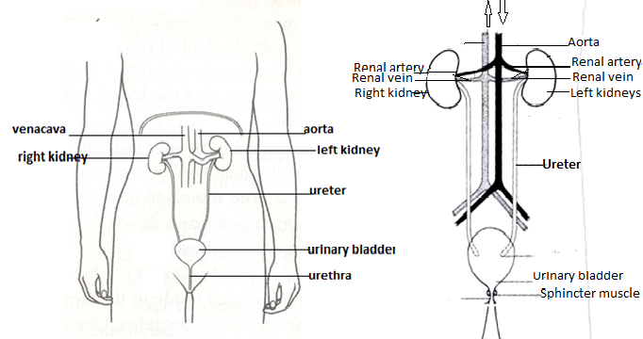

**The cross section of the kidney**



**FUNCTIONS OF THE PARTS OF THE KIDNEY.**

1. **Kidney wall**

Kidney wall protects the internal parts of the kidneys.

1. **Cortex**:

Cortex is wherefiltration of blood takes place

1. **Medulla**

Medulla is a region where selective re absorption of water, salt and other useful substances take place.

The process by which selective re absorption of water and salts from urine is known **as osmoregulation.**

1. **Pyramid**

Pyramid is a hole through which urine from the cortex pours into pelvis.

1. **Pelvis**

Pelvis receives and urine from the cortex before it goes down to the urinary bladder.

1. **Ureter**

Ureter is a passage of urine from pelvis to the urinary bladder.

1. **Renal artery**

Renal artery carries oxygenated blood from the aorta to the kidney.

1. **Renal Vein**

**Renal veins** carries deoxygenated blood from the kidney to the vena cava.

1. **Kidney**

Kidneys filters blood to remove urine

Kidneys regulate amount of salt and water.

1. **Urinary bladder**

Urinary bladder stores urine before it is passed out of the body.

1. **Urethra**

Urethra is a tube through which urine is passed out of the body.

**Note;** urethra in men is a passage for both urine and semen (urinogenital system)

1. **Sphincter muscles**

Sphincter muscles control the flow of urine out of the urinary bladder.

**Functions of the kidney.**

* Kidneys filter blood
* Kidneys regulates the level of water, sugars and salts in the body.

Kidneys help in urine formation

**DISEASES OF THE KIDNEY AND THE URINARY SYSTEM.**

* Kidney stones.
* Nephritis: this is an inflammation of the kidne**y**
* Kidney failure
* Bilharziasis
* Gonorrhoea
* Diabetes
* Cystitis
* Cancer of the kidneys

**Good habits for the kidney**

* Eating a balanced diet
* Doing daily physical exercises.
* Avoid taking a lot of fats, salts and sugars in food and drinks
* Avoid holding back urine for a long time.
* Go for medical examination in case of long time back pains
* Drinking boiled water.  
  **Why do we urinate frequently on a cold day than a hot day**?  
  On a hot day, you sweat a lot, therefore there is less work of kidneys  
  On a cold day, there is less or no sweating as the pores are half or fully closed.  
  So, the kidneys take over the work of removing excess water from the body.  
  **Why do you pass out of urine when you drink a lot fluids?**  
  Kidneys keep a constant amount of water in the blood.

**Why is the left kidney located slightly higher than the right kidney?**

* The right kidney is found under the liver which is the largest internal organ than the left kidney which is under the spleen.

**EXERCISE**

1. **What happens to blood as it pass through the kidneys?**
2. **Name the part of the urinary system where urine is temporarily kept before it is passed out**
3. **Mention two good habits that facilitates the removal of wastes product from the body**
4. **State the difference between the kidneys and skin in terms of their excretory wastes**
5. **Peninah’s child is has pain in the lower belly, fever and passing out faeces with drops of blood. Which kidney disease is peninnah’s child suffering from?**
6. **Write down three symptoms of kidney stones**
7. **How is bilharziasis spread from an infected person to another?**
8. **How can bilharziasis be controlled in the community?**
9. **Name the vector responsible for the spread of bilharziasis**
10. **State the difference between urinary bladder and gall bladder**
11. **How best can you as a p.7 child prevent yourself fro contracting gonorrhoea?**
12. **How does Schistosoma worm enter the body?**
13. **Why do people urinate frequently on cold days than hot days?**
14. **The diagram below is one of the body system. Use it to answer questions that follow.**

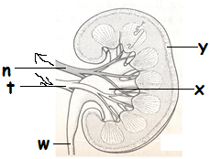

1. **Name the part marked x**
2. **What filters blood in part marked y**
3. **Where does part marked w lead to?**
4. **State the difference between part marked n and t**
5. **(a) What is kidney transplant?**

**(b) What do think would happen to the body if the kidneys failed to function properly?**

**(c) Give two activities that promote the proper functioning of the kidneys**

**16. The diagram below shows the structure of the kidney. Use it to answer questions that follow.**

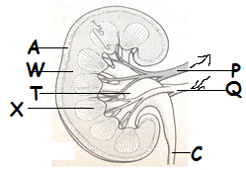

1. **Name part marked A**
2. **Name the substance that go through part marked C**
3. **State two functions of the kidneys that is similar to that of the skin**

**THE LUNGS AS EXCRETORY ORGANS.**

The lungs are the reddish pair of spongy air filled organs located on the other side of the chest cavity.

1. **Why are the lungs reddish in colour?**

The lungs are surrounded by a dense network of blood capillaries.

1. **Why are the lungs referred to as excretory organs?**

The lungs excrete carbon dioxide and water vapour from the body.

1. **Why are the lungs referred to as respiratory organs?**

The lungs allow gaseous exchange to take place in the body.

**RESPIRATION**

Respiration is the process by which the body uses oxygen to burn food to produce energy, carbon dioxide and water vapour

**TYPES OF RESPIRATION**

1. **Aerobic respiration**

Aerobic respiration is the type of respiration that takes in the presence of oxygen.

1. **Anaerobic respiration**

An aerobic respiration is the type of respiration that takes place in the absence of oxygen.

1. **Where in the does respiration takes place in the human body?**

In the body cells

1. **Give two importance of respiration in the body**

* Respiration provides energy to the body
* Respiration enables the body to excretes carbon dioxide and water vapour from the body

1. Write down four organs of the respiratory organ

* Lungs
* Diaphragm
* Trachea
* Nose
* bronchi
* Alveoli

1. Identify the body organ which is both respiratory and excretory organ.

Lungs

**DIAGRAM SHOWING THE LUNGS**

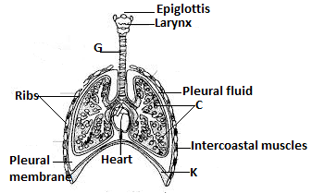

**FUNCTION OF THE PARTS OF THE LUNGS**

1. **Nose**

Nose is used for breathing and smelling

Nose has cilia and mucus

1. **State the function of the cilia and mucus found in the nose**
2. Cilia traps dirt and germs in the air we breathe in.
3. Mucus moistens, filters and warms the air we breathe in.
4. **Give a reason for the following actions that occur on the air that moves towards the lungs**
5. **Moistened**

To prevent h lungs from drying up

1. **Warmed**

To prevent the lungs from chilling

1. **Filtration(filtered)**

To prevent the foreign bodies from entering the lungs and destroy the alveoli

1. **Epiglottis**

**Epiglottis closes the trachea to prevent food from entering it**

1. **Trachea**

Trachea is made of rings of cartilage to keep it open all the time

* Trachea directs air from the nose to the lungs
* Trachea also has cilia to trap dirt and germs in the air we breathe in

1. **The lungs**

The lungs is where gaseous exchange take place. However gaseous exchange takes place in the alveoli.

**How are the alveoli adapted to gaseous exchange?**

* The alveoli are surrounded by a network of blood capillaries to allow gaseous exchange
* The alveoli are thin walled to allow gases to diffuse
* The alveoli are many in numbers to provide a large surface area for gaseous exchange

1. **Ribcage**

Ribcage protects the lungs, heart and liver from external injuries.

1. **Pleural membrane**

Pleural membrane covers the lungs and produces fluid called pleural fluid between the ribs and the lungs.

1. **Diaphragm**

Diaphragm separates chest cavity from the abdominal cavity.

Diaphragm is used for breathing.

**BREATHING**

Breathing is the act of taking in and out of air.

**TYPES OF BREATHING**

Inhalation breathing

Exhalation breathing

1. **What happens to the following organs during inhalation(inspiration)**
2. **Diaphragm**

The diaphragm contracts and flattens

1. **Intercostal muscles**

Intercostal muscles contracts

1. **Lungs**

The lungs expand

1. **The ribs**

The ribs move upwards and outwards

1. **The stomach**

The stomach enlarges and swells

1. **What happens to the following organs during exhalation**
2. **Diaphragm**

Diaphragm relaxes and goes to its domed shape

1. **Intercostal muscle**

Intercostal muscles expand

1. **Lungs**

Lungs contract

1. **The ribs**

The ribs move downwards and inwards

1. **The stomach**

The stomach goes back to its normal shape

**DISORDERS OF THE RESPIRATORY SYSTEM**

* Choking
* Hiccups
* sneezing
* Yawning

**DISEASES OF THE LUNGS.**

**Mention three diseases of the lungs under the following categories**

|  |  |
| --- | --- |
| 1. **Childhood immunisable diseases**  * Whooping cough (pertussis) * Diphtheria * Tuberculosis | 1. **Smoking related diseases**  * Lung cancer * Tuberculosis * Bronchitis |
| 1. **Non communicable diseases**  * Lung cancer * Asthma * Emphysema | 1. **bacterial diseases**  * pneumonia * tuberculosis * diphtheria * pertussis * bronchitis |
| 1. **viral diseases**  * haemophilia influenza * laryngitis * pleurisy | 1. **allergy conditions**  * pneumonia * asthma |

**HOW TO MAINTAIN THE PROPER FUNCTIONING OF THE LUNGS**

* Eating a balanced diet
* Doing regular physical exercises
* Taking children for immunization against immunisable diseases of the lungs
* Avoid smoking
* Cover the nose and the mouth with handkerchiefs when sneezing to prevent contaminating air for other people
* Avoid being in dusty places for a long time
* Make sure you breathe through the nose not the mouth to ensure the health of the lungs

**EXERCISE**

1. **Name the gas given out during respiration**
2. **Why is it not advisable to breathe through the mouth?**
3. **Why are alveoli able to carry out gaseous exchange in the body?**
4. **Name the body organ that is mostly affected by smoking.**
5. **What role do lungs play during respiration/**
6. **What name is given to the hard pipe which air moves in and out of the human lungs?**
7. **Name the respiratory organ protected by the rib cage**
8. **Why would you tell the person breathing through the mouth to stop the habit?**
9. **Write down two characteristics of air we breathe in and out**

**Air we breathe in**

**Air we breathe out**

1. **How does smoking cause lung cancer?**
2. **The diagram below represents the composition of air breathed in and out. Study it carefully and answer the questions that follow.**

|  |  |  |
| --- | --- | --- |
| **TYPE OF AIR** | **AIR BREATHED IN** | **AIR BREATHED OUT** |
| **Oxygen** | **21%** | **16%** |
| **Carbon dioxide** | **0.03%** | **4%** |
| **Nitrogen** | **78%** | **78%** |
| **Water** | **Less water** | **More water** |

1. **State the importance of the above process in the human body.**
2. **Why do you think there is less oxygen gas in the air breathed out?**
3. **Give a reason why there was used during respiration process.**
4. **Why is there more expired water vapour than inspired water vapour?**
5. **(a)Apart from lungs, mention one other respiratory organ.**

**(b) Name the viral disease of the respiratory system.**

**(c) What happens to the lungs during breathing in**

**(d)Which fluid reduces friction between the lungs and the ribs?**

1. **The diagram below shows hoe blood vessels are connected in the body tissues. Use it to answer questions about it.**

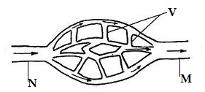

1. **Name the blood vessel marked V and N**
2. **State the function of the blood vessel marked M**
3. **Apart from dropping carbon dioxide, what other activity connected to blood circulation occurs in the lungs? The diagram below is of lungs. Use it to answer the questions that follow.**



1. Name the part marked **G.**
2. what is the function of part marked **C** and **K**
3. Give **two** property of air we breathe out.
4. (a) Where does gaseous exchange take place in the human lungs?

(b)How is food prevented from entering the lungs during swallowing?

(c) How is the function of the part mentioned in **(a)** above adapted to its function?

(d)Which part of the body does respiration takes place?

1. (a) Name the respiratory organs which are protected by the rib cage.

(b)What happens to the rib cage during the following processes?

1. Breathing in
2. Breathing out

(c)Give the use of oxygen we breathe in

**THE LIVER**  
the liver is the largest internal is the largest internal body organ which lies below the diaphragm and partly covers the stomach.

* Liver receives oxygenated blood through the blood vessel called hepatic artery
* Liver receives blood rich in digested food from the ileum through the blood vessel called hepatic portal vein

**Diagram showing the position of the liver in the body**

**FUNCTIONS OF THE LIVER.**

* The liver regulation of blood sugars in the body with the help of insulin
* The liver produces bile salts which aid absorption of fats by emulsifying fats
* The liver stores vitamin **A, D, B2** and mineral salts like iron, potassium, copper etc.
* Liver reduces on excess amino acids in the body (deamination)
* The liver produces plasma proteins.
* It burns fats to forms glucose and release energy.
* The liver converts poisonous compound into harmless substances (Detoxifying harmful substances to harmless)
* The liver produces heat in the body

**DISEASES OF THE LIVER.**

* **Hepatitis:** Caused by a virus spread by contaminated water.
* **Cirrhosis:** Hardening of liver tissue as a result of alcoholism.
* **Liver abscesses**. They are pus filled sacs on the liver.

**HOW TO CARE FOR THE LIVER**

* Eating a balanced diet
* Doing regular physical exercises
* Avoid taking too much alcohol
* Avoid smoking  
  **EXERCISE**

1. State the role of the following blood vessels during circulation of blood to the liver.
2. hepatic vein
3. **hepatic portal vein**
4. **mesenteric artery**
5. How are the following important in our bodies:
6. Kidneys c) liver
7. Lungs
8. **Write SARS in full**
9. **Write down four diseases that are related to SARS**
10. **Why is it not advisable to stay in a congested areas?**
11. **Why do we breathe out more carbon dioxide than we breathe in?**
12. **Why do we breathe out less oxygen than the one we breathe in?**

**TOPIC 6: LIGHT E NERGY**

**VOCABULARY**

* **Light**
* **Luminous**
* **Non-luminous**
* **Incandescent**
* **Ray**
* **Beams**
* **Parallel beam**
* **Converging beam**
* **Diverging beam**
* **Transparent**
* **Translucent**
* **Opaque**
* **Shadows**
* **Eclipse**
* **Umbra**
* **penumbra**
* **Solar**
* **Lunar**
* **Periscope**
* **Optical instruments**
* **Spectrum**
* **Prism**

**LIGHT**

1. **What is light energy?**

Light energy is a form of energy that enables our eyes to see.  
**2. Why are we able to see things around us?**

We see things around us because light **from them** is reflected into **our eyes.**

1. **Why is light referred as a form of energy?**

* Light can be transformed to other forms of energy
* Light is capable of doing work.  
  **IMPORTANCE OF LIGHT IN THE ENVIRONMENT**
* Sunlight enables plants to make their own food(photosynthesis)
* Light enables us and other animals to see
* Light enable our skins to make vitamin D synthesis
* Light is used for photography.
* We use artificial light on the streets to control traffic
* Sunlight energy is used to produce solar electricity
* Sunlight energy is used for drying clothes, harvested crops and disinfecting beddings.

**SOURCES OF LIGHT**

1. **Natural sources**
2. **Artificial sources**
3. **NATURAL SOURCES OF LIGHT**
4. **What are natural sources of light?**

Natural sources of light are objects that produce light provided by nature.

**Examples of natural sources of light include**

* Sun
* Star
* Erupting volcanoes
* Lightning
* Glow worms
* Fireflies

Note; of the above, some are very hot e.g. sun and stars, erupting volcanoes.   
 - Others are not hot at all e.g. fireflies, glow worms   
**(B) ARTIFICIAL SOURCES OF LIGHT**  
1. **What are artificial sources of light?**

Artificial sources of light are man-made objects that produce light.  
**Examples of artificial sources of light**

* Solar lamps
* Electric lamps
* Fluorescent tubes
* Hurricane lamps
* Fire etc.

**Note;** Objects that produce light are divided into two namely;  
i**) Luminous objects**  
ii) **Non luminous objects.**  
**(A) LUMINOUS OBJECTS/ DIRECT SOURCES.**  
1**. What are luminous objects?**

Luminous objects are objects that produce and send their own light.  
**Examples of luminous objects**

* Sun
* Stars
* Erupting volcanoes
* Lamps
* Torches
* Glow worms
* Fire flies
* Burning candles
* Hot charcoal etc.

1. **NON LUMINOUS OBJECTS/ INDIRECT SOURCES**

Non- luminous objects are objects that reflect light from other sources of light.  
**Examples of non- luminous objects**

* The moon
* The planets
* The mirrors
* The jewellery

**EXERCISE**

1. **Name the main source of heat and light on earth**
2. **Why is light regarded as a form of energy?**
3. **How are we able to see things around us?**
4. **How does your skin depend on sunlight?**
5. **How is the moon similar to mirrors?**
6. **What is the importance of light energy to;**
7. **Plants**
8. **Human beings**
9. **Photographers**
10. **Identify the form of energy that enables drivers of vehicles to avoid obstacles at night.**
11. **Why is the moon not regarded as a star?**
12. **Why is sound not matter yet it can be stored?**
13. **Why is erupting volcanoes referred to as an incandescent source of light?**
14. **State the difference between self-luminous and non-luminous objects.**
15. **Why is moon not regarded as a source of light?**
16. **Why does sun give us more light than stars?**
17. **Mention two people made sources of light energy.**
18. **Name any one object that produces light when they are hot.**
19. **Why is sun regarded as the main source of heat and light energy?**

**PROPAGATION/PROPERTIES OF LIGHT**

**HOW DOES LIGHT TRAVELS?**

1. Light travels in straight lines from the source.
2. **Experiment to show that light travels in a straight line from the source**

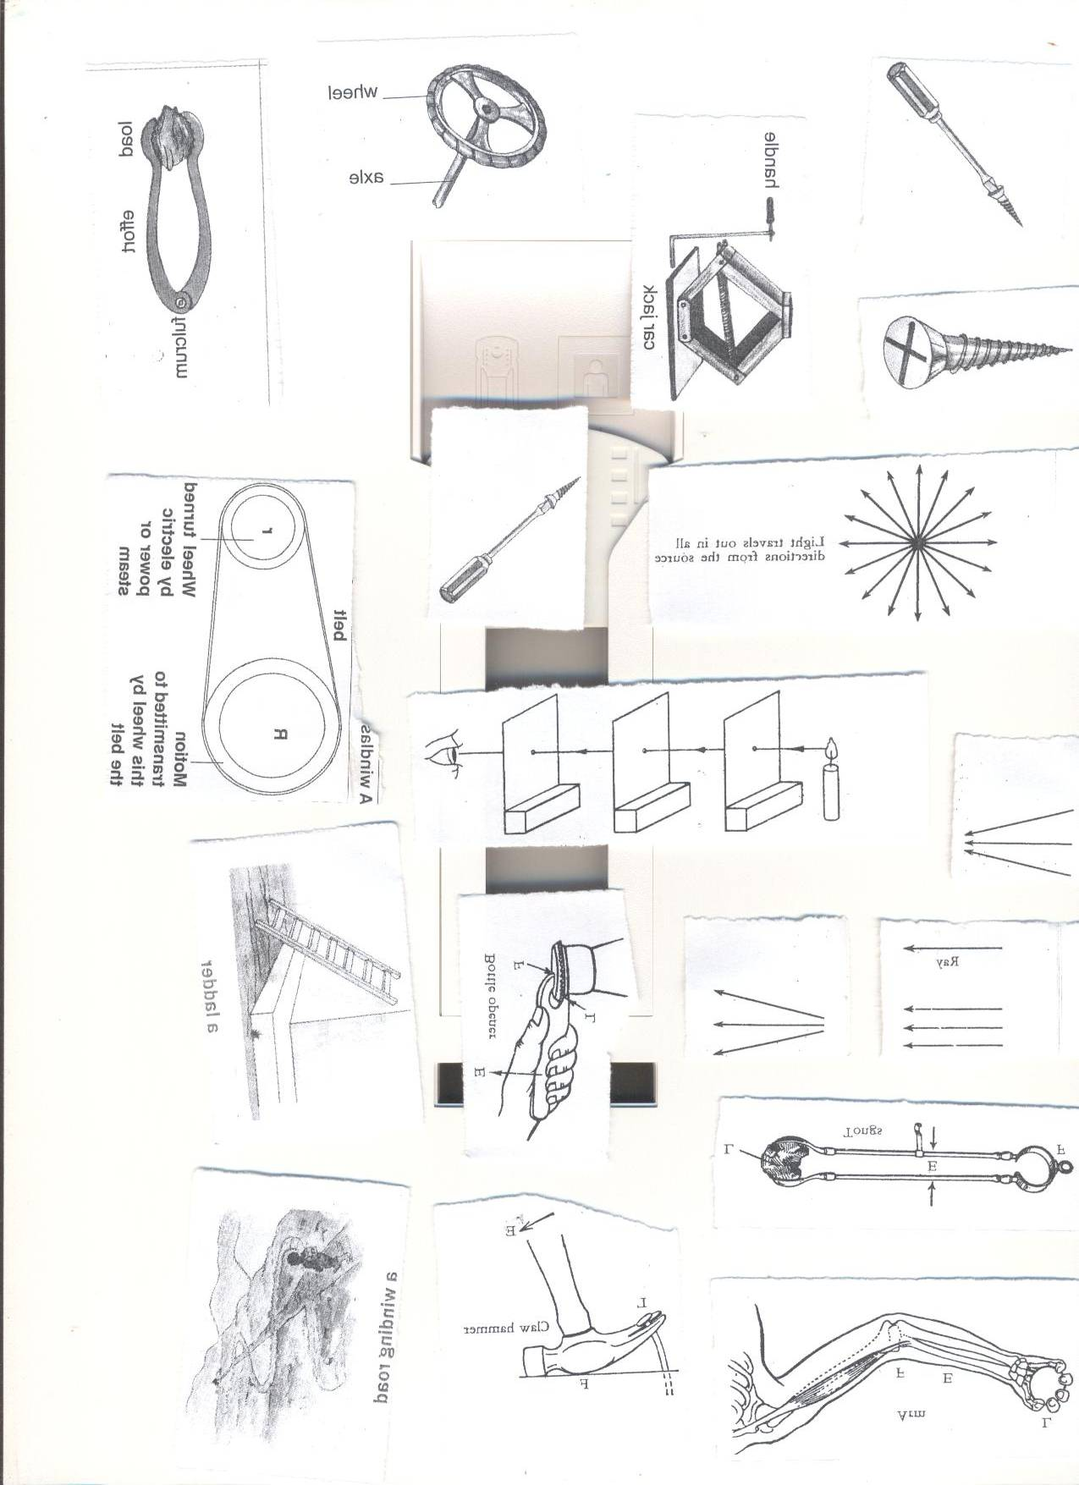

**If one of the card boards is displaced, the holes will no longer be in a straight line and the observer will not be able to see the light shown below.**

**The experiment proves that light travels in a straight line from the source**

**EXERCISE**

**Below is an experiment carried out by two pupils in primary seven red.Use it to answer the questions that follow.**

**A**

**B** 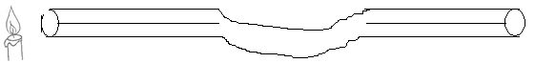

1. **Which of the two pupils will be able to see light rays from the candle?**
2. **Give a reason for your answer in in question (a) above**
3. **Which of the two pupils will be able to see light rays from the candle?**
4. **Give a reason for your answer in in question (c) above**
5. **What was the experiment about?**
6. **Write down two situations to prove that light travels in a straight line from the source.**
7. **Experiment 2**
8. Light travels in all directions from the source

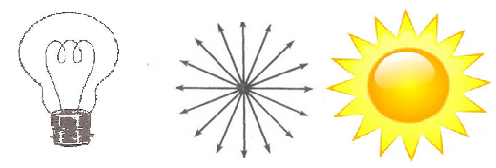

**RAYS**  
A ray is a straight path taken by light.

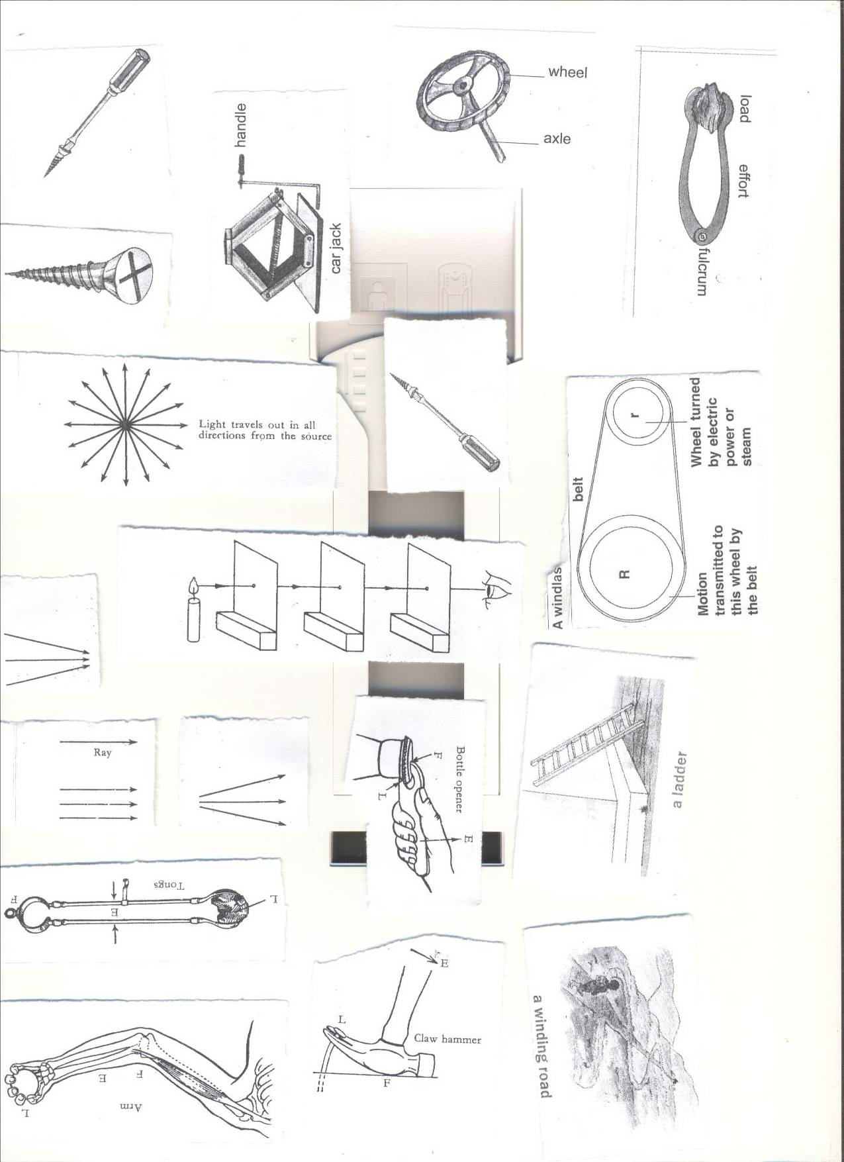

**BEAMS OF LIGHT**

A beam is a group of light rays traveling in the same direction.  
**TYPES OF BEAMS**   
(a) **PARALLEL BEAM**

1. **What is a parallel beam of light?**

Parallel beam of light is the type of beam where the light rays travel in the same direction from the source.

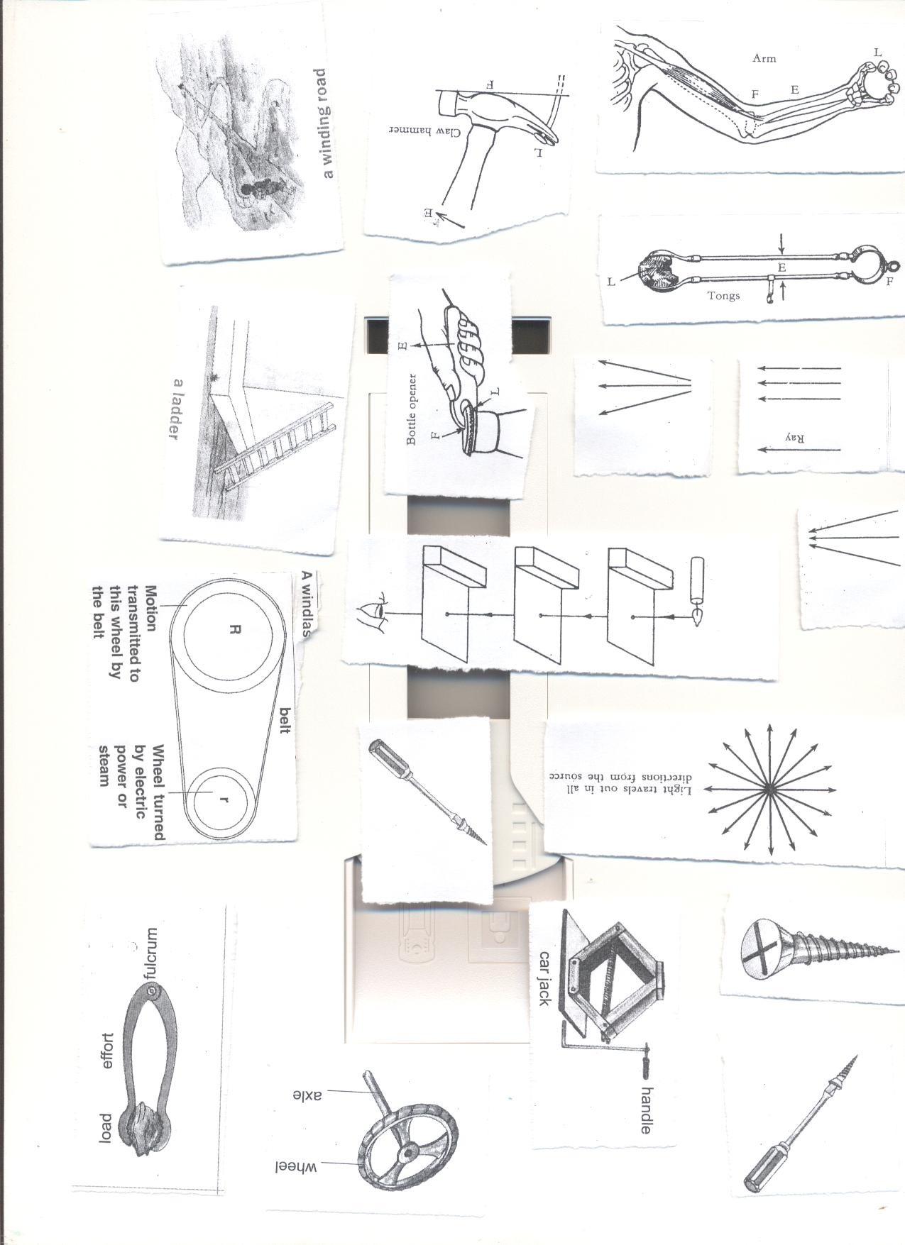

1. **DIVERGENT BEAM**
2. **What is a diverging beam?**

Diverging beam is the type of beam where light rays are spread out in different directions from the source.

  
**(C) CONVERGENT BEAM**

1. **What is a converging beam?**

Converging beam is the type of beam where light rays come towards a point from the source.



**EFFECTS OF DIFFERENT MATERIALS ON LIGHT**

Different objects have different abilities to transmit light.

When light rays meet the an object, one of the following happens;

1. Light rays can be absorbed, diffused or scattered by an object.
2. Light rays can be bounced or reflected
3. Light rays may be allowed to go through or transmitted.

**DIFFERENT MATERIALS DEPENDING ON THEIR EFFECTS ON LIGHT**

1. **TRANSPARENT OBJECTS**

**What are transparent objects?**Transparent objects are materials that allow all light to pass through them and we can see through them clearly  
**Examples of transparent material**

* Clear glass
* Clear still water
* Air

**An illustration of transparent object on material**

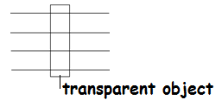

1. **TRANSLUCENT MATERIALS**

**What are translucent objects?**

Translucent materials are objects which allow little light to pass through them and we cannot see through them clearly.

* We can’t see through translucent objects clearly because they scatter light passing through them

**Examples of translucent materials**

* Frosted glass
* Coloured glass
* Oiled paper
* Smoky air
* Thin cloth
* Tracing paper
* Misty air

**An illustration of translucent objects on materials**

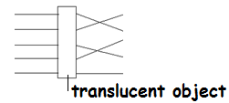

**Effects of translucent objects on light**

* Translucent objects allow little light to pass through them.
* Translucent objects diffuses the light

1. **OPAQUE OBJECTS**

**What are opaque objects?**

Opaque objects are materials which do not allow any light to pass through them.

**Examples of opaque objects**

* A wall
* A hard paper.
* Wood
* Stones
* Human Body
* Metals
* Trees

**An illustration of opaque objects on materials**

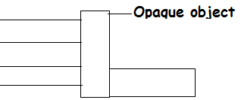

**What happens to right rays when they meet an opaque object?**

* A shadow is formed
* Light rays are reflected or bounced

**Effects of opaque objects on light**

Opaque objects obstruct light and form shadows.

**Note;** Light travels faster in materials less optically) dense than air e.g. warm air and slowly in materials that are optically denser than air e.g. glass, water.

The speed of light in different objects like;

1. **Vacuum** **300,000km/sec**
2. **Air 299,000km/sec.**
3. **Glass 224,000km/sec.**
4. **Water 198,000km/sec.**

**Give three examples to prove that light travels faster than sound?**

* Lightning is seen before a thunder is heard.
* The flash of starter’s gun at a race track is seen before the bang or sound is heard.
* The axe strike on a wood is seen before the sound is heard.

**EXERCISE**

1. **State any one property of light**
2. **How is the movement of sound and light similar?**
3. **Which type of beam does a torch produce when it lights?**
4. **Name two devices that form a diverging beam.**
5. **Why is a thunder heard after lightning is seen during rain storm?**
6. **How does light travel from one place to another?**
7. **How is sound and light energy similar?**
8. **Give any one way in which a transparent object differs from an opaque object.**
9. **PLE booklet 2008 number 46.**
10. **Study the diagram below and use it to answer questions 7 and 8**

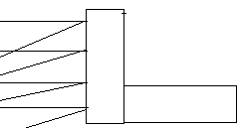

**What type of material affects light as shown in the above diagram?**

1. **Give one example of such material.**
2. **Identify two devices that form converging beam.**
3. **Why are we unable to see clearly through translucent materials?**
4. **What happen to light rays when they strike an opaque object?**
5. **Why are stones regarded as an opaque object?**
6. **In the diagram below B, C and D are cardboards with small holes as shown. A student at E is trying to see the light at A through the holes.**

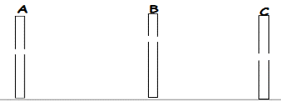

**Explain why the student cannot see the light at E**

1. **Why are we able to see objects which are placed behind a glass of water?**
2. **Name the feature formed when an opaque object obstructs light rays.**
3. **Which property of light is illustrated below**
4. **Which type of beam is formed by car and bicycle head lamps?**
5. **Identify any one example of animal in the environment which is a natural source of light.**

**SHADOWS**

1. **What is a shadow?**

A shadow is a region of darkness caused by obstruction of light rays by an opaque object.

1. **Write down three characteristics of shadows.**

* Shadows are shortest at mid-day and longest at sunset or sunrise
* Shadows have almost the same shape as an opaque object blocking the light rays.
* The size of the shadows often depend on the position of the source of the light

**Formation of a shadow**

**How is a shadow formed?**

A shadow is formed when light rays are blocked by an opaque object.  
(a) The shadow formed from a small source or point of light is dark sharp all over. It is called **umbra.**

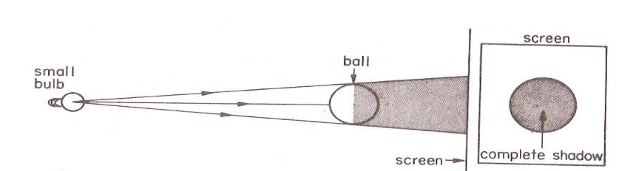

(b) Shadow formed from a far source of light or bigger than a point form a darker **(umbra)** and a lighter ring **(penumbra**) on the screen.

This single shadow has a darker inner portion and less dark outer portion

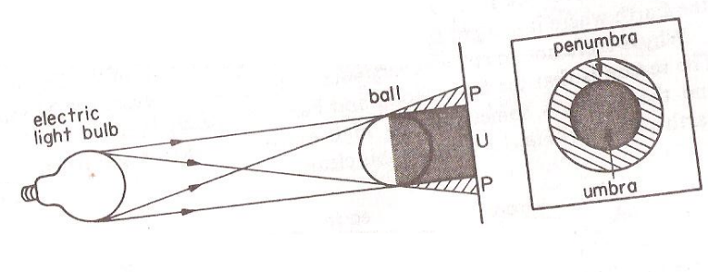

**PARTS OF SHADOW/TYPES OF SHADOWS**

* **Umbra**
* **Penumbra**

1. **What is umbra?**

Umbra is the darker part of the shadow

**How is umbra formed?**

By total obstruction of light rays by an opaque objects

1. **What is penumbra?**

Penumbra is a lighter part of the shadow

1. **How is penumbra formed?**

By partial obstruction of light

**EXERCISE**

1. **At what time of the day is shadows shortest?**
2. **How is the formation of umbra different from that of penumbra?**
3. **The diagram below shows formation of shadows. Use it to answer the questions that follow.**

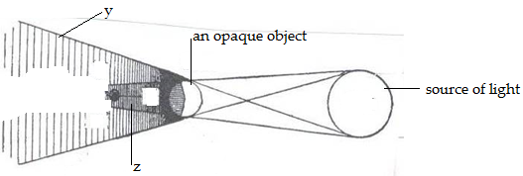

1. **Name the part of the shadows marked y and z.**
2. **y**
3. **z**
4. **What causes the difference in lengths of shadow at different times of the day?**
5. **Draw the shadow of the following objects.**

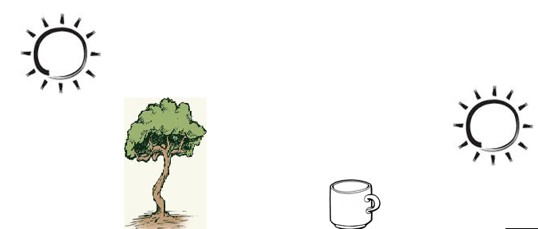

1. **Give two uses or importance of shadows in our daily life.**

* Shadows provide shade to people
* Shadows are used to tell or estimate time
* Shadows are used to determine or show direction

**ECLIPSES**

1. **What does the word eclipse mean?**

Eclipse means to cut off light

1. **What is an eclipse?**

Eclipse is a total or partial shadow formed by obstruction of sunlight by either earth or moon.

* The sun, the moon and the earth are the bodies commonly involved in the eclipse.
* The sun is stationary, but the earth revolves around the sun along its fixed path called orbit.
* The moon also revolves around the earth but the orbit of the moon is not fixed.

**TYPES OF ECLIPSE**

**Solar eclipse (eclipse of the sun)**solar eclipse occurs when the moon comes in between the sun and the earth (SME).

* When solar eclipse occurs, the sun cast the shadow of the moon onto the earth. 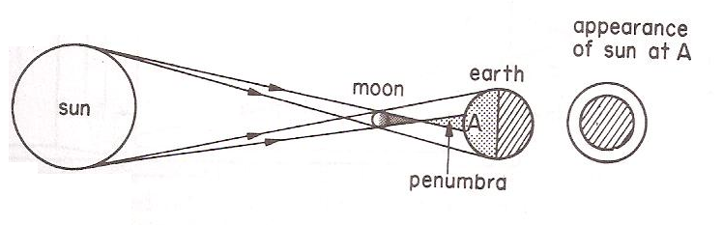
* Sometimes the moon is too far from the earth that its umbra cannot reach the earth, only the penumbra can be seen on earth. The sun will appear as bright ring around a black circle and this is called **annular eclipse of the sun.**

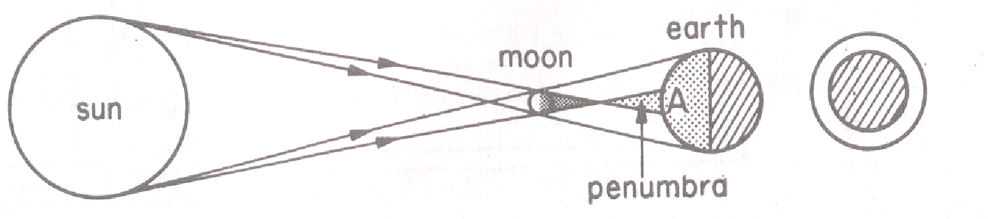

**(b) Lunar eclipse** (**eclipse of the moon)**

Lunar eclipse occurs when the earth comes between the moon and the sun (MES/SEM).

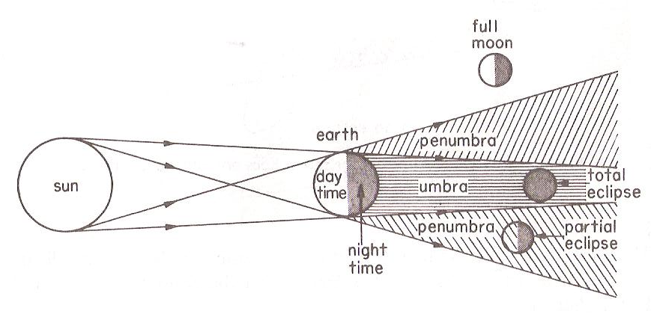

**EXERCISE**

1. **Which scientific term is used to describe the type of shadow formed when light rays from the sun is obstructed by either the moon or the earth?**
2. **How is a shadow different from an eclipse?**
3. **How is the formation of umbra different from that of penumbra?**
4. **The diagram below shows formation of shadows. Use it to answer the questions that follow.**



1. **Name the part of the shadows marked y and z.**
2. **y**
3. **z**
4. **What causes the difference in lengths of shadow at different times of the day?**
5. **Draw the shadow of the following objects.**



1. **Give two uses or importance of shadows in our daily life.**

* Shadows provide shade to people
* Shadows are used to tell or estimate time
* Shadows are used to determine or show direction

1. **Write down the two types of eclipse**
2. **How is a lunar eclipse formed?**
3. **How are shadows important in our daily life?**

**REFLECTION OF LIGHT**

1. **What is reflection?**

Reflection is the bouncing of light rays from the surface.

**TYPES OF REFLECTION**

**Write down two types of reflection.**

* Regular reflection
* Irregular reflection/Diffuse reflection

1. **REGULAR REFLECTION**
2. **What is regular reflection?**

Regular reflection is the type of reflection where beam of lights bounce in a definite direction.

* Regular reflection occurs on shiny smooth surfaces.
* Regular reflection creates clean reflection.
* In regular reflection all incident rays are reflected uniformly in the same direction.

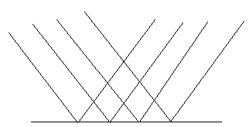

**IRREGULAR/DIFFUSE REFLECTION**

1. **What is irregular reflection?**

Irregular reflection is the type of reflection where beam of light rays bounced in all directions.

* Irregular reflection occurs in rough surfaces like frosted glasses, clothes etc.  
  The reflections are irregular

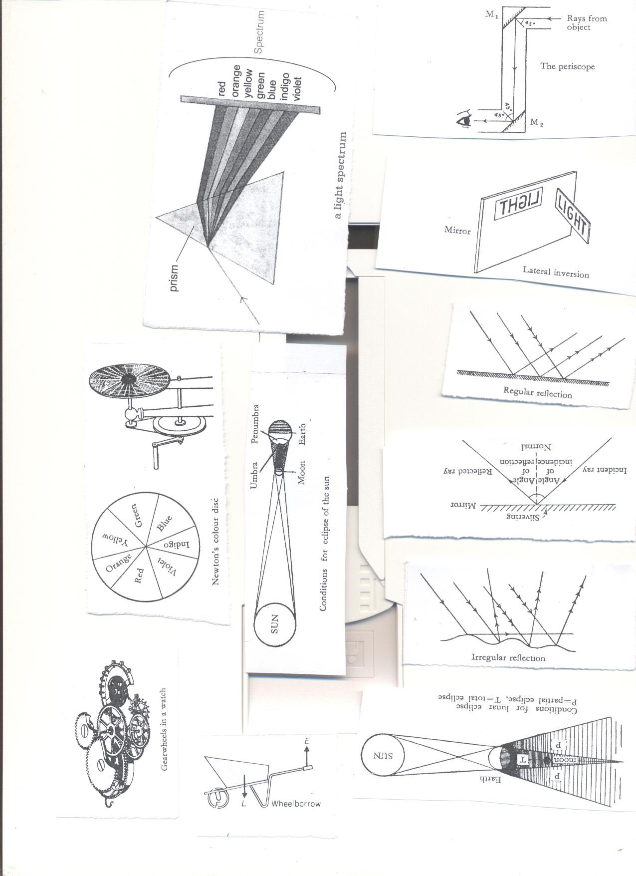

**PRINCIPLE AND LAWS OF REFLECTION**

1. **The incident ray, the reflected ray and the normal at the point of incident all lie in the same plane.**

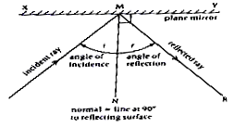

1. **incident ray**

Incident ray is the ray that strikes or hits the surface

1. **Reflected ray**

Reflected ray is the ray that bounces off the surface

1. **The normal**

Normalis perpendicular between the incident ray and reflected ray.

1. **Angle of reflection**

Angle of reflection is angle between the normal and the reflected ray.

1. **Angle of incidence**

Angle of incidence is the angle between the normal and the incident ray.

1. **Glancing angle**

Glancing angle is the angle between the surface, incident ray and the reflected ray  
2. **The angle of incidence is equal to the angle of reflection.**

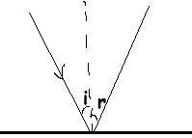

* The ray travelling along the normal is reflected back along itself.

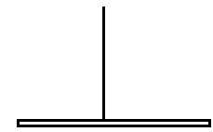

**EXERCISE**

1. **Use the diagram below to answer the questions that follow**

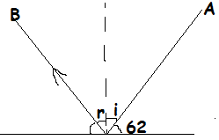

1. **Name the light ray marked B**
2. **Calculate the size of the angle marked r**
3. **Use an arrow to show the light ray that strikes the surface**
4. **Find the angle of incident on the diagram below**

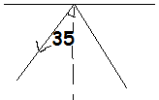

1. **Use the diagram below to answer the questions that follow.**

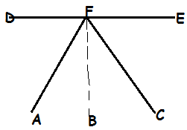

1. **Name the ray marked FA and FC**
2. **Name the angle marked AFB and CFB**
3. **What is the relationship between the angle AFB and CFB?**
4. **The diagram below shows light rays falling in a plane mirror PQ.use it to answer the questions that follow.**

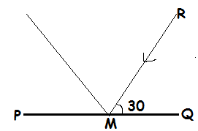

1. **Complete the diagram accurately to show the reflected ray**
2. **What is the value of the angle of reflection**
3. **Calculate the angle of incident**
4. **The diagram below shows the rays of light striking the mirror. Study it and use it to answer questions that follow**

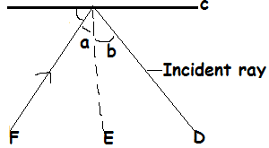

1. **Name the part marked C**
2. **Put an arrow on line D to show the direction of the ray of light**
3. **If angle b is 40,what is the size of angle a**
4. **Give a reason for your answer in c above**
5. **The diagram below shows a ray of light being reflected by a plane mirror. Use it to answer questions that follow.**

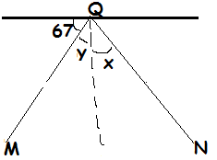

1. **M and N are light rays, if M is the ray striking the surface. Complete**

**the diagram correctly.**

1. **Calculate the size of the angle of reflection**
2. **State the similarity between angle y and x**

**USES OF REFLECTION IN OUR DAILY LIFE**

* People can watch football match over the heads of the crowd using a periscope.
* Soldiers can see enemies without exposing themselves to them using periscopes.
* Submariners can see ships on the surface of the sea using periscopes.
* Mirrors are used on vehicles to see traffic behind and avoid causing accidents.
* Torches, car headlamps have concave reflectors.
* Solar cookers use a concave mirror to focus sunlight on spot and use it for cooking.

Some shaving mirrors are concave as they magnify the image

**REFLECTION AND ABSORBPTION OF LIGHT**

* Light coloured objects reflect more light than the dull ones.
* White light contains all the three primary colours of light.
* A white object absorbs no colour but reflects all.
* A black object absorbs all the primary colors and reflects none.
* An object which absorbs all the primary colors appears black.
* Black light means absence of any color.

**Why do objects appear by their colours?**

Objects absorb all colours and reflect that colour  
**The table shows why certain colours appear the way they appear**

|  |  |  |  |
| --- | --- | --- | --- |
| **Colour** | **Absorbs** | **Reflects** | **Appears as** |
| Red object | Green, Blue | Red | Red |
| Blue object | Red, green | Blue | Blue |
| Green object | Red, blue | Green | Green |
| Black object | Red, Blue, Green(all) | None | Black. |
| White object | None | Red, Blue, Green(all) | White |

**EXERCISE**

1. **Why do blue dress appear blue?**
2. **Why do people prefer white or light clothes on hot days?**
3. **Why do people wear heavy or black clothes on cold days?**
4. **Why are most houses and cars in Uganda painted white?**
5. **Vanessa washed ten black and ten handkerchiefs and she hanged them under sunshine. Which of the handkerchiefs will dry first?**
6. **Give a reason for your answer in (e) above**
7. **How do sweaters keep school children warm?**
8. **Why does a green shirt appear green in colour?**

**IMAGES AND PLANE MIRRORS**

1. **What is an image?**

An image is a light picture formed by light rays.

1. **Name two types images**

* Real images
* Virtual images

1. **What are real and virtual images**

Real images are formed on the screen while virtual images are formed behind the screen

1. **Write down at least four devices which form real images**

* Television
* Computers
* Cameras
* Projectors

1. **What are plane mirrors?**

Plane mirrors are highly polished surface that reflects light and enable us to see images.

**Characteristics of images formed in a plane mirror.**

* The images are erect/upright.
* The images are the same size as the object from which they are formed
* The image is laterally inverted. (the right side becomes the be left in the mirror and vice versa)
* The Image distance is equal to the object distance from the mirror
* The image is virtual. (Cannot be formed on the screen)

**Drawing images or objects in plane mirrors**



**Uses of plane mirrors**

* Plane mirrors are used in periscopes for seeing obstacles around corners.
* Plane mirrors are used as dressing mirrors.
* Plane mirrors are used to see hidden parts of the body we cannot see directly.
* Plane mirrors are used by dentists in hospitals.
* Plane mirrors are also used in saloons

**ACTIVITY**

1. **Why do plane mirrors produce regular reflection?**
2. **Draw the image of the object as seen on the mirror.**
3. **How is an echo similar to an image?**
4. **Nsereko breathed on a mirror several times. Why couldn’t he see himself clearly later?**
5. **When Latifah looked into a plane mirror, she saw her face at the back of the mirror. How did her face get into the back of the mirror?**
6. **The diagram below shows an object 2 metres away from the mirror. Draw the image of the object.**
7. **Why are plane ,mirrors not used as driving mirrors**
8. **State one way in which plane mirrors are used at home**
9. **Mention four places where plane mirrors are used.**

**SIMPLE OPTICAL INSTRUMENTS**   
(a**) what are optical instruments?**

Optical instruments are instruments which use light for their functioning.  
**(b) List down at least seven Examples of simple optical instruments**

* Periscopes
* Microscopes
* Telescopes
* Binoculars
* Magnifying glass
* Cameras
* spectacles
* projectors

1. **Telescope:**  
   telescope is used to look at distant objects.
2. **Microscope:**  
   microscope is used to look at very small objects e.g. bacteria, amoeba, cells etc
3. **Spectacles**

**Projectors**

* Projectors cast images from films and slides to the screen.
* Projector consists of a source of light, a concave reflector and a condenser.  
  The condenser focuses the rays through the film or side.

**PERISCOPE**  
periscopes are instruments used to see objects overhead and around corners

* Simple periscopes contain two plane mirrors fixed inside a tube facing and parallel to each other at an angle of 45 to the object and the eyes.
* A ray of light from the object strikes mirror one at 45 degrees and then turned through 90 degrees to strike mirror two until the object is seen by the observer.  
  **Illustration of a periscope.**



**USES OF PERISCOPES**

* Periscopes are used by soldiers hiding in trenches or tankers to see their enemies without exposing themselves.
* Periscopes are used by soldiers in submarine under the sea to see ships on the surface.
* People at the back of crowd use simple periscopes to see over heads of people in front of them.

**Activity**

1. **Name two groups of people who use periscopes**
2. **Give the use of the following optical instruments**
3. **Microscopes**
4. **Telescopes**
5. **Binoculars**
6. **Magnifying glass**
7. **Projectors**
8. **Why are spectacles referred to as an optical instrument?**
9. **The diagram below shows an optical instrument, use it to answer questions that follow.**
10. **Name the optical instrument.**
11. **How is Elijah able to see the object at point A?**
12. **What type of mirror is used in the above instrument?**
13. **Give two uses of the mirror named above in our daily life.**
14. **State the importance of the above instrument to the submarines.**
15. **How are telescopes similar to microscopes?**

**PINHOLE CAMERA**

A pinhole camera is a form of camera which consists of a box (enclosure) with a small hole in size of a pin head at one side of a metal plate at one end and a screen of tracing paper or frosted glass.

* The pinhole allows limited light rays from each point on an object to form an image on the screen on the other end.

**On which principle does a pinhole camera works?**

A pinhole camera works on the principle that light travels in a straight line.

**An illustration of a pinhole camera**

**Characteristics of images formed with a pinhole camera**

* The image is smaller than the object (diminished).
* The image is upside down.(inverted)
* The image formed is real.

**Why are the images formed in a pinhole camera inverted?**

* A ray of light from the top of the object strikes the bottom of the screen and the ray from the bottom strikes the top of the screen.
* Light travels in a straight line and yet the rays cross each other at a pinhole

**Note;** If the distance between the object and camera is increased, the image becomes smaller and blurred.

* If the distance between the object and the camera is decreased, the image becomes larger and blighter.
* When the hole is too big, the image is blurred.

**EXERCISE**

1. **State three differences between pinhole cameras and plane mirror**

**REFRACTION OF LIGHT**

1. **What is refraction of light?**Refraction is the bending of a light ray as it moves from one transparent medium to another.

**Examples**

* From air to glass
* From air to water
* From glass to water

1. **What causes refraction of light?**

Refraction of light is caused by change of speed of light as it travels from one transparent medium to another

**Refraction through a rectangular glass prism**

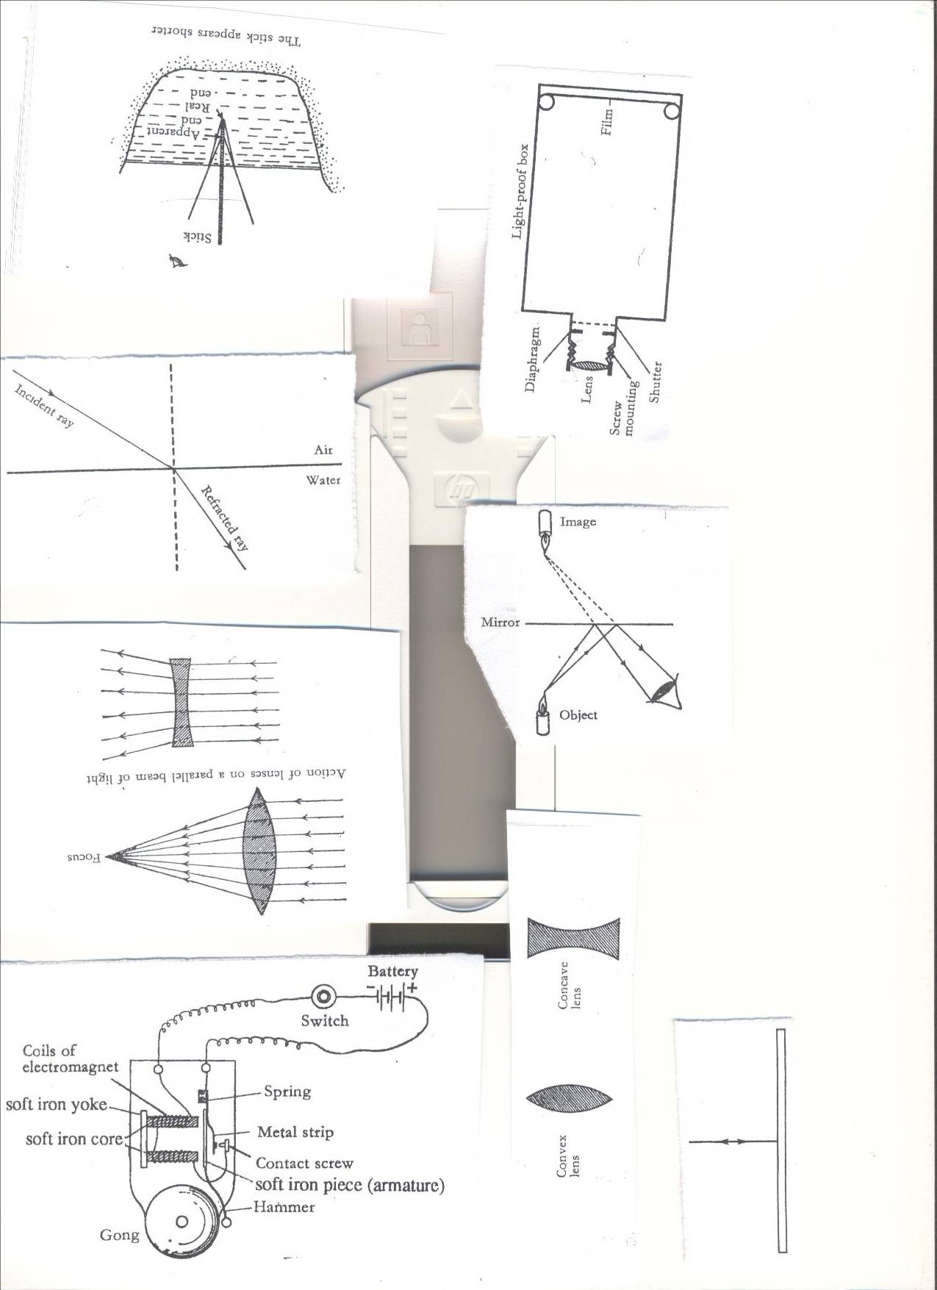

* **I** - Angle of incidence
* **R** - Angle of refraction
* Angle **i** is greater than angle **r.**

1. **What happens to the ray of light when it moves from one medium with fewer molecules to another one with more molecules?**

* The speed slows down.
* The ray of light bends towards the normal

1. **What happens to the ray of light when it moves from one medium with molecules to another with fewer molecules?**

* The speed increases.
* The light ray bends away from the normal.

**PRINCIPLE/LAWS OF REFRACTION**

* The incident ray, the refracted ray and the normal all lie on the same plane.
* The incident ray and the refracted ray are on the opposite side of the normal.
* A ray of light travelling along the normal will not get refracted and will pass unchanged.

**REFRACTION OF LIGHT THROUGH AIR AND WATER**

**Effects of refraction of light**

* Refraction causes fish in water to appear shallower than they are.

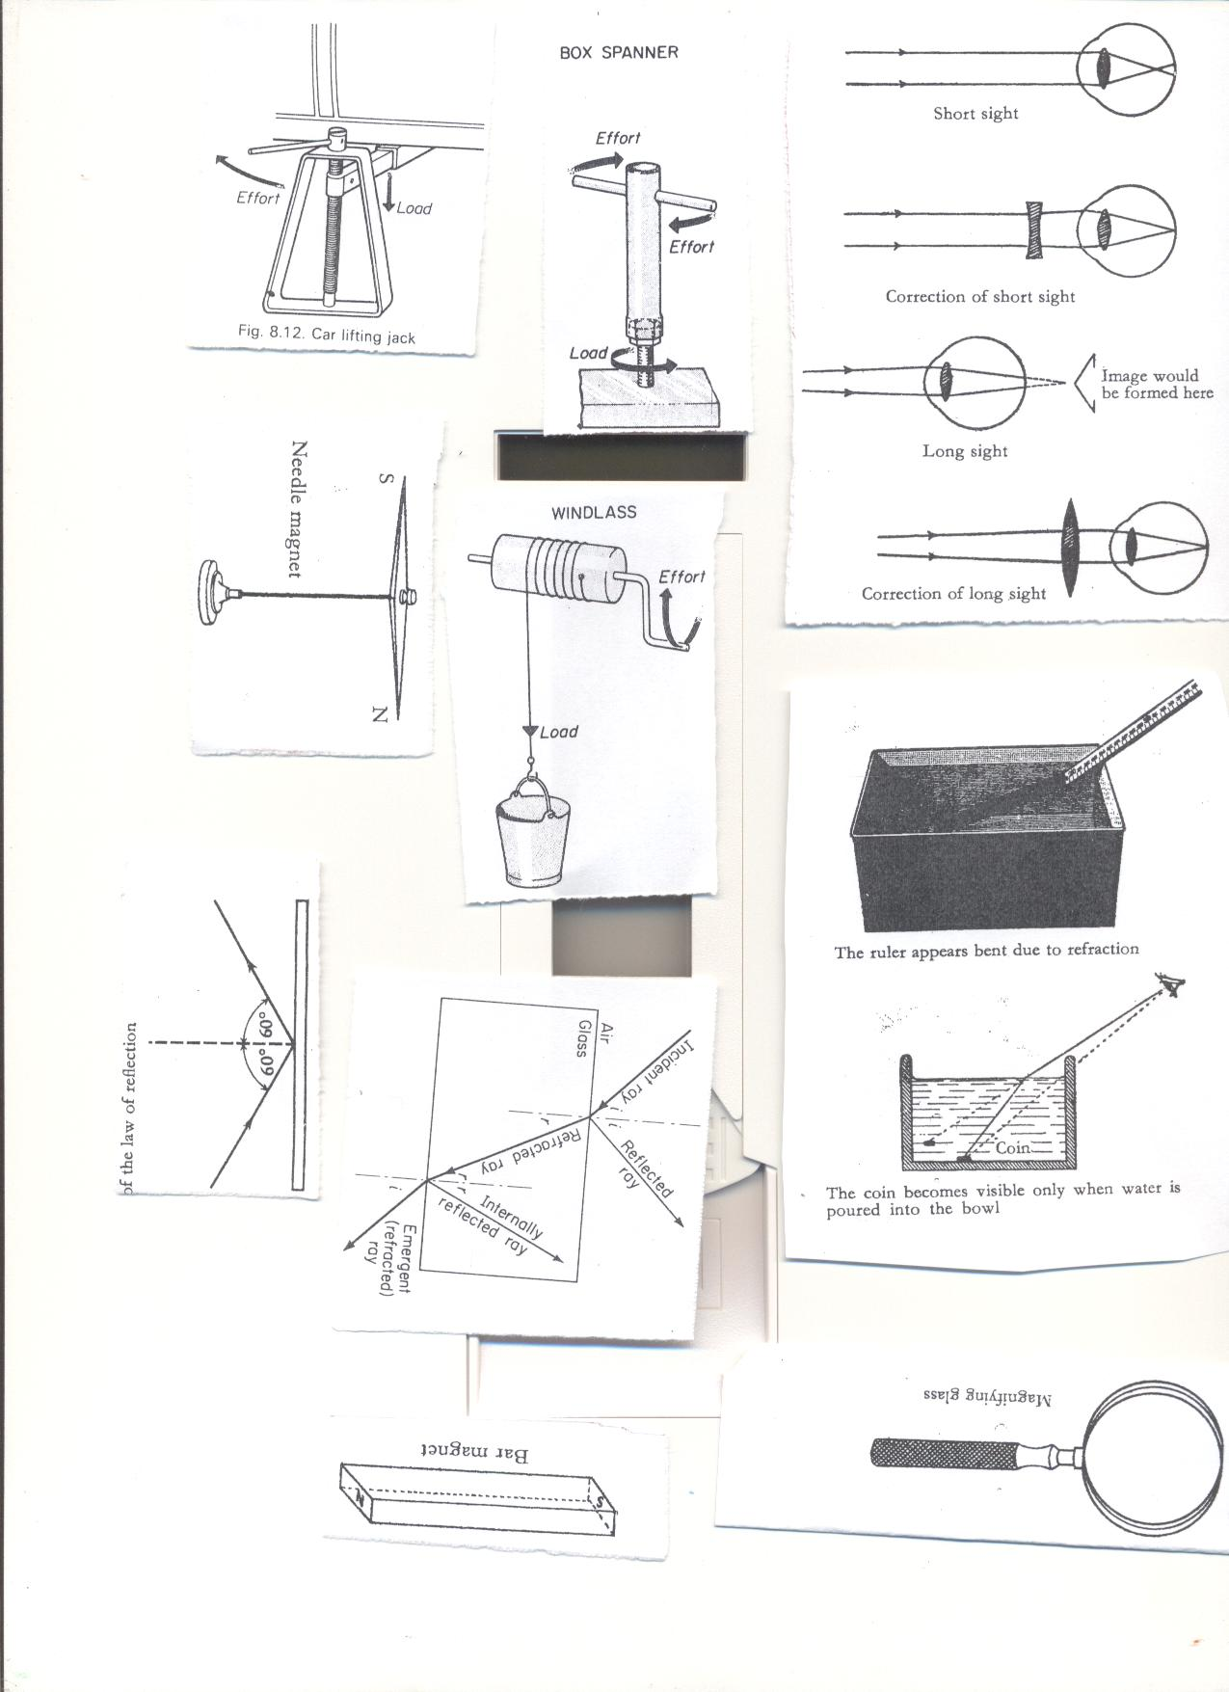

* Refraction cause a pool of water to appear shallower than it really is.this can lead to drowning.
* Refraction causes a pencil, a ruler or a stick put in water to appear bent.
* Refraction produces colors e.g. spectrum
* Refraction causes words under glass appear to be raised on different lines from the glass
* Refraction causes mirage that can lead to accidents on high way.

1. **What is mirage?**

Mirage is an optical illusion caused by bending of light rays due to layers of air having different densities and temperature.

1. **Write down two effects of mirage**

* Mirage can lead to accidents on the highways
* Mirage may cause false image along highways in deserts

**REFRACTION OF LIGHT RAYS THROUGH A RECTANGULAR GLASS PRISM**

**DISPERSION OF LIGHT**

1. **What is dispersion of light?**

Dispersion of light is the splitting of white light into seven distinct colours.

1. **What is light spectrum?**

Light spectrum is the band of seven distinct colours of white light.

1. **How is spectrum formed?**

Spectrum is formed when the white light rays are split by the act of a glass prism.

1. **What is a glass prism?**

A glass prism is a triangular device capable of refracting white light into different colours at different angles.

1. **What causes dispersion of light?**

Dispersion is caused by refraction of light rays at different angles in glass prism.

Light spectrum was first discovered by Isaac Newton in 1672.

Rainbow is an example of light spectrum.

Why does light rays bend at different angles in a glass prism?  
**Dispersion/ Refraction of white light by glass prism**. (ROYGIBIV)

* Light rays in a glass prism bend at different angles because they move at a different speed.

**RAINBOW.**

1. **What is a rainbow?**

Rainbow is a natural spectrum caused when light rays are refracted by drops of water falling from the sky through the air.

1. **How is a rainbow formed**?

Rainbow is formed when sunlight is refracted by droplets of water falling from the sky through the air.

1. **What causes rainbow?**

Refraction of light rays causes rainbow.

**Colours of the spectrum**

The order of the colours of the spectrum from top to bottom is Red, Orange, yellow, Green, Blue, Indigo, Violet.

* Red has the greatest wave length(red is the slowest ray so it bend least)and it has a long wave length
* Violet has the smallest wave length (violet is the fastest ray so it bends most and it has a short wave length.

**Refraction of light through a triangular glass prism**



The seven colours of the rainbow can be memorized in the sentence

**ROYGBIV**

**R**ichard **O**kello **Y**our **G**irl **B**enita **I**s **V**omiting.

**R**un **O**ngom **Y**our **G**irl **B**etty **I**s **V**omiting

**R**ichard **O**f **Y**olk **G**ave **B**etty **I**n **V**olleyball

* The inner colour of the rainbow is violet.
* The outer colour of the rainbow is red.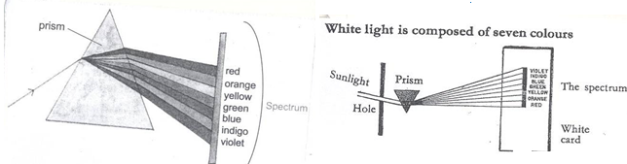

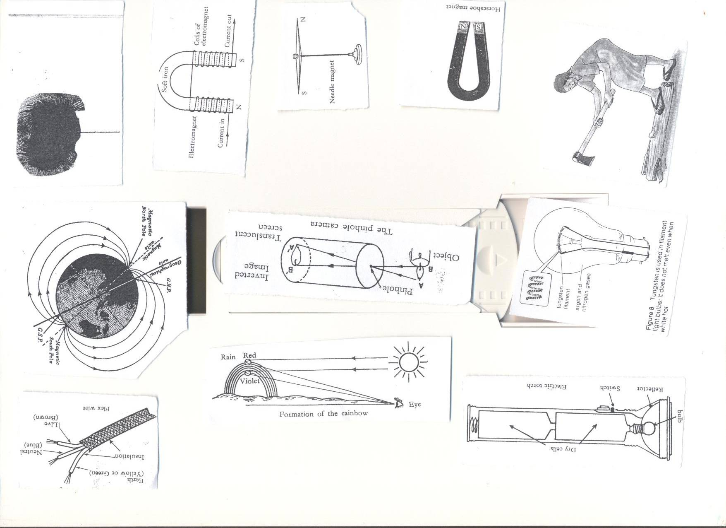

**EXERCISE**

**LENSES**

What is a lens?

A lens is a transparent material with curved sides capable of refracting light.

* Lenses are optical instruments used to focus or defocus.
* The surface of the lens may be convex, concave, plane or a combination of these.
* Lenses are used in materials like; cameras, microscopes, binoculars, magnifying glasses  
  **TYPES OF LENSES**

**Convex (converging) lens**

1. **What are convex lenses?**

Convex lens is the lens thick in the middle and thin at the edges

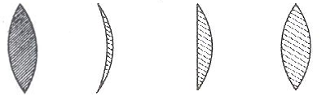

**Concave (diverging) lens.**

1. **What are concave lenses?**

Concave lens is the type of lens thin in the middle and thick at the edges

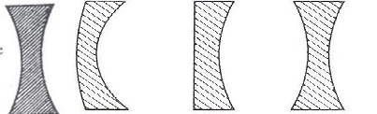

**THE EFFECT OF LENSES ON BEAMS OF LIGHT**

1. **CONVEX (CONVERGING) LENS**.
2. Convex lens refracts light to meet at one point (focal point)

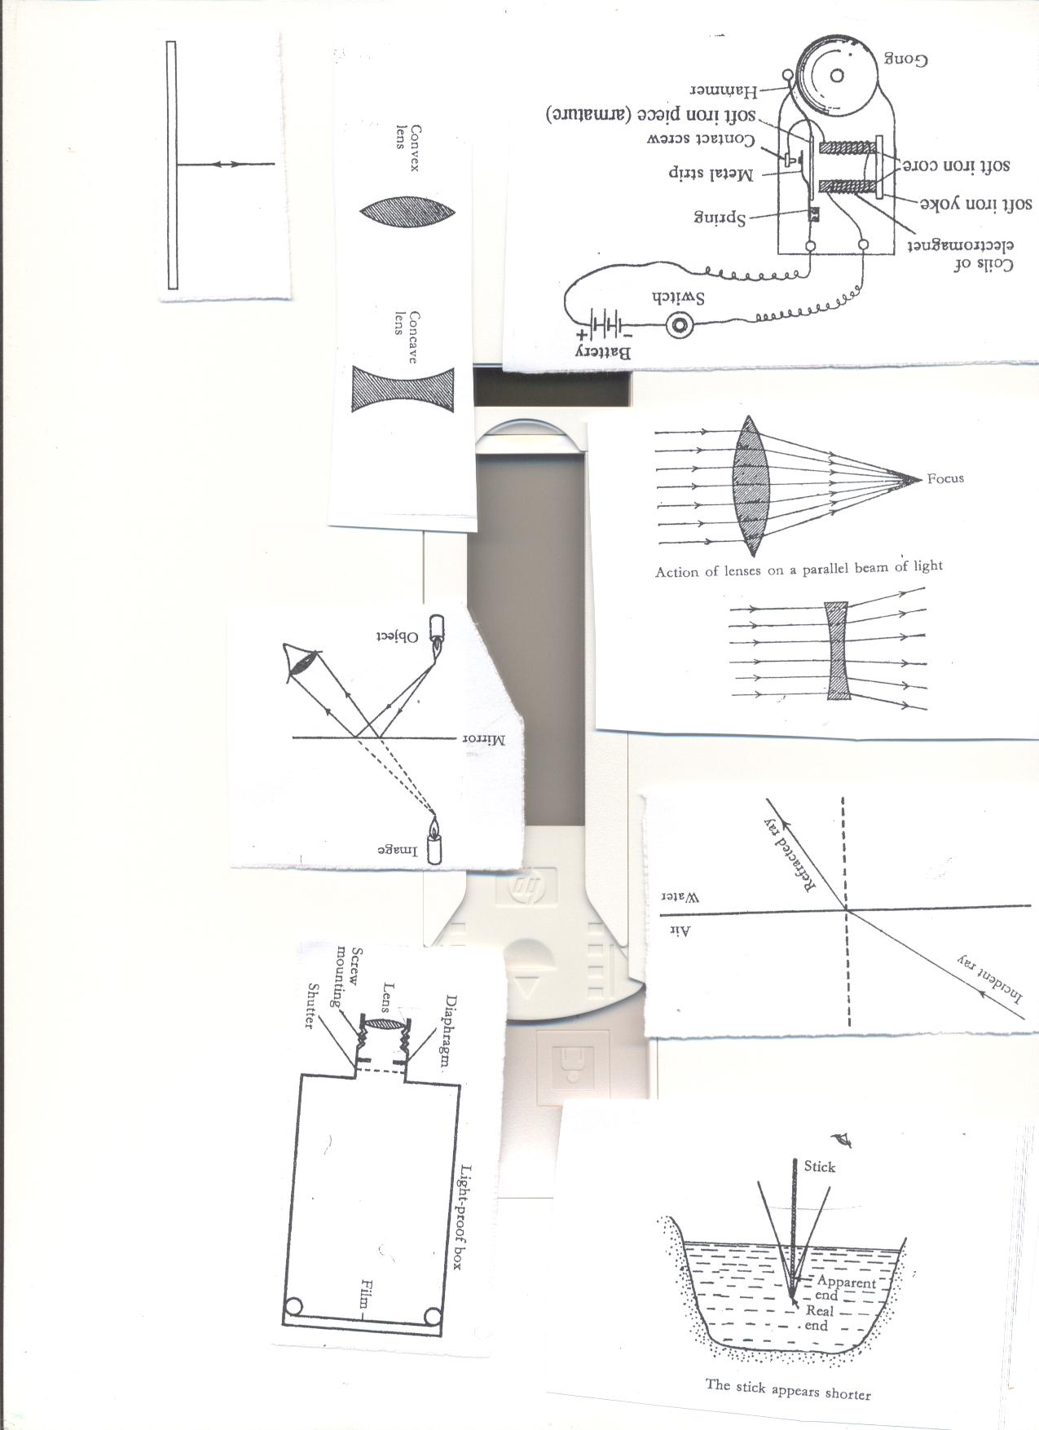

**Characteristics of images formed by convex lenses**

* The images are inverted.
* The images are magnified.
* The image real
* The image formed in infinity.

**USES OF CONVEX LENS**

* Convex lens are used to correct long sightedness/myopia
* Convex lens are used in telescopes and binoculars to make objects appear nearer.
* Convex lens in human eyes to focus images on the retina
* Lens cameras use convex lens to focus images in the retina
* Microscopes use convex lens to make objects look bigger than their normal size

1. **CONCAVE (DIVERGING) LENS**  
   Concave lensrefracts light and spread it out in different directions.



**Characteristics of images formed by concave lens.**

* The images are erect/upright
* The images are virtual
* The images are diminished/reduced in size  
  **Uses of concave lens**
* Concave lens are used in spectacles to correct short sightedness
* Concave lens are used in projectors to form images on photographic slide
* Lenses are used in magnifying glasses.

**The magnifying glass**

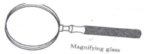

**THE LENS CAMERA**

**A lens camera consists of a light proof box with five functional parts namely;**

* Convex lens
* Film
* Diaphragm (adjusting ring)
* The shutter
* Focusing ring (screw mounting)
* Aperture

**Diagram showing a lens camera.**

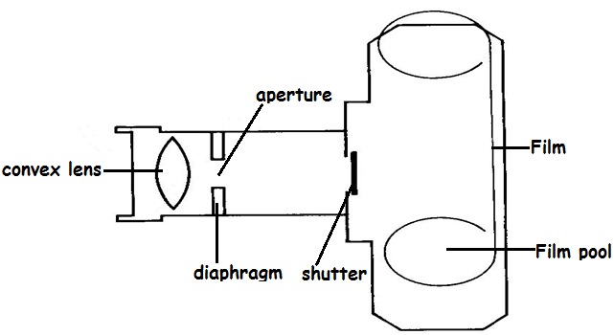

**PARTS OF THE CAMERA AND THEIR FUNCTIONS**

|  |  |
| --- | --- |
| * **Convex lens** | * Convex lens refracts and focus the images on the film. |
| * **Film** | * Film is a sensitive piece of paper where inverted image is formed. * **Film** performs the same function as **retina** in the human eye |
| * **Diaphragm** | * Diaphragm regulates or controls the amount of light entering the camera. * Diaphragm has a circular hole called aperture that allows light into the camera. **Aperture** performs the same function as **pupil** in the human eye * **Diaphragm** performs the same function as an **iris** of the human eye |
| * **Shutter**: | * The shutteruncovers the diaphragm to allow light into the camera. * The shutter blocks light entering the camera. * The shutter performs the same function as the eyelid in human beings. |
| * **Bellows(screw mounting)** | * Focusing ring adjusts the distance of the lens from the film to obtain the sharp image. |

**HOW A LENS CAMERA WORK.**

* The light is allowed into the camera by the lens, diaphragm and shutter.
* The light falls in the film and we say the photo is exposed
* The film is removed from the camera in a dark place and put in the chemical to develop it.
* The result of developing in is negative because bright part of the object photographed appears dark on the film.
* The negative is printed to give a positive (photograph) which has the same shades as the object.

**Characteristics of images formed by the lens camera**

* The images are real (they are formed on the film.)
* The images are smaller than the object.
* The images are inverted

**THE HUMAN EYE**

The eye is the sense organ for sight.  
The complete eye is called the **eyeball**.  
The eye ball is protected by the socket of the skull.

**The structure of a mammalian eye**

**Front view**

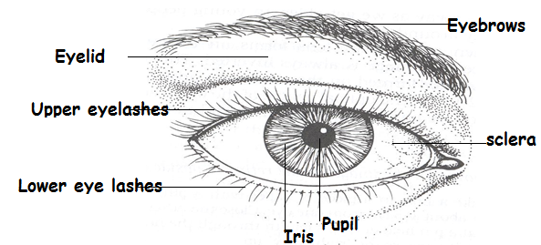

**FUNCTION OF THE PARTS**

|  |  |
| --- | --- |
| 1. **Eyebrows** | * Eye brows prevent water and sweats from entering the eye |
| 1. **Eye rashes** | * The eye lashesprevent water and other particles from entering the eye. |
| 1. **The eye lids** | * Eyelid cover and protect the eye * The eye lidsprevent foreign bodies from entering the eye * Eyelids perform the same function as the shutter of the camera |
| 1. **Sclera** | * Sclera is a tough, non-elastic and fibrous coat round the eyeball |
| 1. **Pupil** | * Pupil admits enough light into the eye * Pupil performs the same function as aperture of a lens camera |
| 1. **Iris** | * Iris controls/regulates the amount of light entering the eye. * Iris performs the same function as the diaphragm of a lens camera * **How does the iris regulate the amount of light entering the eye?** * Iris expands and contracts to reduce the size of the p |

**DIAGRAM SHOWING CROSS SECTION OF THE MAMMALIAN EYE**



**USES OF THE PARTS OF THE EYE**

|  |  |
| --- | --- |
| 1. **Cornea** | * Cornea aids refraction of light rays to begin converging as it passes through it. * Cornea refracts and converges light rays passing through it |
| 1. **Conjunctiva** | * Conjunctiva covers the front part of the eye. |
| 1. **Aqueous humour** | * Aqueous humour maintains the shape of the eye. * Aqueous humour helps to refract light and form an image on the retina |
| 1. **Convex Lens** | * Convex lens refracts and focuses light image on to the retina (accommodation) |
| **(f)Vitreous humour** | * Vitreous humour maintains the shape of the eye. * Vitreous humour also helps to refract light and form an image on the retina |
| 1. **Retina** | Retinais where the image is formed.   * Retina has the rods (light sensitive cells that are responsible for **dim light**) and the * Cones (light sensitive cells that are responsible for **bright light**) |
| 1. **Optic nerve** | * Optic nerve transmits nerve impulses to the brain for interpretation |
| 1. **Choroid** | * Choroid isa black pigment under the sclera that prevents **internal reflection** of light within the eye. |
| 1. **Blind spot** | * Blind spots have no light sensitive cells. If part of an image falls on it no impression is recorded in brain. |
| 1. **Fovea** | * Fovea gives the most accurate interpretation of an image. |
| 1. **Tear glands** | * Tear glandsproduces a solution that keeps the eye moist and washes dust from them. |
| 1. **Ciliary muscles** | * Ciliary muscles change the shape of the lens for accommodation |
| 1. **Ciliary body** | * Ciliary body contains blood vessels which supply blood to the eye |

1. **How is regular blinking important to the eye?**

Regular blinking of eyes distributes the fluid over the surface of the eye and prevents it from drying up.

**Characteristics of images formed by the eye**

* The image is upside down/inverted.
* The image smaller than the object/diminished.
* The image is real.

**Normal vision**

In normal vision, the image of the object seen is formed on the retina.

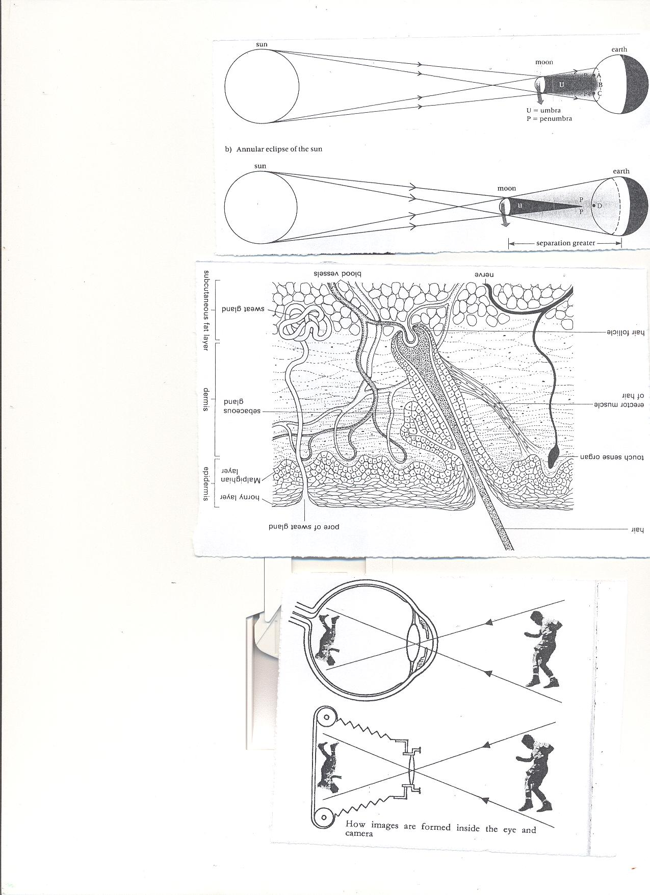



The Lens in the person’s eye is **convex.**

**COMPARISON OF THE MAMMALIAN EYE AND THE LENS CAMERA.**

**DIFFERENCES**

|  |  |
| --- | --- |
| **Eye** | **Camera** |
| 1. Lens focuses light on the retina | 1. Lens focuses light on the film |
| 1. Iris controls light intensity. | 1. Diaphragm controls light intensity |
| 1. Eyelids block light from entering the eye | 1. The shutter blocks light into the camera |
| 1. The images are formed on the retina | 4.The images are formed on the film |
| 5.The pupil allows light into the eye | 5. The aperture allows light into the eye. |
| 6.The choroid prevents internal reflection | 6.The black inside parts prevents internal reflection |

**SIMILARITIES BETWEEN IMAGES FORMED IN A CAMERA AND EYE.**

|  |
| --- |
| The images are real, diminished and upside down |



**Compare a mammalian eye and a pinhole camera.**

|  |  |
| --- | --- |
| **Eye** | **Pin hole camera** |
| 1. Focusing is done by changing the shape of the lens. | 1.Focusing is done by moving the camera forwards or backwards |
| 2. Image is formed on the retina. | 2.Image is formed on the screen |
| 3.Iris controls light entering the eye | 3. No control of light. |
| 4. The eye can be covered by eyelids. | 4. The pinhole is always exposed to light. |

**Similarities between human eye and a pinhole camera**

|  |
| --- |
| * The image formed is upside down * The image is diminished * The images formed are real |



**The parts of the eye and Camera with similar functions**  
**Eye Camera**

* Convex Lens____________Convex Lens
* Iris_____________________Diaphragm
* Eye lid_________________Shutter
* Retina _________________ Film
* Pupil________________ Aperture
* Choroid ________________The black inside part of the camera.

**EXERCISE**

1. **What is accommodation as related to the eye?**
2. **State the importance of tears in the eye**
3. **State the importance of regular blinking to the eyes**
4. **Write down three similarities between the images formed in the human eye and those in the photographic cameras**
5. **Write down three difference between the human eye and a pinhole camera**
6. **Write down five differences between the human eye and a lens camera**
7. **Which part of the body corrects the inverted image in the eye to be upright?**
8. **Which layer of the eye contains a network of blood capillaries and supplies the eye with food and oxygen?**
9. **Why is choroid pigmented black?**
10. **Which term is used to describe the focusing of near and far objects by the lens of the eye?**
11. **State the similarity between the optic nerve and auditory nerve**
12. **Name two fluids that maintain the shape of the eye**
13. **Which light sensitive cells are responsible for the following**
14. **Colour and bright light**
15. **Night visions**
16. **The diagram below shows the regulation of the size of the pupil by the iris in different lights**
17. **Which diagram shows the regulation of the pupil in;**

**Dim light**

**Bright light**

1. **Name the part marked X and Y**

**EYE DEFECTS/DISORDERS**

1. **What are eye defects?**

Eye defect is the inability of an eye to focus certain distance normally.

1. What are the causes of eye defects?

* Abnormal shape of the eyeball
* Abnormal shape of the eye lens
* Eye strain
* Colour blind

1. **What is colour blind?**

Colour blind is a person who cannot differentiate any one of the three primary colours

1. **What is colour blindness?**

Colour blindness is the condition when a person cannot differentiate colours.

1. **Short sight (myopia)**
2. **What is short sightedness?**

Short sight is a condition where a person is able to see only nearby objects clearly.

Short sightedness occurs when the image is formed before or in front of the retina.

df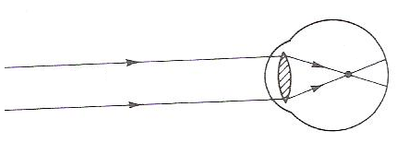

1. **What are the causes of short sight?**

* Having a very thick eye lens
* Large/elongated eyeballs (having a very long eyeball)

1. **How is short sightedness corrected?**by wearing spectacles with concave lens

**Diagram showing the correction of short sightedness**

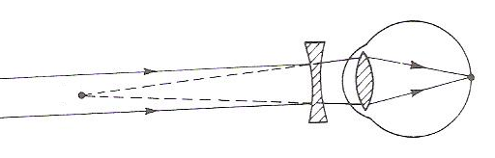

1. **LONG SIGHTEDNESS. (HYPERMETROPIA**)
2. **What is long sightedness?**

Long sightedness is a condition where a person can only see distant objects clearly.

**Diagram showing long sightedness**

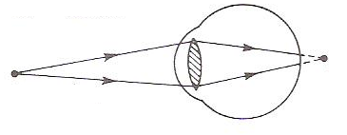



1. **What causes long sightedness?**

* Having a very thin eye lens
* Having a very short eyeball

1. **How is long sightedness corrected?**  
   By wearing spectacles with convex lens.

**Diagram showing correction of long sightedness.** 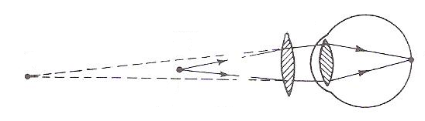



1. **Astigmatism.(distorted vision at all distances)**
2. **What is astigmatism?**  
   Astigmatism is the condition in which one is unable to see both vertical and horizontal objects clearly at the same time.  
   Astigmatism is common during old age.
3. **What causes of astigmatism?**  
   astigmatism is caused by having irregular cornea
4. **How is astigmatism corrected?**  
   By wearing glasses fitted with cylindrical lenses.
5. **Old age sight(presbyopia)**

Old age sight occurs when a person is very old and the eye lenses have lost its elasticity.

Old age sight is corrected by wearing glasses with converging lenses  
**DISEASES OF THE HUMAN EYE**

**Conjunctivitis**

|  |  |  |
| --- | --- | --- |
| **Disease** | **Germ** | **How it spread** |
| Conjunctivitis | **Bacteria /viruses** |  |
| Trachoma | **Bacteria - Chlamydia** | Housefly |
| River blindness | **Worm – Onchocerca volvulus** | Simulium or black fly |
| Gonorrhoea | **Bacteria** | Having unprotected sexual intercourse with infected person |
| Night blindness | **Lack of enough vitamin A in the body** | Non-communicable |
| Sty | **Bacteria** |  |

**EYE DISEASES**  
**1.Conjuctivitis (Red eyes/pink eyes)**   
conjunctivitis is caused by **bacteria or viruses**.  
**How is conjunctivitis spread?**  
Conjunctivitis is spread through sharing finger and face towels with an infected person.  
**Write four signs and symptoms of conjunctivitis**

* Red eye/pink eye
* Mild burning in the eyes
* Swelling of the eyelid
* Eyelids stick together during sleep
* Watery fluid discharge

**How can conjunctivitis be controlled?**

* Isolation of the sick
* Avoid sharing towels, handkerchiefs and bathing containers.
* Always wash hands with clean water.
* Treat pregnant mothers with gonorrhea.

1. **Trachoma**
2. **What causes trachoma?**

Trachoma is caused by a bacterium called **Chlamydia trachomatis**

1. **How is trachoma spread?**

* Trachoma is spread by sharing houseflies
* Trachoma is spread through shaking hands with an infected and face towels
* Sharing basins, face towels with an infected person

1. **Write down five signs and symptoms of trachoma**

* The eye turns red(Redness of the eye)
* The eyes produce watery fluids(discharge of watery fluids from the eyes)
* Irritation in the eyes.
* Small lamps under the upper eyelids.
* The white part swells.

1. **How can trachoma be controlled in the community**

* Wash hands and eyes regularly.
* Do not shake hands during the outbreak.
* Do not share hankies and face towels.
* Treat the infected ones.  
  **(C) RIVER BLINDNESS(ONCHOCERCIASIS)**

1. **Name the germ that causes river blindness**

River blindness is caused by **Onchocerca volvulus**

1. **How is river blindness spread from an infected person to another?**  
   River blindness is spread by black flies/simulium/Jinja fly.
2. **Write down four signs and symptoms of river blindness**

* The redness of the eye
* Tears flow.
* Inflammation of the iris.
* The skin gets rough.
* Enlargement of lymph nodes.
* Itching on the trunk.
* Lumps from under the skin.

1. **How can river blindness be prevented in the community?**

* Clear vegetation on banks of rivers.
* Spray the larva of simulium fly using insecticides

**EYE DISORDERS**

* Foreign bodies falling in the eye like insects and dust particles.
* Cataracts-clouded lenses
* Glaucoma- damage to the optic nerve from too much pressure in the eye
* Blepharitis

**Care of the human eye**

* Wash eyes with clean water and soap every day.
* **Avoid sharing handkerchiefs and face towels with other people**
* Don’t look directly at very bright light e.g. sun
* Don’t share face towels
* See the optician in case of a problem.
* Avoid reading on dim light.
* While reading, let the light come from over the shoulders**.**
* Avoid rubbing your eyes.
* While reading don’t be too close to the source of light.

1. **State any one reason why it important to keep our eyes clean always.**
2. **How are translucent objects important in our daily life**

**TOPIC 7: INTERDEPENDENCE OF THINGS IN THE ENVIRONMENT.**

**VOCABULARY**

* **Interdependence**
* **Dependence**
* **Agro forestry**
* **Pollarding**
* **Lopping**
* **Coppicing**
* **Ecosystem**
* **Wood seasoning**
* **Warping**

**ENVIRONMENT**

1. **What is environment?**

Environment us people and their surrounding

1. **Name two types of environment**

* Biotic or living environment
* Abiotic or non-living environment

1. **What are components of the environment?**

Components of the environment are things that make up environment

1. **Write down five components of environment**

* Plants
* Animals
* Soils
* Air
* Water bodies

1. **Write down two living components of the environment**

* **Plants**
* **Animals**

1. **Identify the three non-components of the environment**

* **Soils**
* **Water bodies**
* **Air**

**INTERDEPENDENCE:**

**1. What is interdependence?**

Interdependence is the way things benefit from each in the environment.

**HOW DO ANIMALS DEPEND ON PLANTS?**

* Animals get Oxygen from plants
* Animals get food plants
* Animals get where to stay (habitat)
* People get fire wood from them.
* Animals get building materials from plants
* Animals get herbal medicine from plants

**HOW DO ANIMALS DEPEND ON OTHER ANIMALS IN THE ENVIRONMENT?**

* Some animals feed on others (predators)
* Some animals live in/on others.eg internal parasites and external parasites.
* Some provide transport to others.eg donkey, horse, camels and oxen
* Animals like dogs provide security

**HOW DO PLANTS DEPEND ON OTHER ANIMALS?**

* Plants get carbon dioxide for photosynthesis
* Plants get manure from animal droppings
* Plants are pollinated by some animals
* Plants get care from animals weeding, watering etc.
* Plants are dispersed by animals

**HOW PLANTS DEPEND ON OTHER PLANTS IN THE ENVIRONMENT**

* Some weak plants get support from other plants.eg morning glory
* Some parasitic plants obtain food from the host plants.
* Some tall plants provide shade to small trees.
* Plants are protected from strong wind by other plants
* Plants get manure from other plants.

**INTERDEPENDENCE OF LIVING THINGS AND NON LIVING THINGS**

1. **HOW DO ANIMALS DEPEND ON NON- LIVING THINGS LIKE (AIR, WATER, AND SOIL)?**

* Some animals live in the soil like termites, earthworms, rats etc.
* People use soil to build houses, pottery etc.
* People get rocks for construction of roads, houses etc.
* Animals drink water.
* Animals breathe in oxygen
* Animals get heat and light from the sun.

1. **HOW DO PLANTS DEPEND ON NON- LIVING THINGS (AIR, WATER, AND SOIL)?**

* Plants use air to grow and make food
* Plants get heat and light from the sun.
* Plants grow on fertile soils.
* Plants use water to make their own food.

**HOW DO NON- LIVING THINGS BENEFIT FROM LIVING THINGS LIKE ANIMALS AND PLANTS?**

* Plants purify air by absorbing carbon dioxide from the atmosphere.
* Plants control silting of water bodies.
* Animals add manure to the soil.

**ACTIVITY**

1. **Write one sentence to show the meaning of “interdependence” in living things.**
2. **Apart from plants and animals, name any other two components of the environment.**
3. **How do plants benefit from animals?**
4. **Mention three ways in which animals gain from other animals in the environment.**
5. **Outline four ways in which plants depend on each other for survival.**
6. **How do domestic animals make use of the air around them?**
7. **Give four values of plants to people.**
8. **How do animals depend on non- living things?**
9. **Cite two ways in which non- living things depend on living things.**
10. **Which component of environment do we find human habitat?**
11. **What is the role of sunlight during photosynthesis?**
12. **Mention one importance of co-existence of living things in the environment**

**FOOD CHAIN**

1. **What is food chain?**

Food chain is the feeding relationship between organisms in the environment.

**OR;** Food chain is the way living organisms get their food in the environment

* All organisms depend on food for survival which is got from plants therefore plants are called **producers.**
* Living organisms that depend on food that is already made are called **consumers.**
* **Consumers are divided into three namely;**

1. **Primary consumers**
2. **What are primary consumers?**

Primary consumers are organisms which feed directly on the plants (producers)

1. **Mention at least four examples of primary consumers.**

* Monkeys
* Grasshoppers
* Rabbits
* Goats

(b) **Secondary consumers**

**1. What are secondary consumers?**

Secondary consumers are organisms which feed on primary consumers.

2. **Cite four examples of secondary consumers**

* Snakes
* Lions
* Tigers
* Frogs
* Leopards

**c) Tertiary consumers**

1. **What are tertiary consumers?**

Tertiary consumers are organisms that feed on the secondary consumers.

2. **Mention five examples of tertiary consumers.**

* Man
* Eagles
* Kites
* Owls
* Vultures

**Examples of food chain in the environment**

* Leaves→Grasshopper→Lizards→kites
* Cassava→Squirrels→Snakes→Owls
* Plants→Insects→Toads→Eagles
* Cassava→ squirrels→ snakes→ man→ bacteria
* Sun→ grass→ ant→ echidna
* Sun→ insects→ toads→ eagles

Note**: Fungi** **and bacteria** are decomposers because they help in **the decomposition of organic matter.**

**ACTIVITY**

1. **What is a food chain?**
2. **Why does a food chain start with the producer?**
3. **Why are all herbivorous primary consumers, but not all primary consumers are herbivorous?**
4. **How do plants and algae make their food?**
5. **What name is given to grass in the food chain?**
6. **Why are goats group under herbivorous animals?**
7. **Why are goats grouped under herbivorous animals?**
8. **Write one sentence to show the meaning of the following words.**
9. **Producer**
10. **Primary consumer**
11. **Secondary consumer**
12. **Decomposer**
13. **Study the list of things below and use the information to answer questions that follow.**

**Bean plant, Sun, lion, bacteria, and goat**

1. **Name the following**
2. **Producer**
3. **Primary consumer**
4. **Bacteria**
5. **State the role of sun in the list above.**
6. **(a) Use arrows to complete the food chain below.**

**Grass Zebra lion**

1. **What do arrows you have drown show?**
2. **What is the difference between a prey and a predator?**
3. **How do lions obtain their food?**
4. **The list below is of different organisms in the environment. Study the list and answer questions that follow.**

|  |  |  |  |
| --- | --- | --- | --- |
| **Cow** | **Maize** | **Leopard** | **Fungi** |

1. **Which of the organisms shown in the list is;**
2. **Producer**
3. **Decomposer**
4. **How does a cow differ from a leopard as regards their feeding?**
5. **How is the sun useful to the maize in the list above?**
6. **(a) Use the list of organisms below and fill in the food chain pyramid.**

**Frog, grass, snake, hawk, grasshoppers**

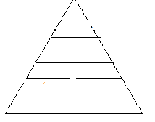

1. **What is the tropical level of grass in the above food chain?**
2. **Give a reason for your answer in (b) above.**

**TYPES OF ENVIRONMENT**

1. **Biological environment**

Biological environment is composed of living things like plants and animals

1. **Physical environment**

Physical environment is consists of nonliving things like soils, air and water bodies.

**Ecosystem**

Ecosystem refers to the number of living organisms in an area.

**FOOD WEB**

Food web is the feeding interrelationship among organisms in the environment

**An illustration of food web**

**AGRO FORESTRY**

**1. What is agro forestry?**

Agro forestry is the growing of trees along side crops in the garden

1. **What are the importance of growing crops and trees together?**

* Trees provide shelter to other crops.
* Trees control soil erosion.
* Crops get protection from wind and strong sunshine.
* Some trees have nitrogen fixing bacteria that make the soil fertile.
* A farmer gets double income e.g. food and timber.
* Trees reduce global warming as trees use carbon dioxide.
* Trees contribute to rain formation.  
  **3. What are the importance of growing trees and keeping animals on the same farm?**
* Trees provide shade to animals.
* Trees provide oxygen to animals.
* Trees purify the environment by using the carbon monoxide gas.
* Some leguminous trees are used as animal feeds.
* The farmer can get double income from trees and animals.

**4. What are the importance of rearing animals and growing crops on the same farm?**

* Animals get food.
* Crops get manure.
* The farmer can get double income.
* Animals give carbon dioxide to crops.
* Crops provide oxygen to animals

**5. What are the advantages of rearing and caring for animals, growing crops and trees on the same farm?**

* Some trees are used to make live fences (hedge)
* Some leguminous trees may be used as sources of animal feeds.
* Trees provide oxygen to animals.
* Animals give carbon dioxide to plant

**ACTIVITY**

1. (a**) what name is given to the practice of growing crops and trees together on the same piece of land?**

**(b) State any three ways in which crops benefit from trees when they are grown together.**

**(c) How do plants purify the environment?**

**(d) Give two ways in which farmers benefit from the practice named in (a) above**

**2. Cite four ways in which crops benefit from trees**

**3. Give three importance of trees in the environment**

**4. Give one way in which animals are important during photosynthesis**

**TREE GROWING IN UGANDA**

1. **How are trees propagated?**

* Trees grow from seeds
* The seeds selected should be healthy.

2**. Identify two species or types of trees grown in Uganda.**

* Indigenous trees
* Exotic trees

1. **Indigenous trees**
2. What are indigenous trees?  
   Indigenous trees are trees that have been growing in Uganda for many years.

* Indigenous trees are commonly found in natural forests.

**Examples of indigenous trees**

* Musizi
* Acacia
* Mvule
* Mahogany
* Mutubba

**Characteristics of indigenous trees**

* Indigenous tree produce hard wood.
* Indigenous trees take long to mature.
* Indigenous trees can withstand rough soil and weather.
* Indigenous trees grow by themselves (grow wildly)

1. **EXOTIC TREES**

**What are exotic trees?**

Exotic trees are the recently introduced species of trees in Uganda.

* Exotic trees are commonly found in artificial forests.

**Examples of exotic trees**

* Cypress
* Pine
* Cedar
* Mango
* Black wattle
* Eucalyptus
* Jack fruit tree
* Ficus tree

**Characteristics of exotic trees**

* Exotic trees produce soft wood.
* Exotic trees mature faster than the indigenous trees.
* Exotic trees need proper care.
* Some exotic trees cannot withstand harsh weather.

**Activity**

1. **(a) State the difference between indigenous and non- indigenous trees.**

**(b)Give two examples of each of the above trees**

**(c) How are the above trees propagated?**

**(d)Give one reason why people plant trees around their homes**

1. **(a) What is mixed farming?**

**(b) Give two importance of mixed farming**

**(c) Mention three disadvantages of mixed farming.**

**STARTING A TREE NURSERY BED**

1. **What is a nursery bed?**  
   A nursery bed is a small piece of land prepared for raising seedlings.
2. **List down the examples of seeds planted in the nursery bed.**

* Tomatoes
* Passion fruits
* Oranges
* Tea
* Pine tree
* Cypress trees
  + Ficus trees
  + Coffee
  + Mango trees
  + Tobacco

1. **What are the reasons for growing crops in a nursery bed?**

* A nursery bed protects seedlings from bad weather conditions.
* A nursery bed makes it easy to care for seedlings e.g. weeding, thinning, spraying etc.
* A nursery bed improves water infiltration into the soil.
* A nursery bed enables the seeds to germinate well as the soil is loose and moisture.

**Structure of a nursery bed**

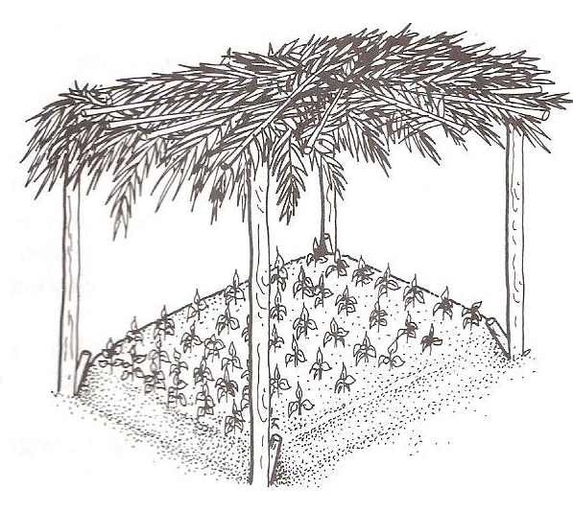

**TYPES OF NURSERIES**

1. Nursery bed-raised on the ground.
2. Seed boxes-Wooden boxes filled with soil.
3. Soil blocks-Soil put in polythene bags and sacks.

**2. Give any four ways of caring for seedlings in the nursery bed.**

* Watering
* Thinning
* Spraying using chemicals
* Hardening off seedlings

**A SEED BED**

1. **What is a seed bed?**  
   A seed bed is a large piece of land where seedlings are planted for further growth.

**Steps taken when starting a nursery bed**

1. Choose a good site, clear the land and dig deep to make the soil fine.
2. Add manure in the nursery bed and mix it well with soil.
3. Furrow the soil using a stick and plant the seeds you have selected.
4. Cover the prepared area with mulches, provide a shade and water.

NB: Remove the shade when the seedlings are about to be transplanted.

1. **What is hardening off?**  
   Hardening off is the making of seedlings get used to harsh garden conditions.

* The garden conditions are rain, sunshine and pests.

1. **What are some of the activities done during hardening off?**

* Shelter is removed.
* Watering is reduced.
* Weeding of seedlings
* Transplanting seedlings

**Transplanting**

Transplanting is the process of transferring seedlings from the nursery bed to the main field.  
(Seed bed)  
-Transplanting should be done in the evening when the weather is cool and wet to prevent the plants from losing a lot of water due to transpiration of water.

**Diagram showing a garden tool for transplanting**

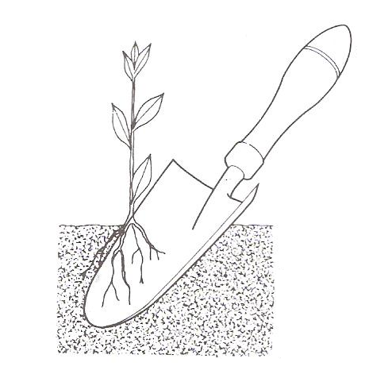

**Ways of caring for trees in agro forestry**

1. **Watering**

Watering is the application of water to plants

1. **Fencing**

Fencing is the construction of wooden fence around the gardens or individual plant

1. **Transplanting**

Transplanting is the transfer of seedlings from the nursery bed to a seed bed.

1. **Gap filling**

Gap filling is the replacing of plants that may have died in the garden.

1. **Spraying**

Spraying is the application chemicals to plants to kill pests

1. **Mulching**

Mulching is covering of top soil with dry plant materials.

**Advantages of mulching**

* Mulching controls soil erosion

**How does mulching control soil erosion?**

By reducing the speed of running water

* Mulching controls the growth of weeds

**How do mulches control the growth of weeds?**

By suffocating weeds

* Mulching improves soil fertility

**How does mulching improve soil fertility?**

Mulches rot/decompose to form humus in the soil

* Mulches keep or conserve moisture in the soil

**How does mulching keep moisture in the soil?**

By reducing the rate of evaporation

**Disadvantages of mulching**

* Mulches can be fire hazards
* Mulches can be the hiding places of pests
* Mulches can be source of weeds
* Mulching is tiresome and expansive

**PRUNING**

1. **What is pruning?**

**Pruning is t**he cutting of excess branches from a plant.

**Diagram showing a tool for pruning**

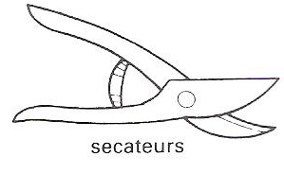

**Advantages of pruning**

* Pruning reduces competition for air.
* Pruning controls pests by removing hiding places for pests.
* Pruning eases harvesting.
* Pruning reduces transpiration.
* Pruning reduces the rate of transpiration
* Pruning reduces the weight of a plant.
* Pruned materials can be used for mulching.

**THINNING**

Thinning is the removal of excess or poorly growing seedlings from the garden.

**Advantages of thinning**

* Thinning gives enough space for other crops to grow.
* Thinning controls the spread of diseases.
* Thinning controls the spread of pests.
* Thinning eases spraying.
* Thinning improves yields and quality of harvest.

**Staking**

Staking is the providing of support to plants with weak stems

**Diagram showing staking**

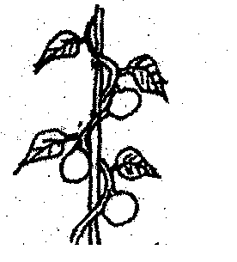

**Advantages of staking**

* Staking controls ground pests.
* Staking eases harvesting.
* Staking eases pruning.
* Staking eases spraying.
* Staking improves plant access t

**CROP SPACING**

Crop spacing is the leaving of open spaces between individual plants

-Crop spacing is the planting of crops leaving spaces between individual crops.

**Importance of crop spacing**

* Crop spacing reduces competition for water and space.
* Crop spacing ensures proper circulation of air to the plant.
* Crop spacing enables plants to get enough sunlight.
* Crop spacing eases weeding.
* Crop spacing eases harvesting.

**WEEDING**

Weeding is the removal of unwanted plants in the garden.

1. **How dangerous are weeds in crop farming**

* Weeds hide pests.
* Weeds compete with crops for sunlight and other nutrients.
* Some weeds are poisonous to plants and livestock. E.g. tick berry bush.
* Weeds increase the cost of farm management.

1. **What are the advantages of weeds?**

* Leguminous weeds fix nitrogen in the soil and increase soil fertility.
* Weeds can be used as animal feeds.
* Source of herbal medicine.
* Weeds rot to form manure.
* Weeds can be used as mulches.

**How to control weeds**

* By uprooting and burning the weeds.
* By digging or cutting with a hoe.
* Spraying with herbicides.
* By practicing mulching.

1. **Mention two mechanical methods of controlling weeds.**

* Hand pulling the weeds
* Hand hoeing the weeds
* Slashing the weeds

1. **Give three cultural methods of controlling weeds**

* By mulching
* By carrying out crop rotation
* By burning
* By flooding to kill weeds that cannot resist water-logging.

**ACTIVITY**

1. **A nursery bed is a small piece of where seeds are grown before being taken to the main garden?**
2. **Suggest four factors to consider when selecting seeds for planting in a nursery bed.**
3. **Rearrange the following steps of making a nursery bed in their order**
4. **Put seeds in small holes**
5. **Clear the land and dig deep to make soil fine**
6. **Construct a shade and cover with grass**
7. **Add manure to the soil in the nursery bed and mix well with soil.**
8. **(a) Why is hardening off carried out by farmers?**
9. **Mention three activities carried out during hardening off.**
10. **Why do farmers cut off the leaves of banana sucker before planting?**
11. **Name two vegetable crops grown in a nursery bed.**
12. **Name the garden tool used for;**
13. **Transplanting**
14. **Pruning**
15. **The lists below gives some of the methods farmers use to control soil erosion use it to answer questions that follow.**

**-terracing**

**-planting trees**

**-contour ploughing**

**-mulching**

**(a) Which of the methods given above are best for ;**

**(i) Land with a gentle slope**

**(ii) Land with steep slope**

1. **How does mulching;**
2. **Improves soil fertility**
3. **Conserves/keeps moisture in the soil**
4. **Controls soil erosion**

**TREE PESTS AND THEIR CONTROL  
1. What is a pest?**  
A pest is a living organism that destroys crops.  
**A vermin** is an animal pest.  
Examples of vermin include; rats, monkeys, elephants etc.

**Examples of crop pests**

|  |  |  |
| --- | --- | --- |
| **PEST** | **CROPS ATTACKED** | **DAMAGE.** |
| Mealy bug | Pineapples, coffee | Leaves turn yellow or pink. |
| Aphids | Oranges, coffee, cabbages etc. | Wilting back of terminal bud. |
| Banana weevils | Bananas | Leaves turn yellow Bananas fall easily. |
| Codling moth. | Citrus fruits like oranges and mangoes | Fruits fall off. |
| Thrips | Bananas | -Premature ripening of bananas -Banana fruits burst. |
| Moles, rats, squirrels, mice, cane rats. | Cereals | Direct consumption of seeds and stems. |
| Citrus black fly. | Citrus fruits | The flies suck sap from leaves and tender shoots. |
| Leaf miners | Coffee, cocoa, pineapples, aloe Vera, sisal | Plant’s ability to make sugar is reduced. |
| Cut worms | Vegetables | Leaves are destroyed. |
| Locusts | All crops |  |
| Army worms | Cereals and grasses |  |
| Maize stalk borer | Maize | Holes in the seeds |
| Boll worm | Cotton |  |
| Antestia bug | Coffee |  |
| Game animals e.g. monkeys | Oranges, mangoes |  |
| Birds. | Maize, sorghum. |  |

**Methods of controlling pests**

* Early planting.
* Spraying with pesticides.
* Use of birds to eat lady birds. (Biological method)
* Practicing crop rotation(cultural or traditional method)
* Weeding.(mechanical methods)
* Plant clean materials

**Crop diseases**

|  |  |  |  |  |
| --- | --- | --- | --- | --- |
| **DISEASE** | **CROP** | **CAUSE** | **SIGN** | **CONTROL** |
| Panama disease | Bananas |  | Plant Banana Wilts | Burn entire stock Plant healthy suckers |
| Cigar End rot | Banana | Bacteria | Banana tips resembles burning cigar | Burn infected crops. |
| Banana bacterial wilt | Banana | Bacteria | Banana stem rots and falls down |  |
| Powdery mildew. | Mangoes | Fungi | Powdery patches on leaves | Spray with fungicides |
| Green mould | Citrus fruits | Fungi | The stem dries with a green powder | Spray with fungicides. |
| Stem pitting | Citrus fruits | Fungi | Dry patches on the stem. | Spray with fungicides. |
| Tomato blight | Tomatoes, potatoes | Bacteria | Yellow leaves |  |
| Crown gall | Fruits | Bacteria | Leaves shrink |  |
| Fire blight. |  | Bacteria | Wilting |  |
| Rust fungus | Cereals | Fungi | Black spot on leaves |  |
| Root rot | Tea plants | Fungi |  |  |
| Coffee berry diseases(CCB) | Coffee | Fungi | Brown spots appear on berries. |  |

**Factors that affect crop production**

* Crop pests and diseases.
* The use of poor methods of farming.
* The harvesting of immature seeds
* Poor farming methods
* Poor attitudes towards farming
* Poor storage facilities
* Natural calamities like floods, drought, storms etc.
* Infertile soils

**What are common signs of pest and disease damage in crops?**

* Holes in leaves
* Spots on fruits
* Change of colour in the stems
* Deformed plant parts
* Rotten plant parts

**PROPER METHODS OF HARVESTING TREES**

1. **Coppicing**

Coppicing is the cutting of the whole tree but leaving room for it to sprout again.

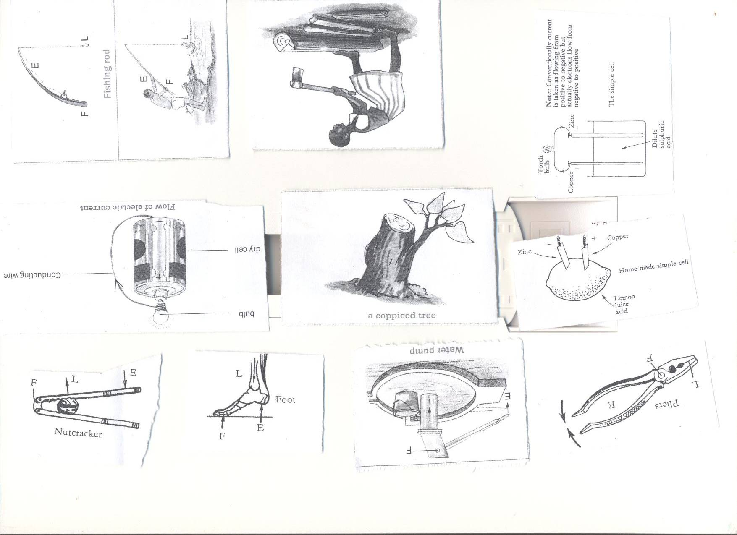

1. **Pollarding**

Pollarding is the cutting of the top part of a tree allowing new branches to develop.

* Pollarding makes harvesting of ready fruits easy.

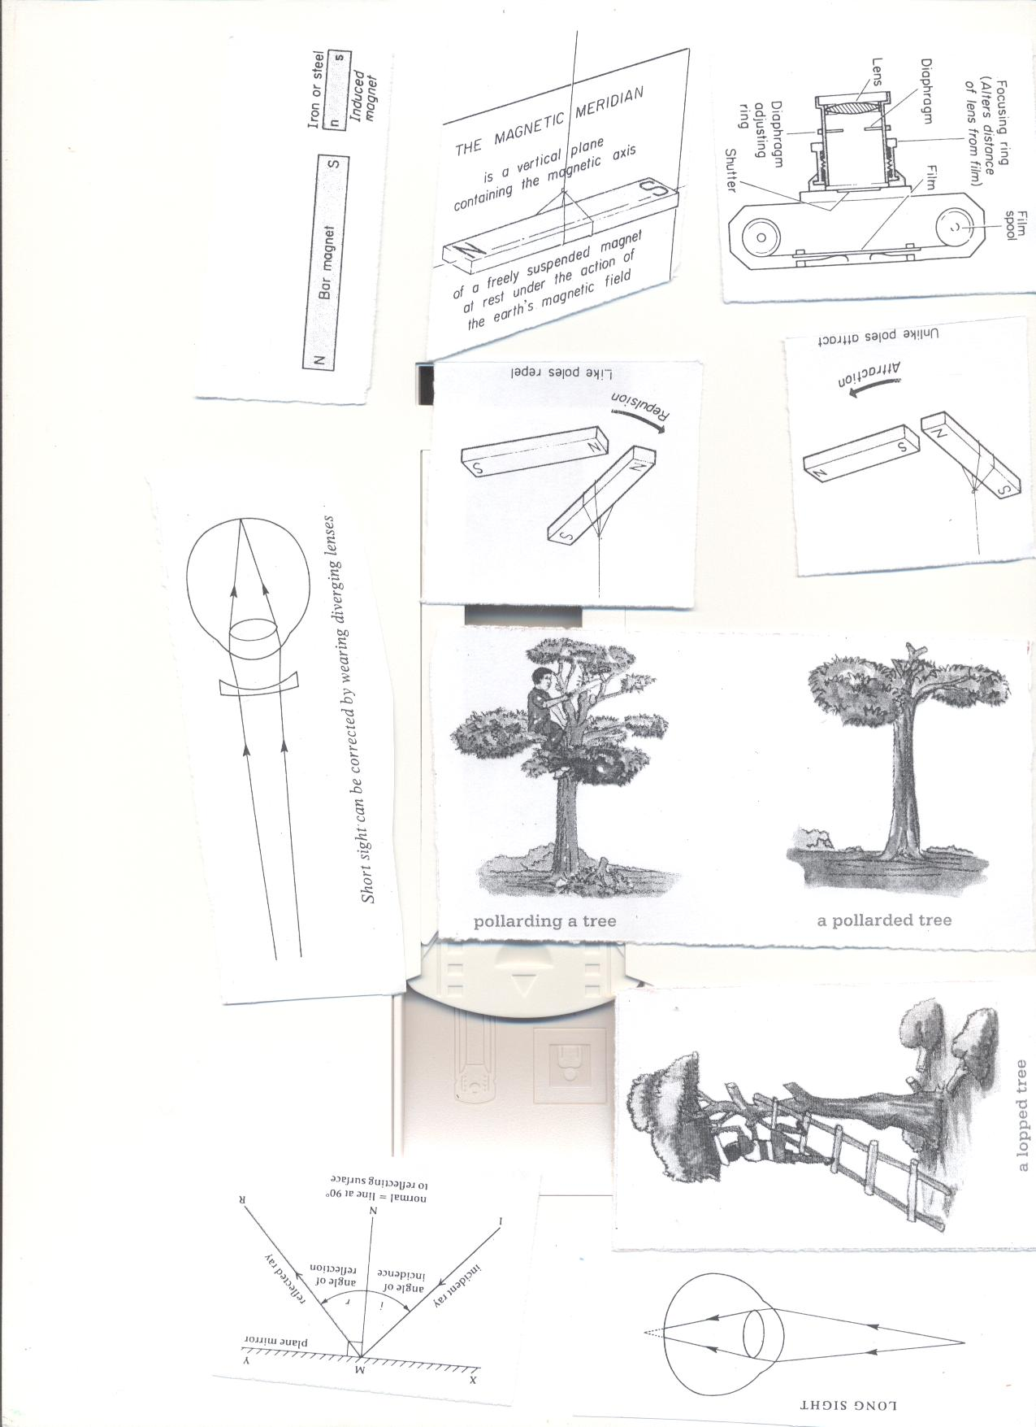

1. **Lopping**

Lopping is the cutting of the side branches of a tree from the truck.

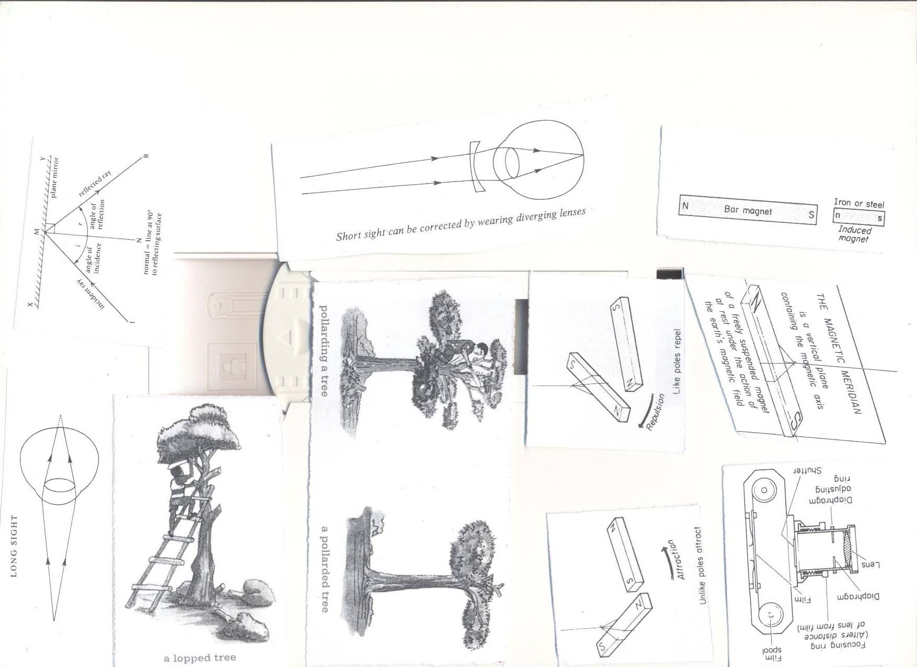

**WOODLOT PROJECT**

**What is a woodlot?**

A woodlot is a small garden where trees are planted for a small scale production such as wood fuel

* Wood project can be started at homes and schools

**Advantages of Starting and managing a school/home wood project**

* Wood project help in the production of food for the family.
* Wood project is a Source of income when sold
* Practicing the science learnt in class.
* Trees provide shelter.
* Trees are source of wood fuel.

**What are factors to consider when starting a tree and crop growing project?**

* Site-near your home.
* Soil drainage.
* Nearness to the water source.
* Fertility of the soil.
* Security.
* Accessibility.
* Nearness to the home/school.

**What are the factors to consider when choosing crops or trees for planting?**

* Those which mature faster
* Those that give high yields.
* Those that are not easily attacked by disease
* Those which are multipurpose.

**PREPARING WOOD FOR DIFFERENT PURPOSES AND PROPER STORAGE**  
**Uses of wood**

* Woods are used for charcoal.
* Woods are used as fire wood.
* Woods are used as medicine.
* Woods are used as timber.
* Woods are used to make electricity and telephone poles.
* Wood produces a pleasant smell when burnt.

**WOOD FOR FIREWOOD**

* Wood for firewood is split, dried and then kept in a shed.
* Trees store much water inside their cells.
* When wood is split water evaporates from it.

**Wood for electricity and telephone poles**

* Poles are treated with chemicals known as wood preservatives.  
  A strong salt can act as a **wood preservative.**
* The bark is first removed then soaked.  
  **Wood for timber**
* Trees are cut into different pieces.
* The pieces are put under shade to dry at slow pace.  
  **WOOD SEASONING.**

1. **What is seasoning?**  
   Wood seasoning is the putting of pieces of timber under shed to dry at slow pace.  
   If timber is dried under direct sunshine it gets twisted/out of shape.  
   The twisting of the pieces of timber is referred to as **warping.**
2. **What is warping?**

Warping is the twisting of the pieces of timber.

1. **Give two reasons for seasoning timber.**

* Seasoning prevents woods from splitting.
* Seasoning prevents woods from warping/bending.

**RECORD KEEPING**

1. **What is record keeping?**

Record keeping is the gathering and storage of information about farm activities.

1. **What are farm records?**

Farm recordsare written information showing different out puts and inputs on a farm.

1. **Mention at least six types of records kept on a farm.**

* Inventory records e.g. farm tools, farm machinery,
* Production records
* Health records
* Breeding records
* Feeding records
* Income and expenditure records.

1. **What are the importance of keeping farm records?**

* Farm record enables a farmer to know the income and expenditure.
* Farm records enable a farmer to know whether they are making profits or losses**.**
* Farm records enable a farmer to identify areas of development and investment.
* Farm records enable a farmer to budget for the farm.
* Farm records enable a farmer to get loans

**YOUNG FARMERS’ CLUB**

1. **What is a young farmers’ club?**

Young farmers’ club is a club in a school in which members learn practical skills about keeping animals and growing crops.

1. **What are the roles or functions of young farmers’ club at school?**

* Young farmers’ club teach children how to grow and care for crops and animals
* Young farmers’ club produces food
* Young farmers’ club grows crops, rear animals and sells to get money
* Young farmers club organizes science exhibition in the school
* Young farmers’ club teach farmers good (modern) farming methods
* Young farmers’ club encourages conservation of environment
* Young farmers’ club coordinates information from agricultural assistants to rural areas

1. **How can young farmers’ club be promoted in your community**

* Some schools have gardens where they practice farming.
* Young farmers’ clubs organize trips to agriculture research stations.

**QUESTION ANALYSIS**

1. **What is agroforestry?**
2. **Suggest any one importance of keeping animals and growing crops on the same piece of land at the same time?**
3. **Suggest one method of properly harvesting trees.**
4. **Why is it important to treat wood for electric poles before planting them?**
5. **How are young farmers clubs important in schools?**
6. **Why is it important to keep records on farms?**
7. **Give any one reason why it is important to keep trees.**
8. **Write down any one disease that affects bananas.**
9. **How important are the following farm practices important on a farm.**
10. **Thinning b) staking c) pruning**
11. **How are vermins different from vectors?**
12. **Why is it important for farmers to plant their crops in nursery beds?**
13. **State any three crops that are first planted in a nursery bed.**
14. **State one thing done to seedlings in a nursery bed that are about to be transplanted.**
15. **Why watering seedlings important when they are in a nursery bed**
16. **Mention any one characteristic of exotic trees.**

**TOPIC 8: POPULATION AND HEALTH**

**VOCABULARY**

* **Health concerns**
* **Community**
* **Health surveys**
* **Immunization**
* **Demography**
* **Health data**
* **Population**
* **Sex deviation**
* **Antisocial behavior**

**COMMUNITY HEALTH AND SOCIAL PROBLEMS**

**Population is the total number of organisms in an area.**

**Community**

1. **What is a community?**

A community is a group of people living or working together having common needs, interests and problems.

1. **What is health?**

Health is a state of being physically, socially, economically and mentally well but not merely the absence of sickness.

1. **What is a community Health?**

Community health refers to the essential health conditions in which individuals and families within a community live.

1. **Mention four examples of communities**

* A school
* A town
* Prison
* convent
* A village
* Market
* hospital

1. **Identify four examples of common health and social problems in communities;**

* Smoking
* Alcohol and drug abuse
* Poor sanitation standards
* Malnutrition
* Disease outbreak
* Anti-Social behavior

**Types of common sickness in a home**

* Immunisable diseases
* Deficiency diseases
* Communicable diseases
* Self-inflicted diseases
* Sexually Transmitted diseases
* Hereditary (genetic) diseases

**IMMUNISABLE DISEASES**

1. **What are immunisable diseases?**

Immunisable diseases are diseases which can be prevented through immunization.

**Immunisable diseases are in two categories namely;**

1. **List down eight childhood immunisable diseases**

* Tuberculosis
* Tetanus
* Whooping cough (pertussis),
* Diphtheria
* Hepatitis B
* Polio
* Measles
* Haemophilia Influenza b

1. **List down non-childhood immunisable diseases**

* Typhoid
* Meningitis
* Cholera
* Yellow fever
* Small pox
* German measles (rubella)

**DEFICIENCY DISEASES**

**What are deficiency diseases?**

Deficiency diseases are diseases that are caused by lack of some food values in our daily diet.

**Examples of deficiency diseases**

|  |  |
| --- | --- |
| **Deficiency disease** | **Cause** |
| Night blindness | Lack of enough vitamin A |
| Beriberi | Lack of enough vitamin B1 |
| Pellagra | Lack of enough vitamin B2 |
| Scurvy | Lack of enough vitamin C |
| Rickets | Lack of enough vitamin D |
| Infertility | Lack of enough vitamin E |
| Poor blood clotting (haemorrhage) | Lack of enough vitamin K |
| Goitre | Lack of Iodine in the diet |
| Marasmus | Lack of enough carbohydrates |
| Kwashiorkor | Lack of enough proteins in the diet |
| Anemia | Lack of Iron in the diet |

**COMMUNICABLE DISEASES**

Communicable diseases are diseases which can be spread from one infected person to another person.

* Communicable diseases are caused by **germs**

**Examples of communicable diseases**

|  |  |  |  |  |
| --- | --- | --- | --- | --- |
| **Bacteria** | **Virus** | **Protozoa** | **Worm infections** | **Fungal** |
| Gonorrhoea | HIV/AIDS | Malaria | Round worms | Athletes foot |
| Syphilis | Measles | Sleeping sickness | Tape worms | Ring worm |
| Trachoma | Polio | Amoebic dysentery | Flat worms |  |
| Diphtheria | Influenza |  | Thread worms |  |
| Bacillary dysentery | Common cold |  | Hook worms |  |

**SELF INFLICTED DISEASES**

**What are self-inflicted diseases?**

Self-inflicted diseases are diseases which people get due to poor health life styles.

**What are poor life styles?**

Poor life style is the way of living which affects the health of a person.

**Examples of poor life styles**

* Smoking
* Alcoholism
* Drug abuse
* Over eating
* Lack of physical exercises
* Prostitution etc.

**List down four examples of self-inflicted diseases;**

* Lung cancer
* Sexually Transmitted Infections.
* Emphysema
* Obesity

**SEXUALLY TRANSMITTED DISEASES (VENEREAL DISEASES)**

1. **What are sexually transmitted diseases?**

Sexually transmitted diseases are spread through having unprotected sexual intercourse with infected persons.

1. **Mention at least five examples of sexually transmitted diseases**

* HIV/AIDS
* Gonorrhoea
* Syphilis
* Genital warts
* Candida

**HEREDITARY (GENETIC) DISEASES**

1. **What are hereditary diseases?**

Hereditary diseases are diseases that are passed on from parents to off springs through genes.

1. **Give three examples of hereditary diseases**

* Sickle cell anemia
* Diabetes
* High blood pressure

1. **What are the causes of sicknesses in the home and community?**

* Poor disposal of human and industrial wastes.
* Alcohol and drug abuse.
* Poor nutrition
* Some diseases are inherited from parents e.g. sickle cell.

**Controlling common sicknesses in a home and community**

* Proper sanitation.
* Family planning
* Good nutrition.
* Brushing the teeth after every meal
* Doing daily physical exercises.

**How to avoid health and social problems**

* Proper sanitation
* Proper waste disposal
* Keep our homes and water sources clean.
* Proper feeding.
* Avoid drug abuse
* Abstain from sex if not married

**Methods of preventing diseases in the community**

* Immunization
* Through proper nutrition
* Personal hygiene
* Boiling water for drinking.
* Good food hygiene.
* Proper rubbish disposal.

**How young people can avoid social and health problem**

* Avoiding bad peer groups.
* Form clubs such as young farmers club, drama and music.
* Join church choirs
* Participating in sports activities such as football, netball, swimming and athletics.
* Attending youth seminars and conferences on morals, drug abuse, HIV and AIDS.
* Using their leisure time to learn practical skills e.g. weaving, tailoring, and computer use.

**Life skills of avoiding social and health problems**

* Critical thinking
* Decision making
* Problem solving
* Self-awareness
* Effective communication
* Creative thinking

**ANTISOCIAL BEHAVIOURS**

1. **What are antisocial behaviors?**

Antisocial behaviors are unacceptable behaviors in the society.

1. **Delinquency**

Delinquency is a bad act performed by a juvenile and is punishable by law.

1. **Juvenile delinquency**

Juvenile delinquency is a bad act performed by a juvenile and is punishable by law.

1. **A Juvenile**

A juvenile is person below 18 years

1. **A delinquent**

A delinquent is a young person who commits an act punishable by law.

**EXAMPLES OF ANTISOCIAL BEHAVIOURS**

* Lying
* Truancy
* Stealing
* Arson (fire setting),
* Sex offences like prostitution, rape, defilement
* Wandering
* Fighting
* Teasing in school/bullying
* Murder,
* Drug abuse like smoking, alcoholism
* Aggression/violence

1. **What is truancy?**

Truancy is running away from school

1. **What are some of the causes of truancy?**

* Learning difficulty in reading ,writing and mathematics
* Overcrowding in class
* Boredom in class
* Bulling by other children or school staff
* Various attraction from outside the school like video films

**CAUSES OF ANTISOCIAL BEHAVIOURS**

* Disturbed homes(disfunctional broken families)
* Bad peer influence
* Poor social environment.
* Poor home atmosphere like fighting by parents.
* Over strictness by both parents and teachers.
* Unfulfilled expectations.
* Pampering of children.
* Failure to enforce rules in the community.
* Poor family back ground.
* Poor social environment.

**Effects of antisocial behaviors**

* Many delinquent children may become adult criminals.
* Individuals suffer from pain, injury and death.
* Sex offences may result into sexually Transmitted Diseases.
* Fire setting leads to destruction people’s property.
* Drug abuse may be a bad example to the children.
* Leads to School dropout.
* Causes Shame to parents.
* May lead to Death.
* The family may disown the child.
* Weaken the custom, religion and organization.

**How to prevent and control antisocial behaviors**

* All parents should create stable families.
* Parents should take children through counseling and guidance lessons.
* Children should join youth clubs and societies.
* Children should avoid bad peer groups.
* Children should be exposed to sex education.
* Punish wrong doers and praise good behavior.
* Equal treatment should be given to all children.
* Elders should be exemplary.
* Children should engage in gainful activities during free time
* Avoid setting too high standards of behavior.
* Children should join youth and sports clubs and societies.

**VIOLENCE**

Violence is a state in which a person is aggressive and has destruction behavior.

**Types of violence**

* **Sadism:** an extreme motive to harm others.
* **Masochism**: an extreme motive to harm oneself

**SEXUAL DEVIATIONS**

**What is sexual deviation?**

Sexual deviation is an abnormal sexual practice in the community.

Sexual deviation is an acceptable sexual practice in the community

**FORMS OF SEXUAL DEVIATIONS**

* **Bestiality**

Bestiality is the sexual intercourse between a man and an animal

* **Homosexuality**

Homosexuality is the sexual intercourse between a man and a man

* **Masturbation**

Masturbation is the touching of the one’s body parts (sex organs) for sexual pleasure.

* **Oral sex**

Oral sex is the stimulation of one’s genitals or sexual organs with your mouth, lips or tongue.

* **Lesbianism**

Lesbianism is the sexual attraction between females.

* **Incest**

Incest is the sexual intercourse between close relatives like father and the daughter, brother and sister, mother and son etc.

* **Fellatio**

Fellatio is the sexual intercourse between a living person and a dead body.

* **Prostitution**

Prostitution is a business or a practice of engaging in sexual intercourse in exchange for payment or some other benefit.

**Reasons why people practice sexual deviations**

* Lack of personal or sexual satisfaction
* Drug abuse
* Exposure to pornography
* Bad peer influence
* broken homes or families
* Poverty
* Foreign influence

**WAYS OF AVOIDING SEXUAL DEVIATIONS.**

* Engaging in activities that can keep you busy like football, netball, chess etc.
* By joining church choirs during leisure
* Take good advice from your teachers, parents and elders about the dangers of sexual deviation.
* Avoid bad peer groups
* Avoiding drug abuse
* Through guidance and counseling.
* Avoid watching pornography.
* Avoid incentives from strangers.
* Join gainful clubs during leisure.

**POPULATION AND HEALTH CONCERNS**

**What is population?**  
Population is the number of organisms living in an area.

**Health concerns.**

Health concerns are health problems that affect people and need immediate solutions.

**Population and health concerns**

* Poor sanitation.
* Anti-social behavior.
* Poor water supply.
* Inadequate food.

1. **POOR SANITATION**

Poor sanitation is the improper disposal of human faeces and other waste products into the environment.  
**INDICATORS/SIGNS OF POOR SANITATION**

* Poor ventilation of houses.
* Bushes around homes.
* Presence of houseflies
* Bad smell around the place
* Poor disposal of faeces and urine.
* Sharing houses with animals.

**The following should be observed when constructing a dwelling house.**

* Dwelling house must be constructed downhill.
* Dwelling house should be ten metres from the latrine and **30**m from the water source.
* Dwelling house should be below the water level.
* In a home there should be a **rubbish pit** to hold refuse.

**QN. Give three disadvantages of sharing of sharing houses with animals?**

* Sharing houses with animal leads to easy spread of diseases
* Sharing house with animals leads to competition for oxygen by man and animals  
  **ACTIVITIES OR SOLUTIONS DONE TO CONTROL POOR SANITATION**
* Construct rubbish pits in a home for proper disposal of rubbish
* Constructing pit latrines for proper disposal of faeces
* Sweeping the compound
* Picking rubbish around homes.
* Slashing tall grass around our homes
* Draining stagnant water near our homes
* Build well ventilated houses
* Avoid sharing houses with domestic animals.

1. **POOR WATER SUPPLY**

Poor water supply is when the community receives little or dirty water for use.

**Water associated diseases**

Categories of water associated diseases.  
**(a) WATER BORNE DISEASES**  
Water borne diseases are diseases spread through drinking contaminated water.  
**Examples water borne diseases**

* Cholera
* Typhoid
* Bilharzia
* Polio
* Dysentery.
* Hepatitis.
* Diarrhoea.

**(b) WATER CONTACT DISEASES**

**What are water contact diseases?**  
Water contact diseases are diseases which spread when our bodies get into contact with contaminated water.  
**Examples of water contact diseases**

* Bilharzia
* Swimmer’s itch
* Ear, eye and nose infections

1. **WATER CLEANED DISEASES**

**What are water cleaned diseases?**

Water cleaned diseases are diseases we get when we don’t have enough water to use.

**Examples of water cleaned diseases**

* Scabies.
* Impetigo.
* Trachoma
* Conjunctivitis
* Eczema.

**WATER HABITAT VECTOR DISEASES**

**What are habitat vector diseases?**

Water habitat vector diseases are diseases which spread by vectors which spend part of their life cycle in water.

**Examples of water habitat vector diseases**

* Malaria.
* Bilharzia.
* River blindness.
* Dengue fever.
* Yellow fever.

**Ways of making dirty water safe for drinking**  
-Boiling.  
-Use chemicals like chlorine, calcium chloride, potassium permanganate.  
**Processes at national water sewerage co-operation (NWSC**)

* Sedimentation
* Filtration
* Coagulation
* Chlorination

**ACTIVITIES TO ADDRESS POOR WATER SUPPLY**

* Constructing wells and boreholes
* Cutting slashing bushes around wells
* Fencing the water sources
* Treating water
* Boiling water for drinking

1. **INADEQUATE FOOD**

Inadequate food is the situation in which a family or community members lack enough food

**Causes of inadequate food**

* High population increase.
* Laziness and inability to grow crops.
* Poverty.
* Ignorance of good farming methods.
* Drought.
* Wars.
* Floods.
* Poor attitude towards farming
* Pests and diseases.

**Write down five natural causes of inadequate food supply**

**Food security**

**What is food security?**

Food security is when the community has enough food for future use.

**What is food insecurity?**

Food insecurity is when the community lacks enough food

**Effects of malnutrition in people**

* Chronic fatigue.
* Low concentration at work.
* Poor spirit of doing things.
* Loss of interest at work

**ACTIVITIES TO ADDRESS INADEQUATE FOOD SUPPLY**

* Seek advice on good farming methods from agricultural officers.
* Construct valley dam to trap water for irrigation during drought.
* Avoid draining wetlands to avoid floods.
* Introducing agriculture at schools.
* Digging should not be given as punishment in schools.
* Grow crops which are resistant to diseases.

**ACTIVITIES TO ADDRESS HEALTH CONCERNS**

1. **Care for a home**

A home is a place where people stay and live.

**How can one care for a home?**

* Slashing tall grass around homes
* Draining stagnant water around our homes.
* Construct a latrine for proper disposal of faeces
* Have a rubbish pit for proper disposal of rubbish

**Healthy life styles**

**What are healthy life styles?**

Healthy life styles are the ways of living that promotes health

**Examples of healthy life styles**

* Doing physical exercises.
* Resting after meals
* Bathing daily.
* Eating a balanced diet.
* Going for medical checkups.
* Going for immunisation

**Importance of resting after meals**

* Digestion of food is carried out smoothly.
* The brain rest and gets refreshed.
* The body is able to repair worn out cells.

**Reasons for doing daily physical exercises**

* Physical exercises make the body flexibility.
* Physical exercises strengthen body muscles.
* For proper functioning of the body organs and systems
* Physical exercises reduce excess fats level in the body.

**HEALTH EDUCATION**

Health education is the making of the community get aware of the matters concerning diseases and how to prevent them.   
**Ways of educating people**

* Through Songs, plays, storytelling.
* Through Radios, newspapers, talks
* School pupils pass information to their parents, brothers, sisters and relatives.

**COLLECTING INFORMATION/DATA ON HUMAN POPULATION**

1. **DEMOGRAPHY**
2. **What is demography?**

Demography is the study of the changing numbers of births, deaths and diseases in a community.

* Information can be collected from hospitals and by going to homes.

1. **Give two importance of demography**

* Demography enables the government to plan for the community services e.g. health centres, markets and water.
* Demography enables the government is able to know the general health of people in the community

1. **HOUSING INFORMATION**

Housing information is the finding out of the number of people who sleep in permanent or temporary houses to estimate the poverty line of the people.

**(c)AVAILABLE HEALTH SERVICES**

The government needs information on these services to be able to deliver medical services quickly and monitor the health of its population

**Information available on health services include**

* Immunization.
* Family planning.
* Treatment of infections.
* Provision of water.
* Control of epidemic diseases.

**IMMUNIZATION**

**What is immunization?**

Immunization is the introduction of vaccines into the body to produce anti bodies against certain diseases  
**Collecting information on immunization**

* Number of immunization centers.
* People involved in carrying out immunization.
* Days and time on which immunization is done.

**Importance of immunization**

* Immunization protects children against the childhood immunisable diseases.
* Immunization boosts the immunity.
* Immunization reduces the rate at which children die / reduces infant mortality rate.

**A CHILD HEALTH CARD**  
A child health card is a document given by the government to every child with information about his/her immunization.

**IMPORTANCE OF A CHILD HEALTH CARD**

1. **To the parent**

* A child health card reminds the parent the next date for immunization
* A child health card enables the parent to monitor the growth of the child
* A child health card enables the parent to know remember when the child was born

1. **To the doctor/nurse(health workers)**

* A child health card enables health worker to know the date of the next dose to be given to the child
* A child health card enables health workers to monitor the growth of the child by looking at the growth curve
* A child health card enables health workers to know the child’s name, sex, date of birth, birth order, mother’s name, mother’s occupation, father’s name and where the family lives.

1. **To the school administrators( teachers)**

* A child health enables school administration or teacher to know the age of the child during admission
* A child health card enables the teacher to know if the child was immunized against childhood immunisable diseases.
* A child health card enables school administration to know the parents of the child and their occupation

**Mention at least five information found in the child health card**

* The date of birth
* The age of the child
* The growth curve
* The place of birth
* The sex of the child
* Parents name and occupation

**Give the role of the following people during immunization**

1. **Individual**

* By taking children for immunization
* By passing information about immunization to other people in the community
* By assisting health workers in organizing health activities at immunization centres

How can a primary seven pupils participate in immunisation?

1. **Family**

* Taking children for immunisation
* Allowing health workers to use their family premises during immunisation
* Encouraging others to take their children for immunisation
* By keeping immunisation records

1. **Community**

* Organizing the venue for immunisation
* By organizing activities like drama, songs and plays about immunisation
* Teaching people in the community the importance of immunisation
* Health workers and community leaders should organize seminars, workshops and concert about immunisation
* Schools should perform plays, drama, plays and concert about immunisation on sports day and speech or open days.

**Collecting information on available health services**

**Advantage of collecting information on available health services**  
-The information helps in quick delivery of medical services.  
-The information control of epidemic diseases  
-The information helps the government to monitor the health of people.

**HEALTH SURVEYS**

**What is a health survey?**

A health survey is a strategy of finding out health problems and getting solutions to them.

* The information obtained from a healthy survey is called **health data**
* The health survey is carried out by village health committee and government officials.

**Nature of questions asked.**

1. What are the common sicknesses in the community?
2. What kind of treatment is given for each sickness?
3. What are the Causes of the sickness

**A HEALTH CLUB**

**What is a health club?**

A Health club is an association of members in a school or community who voluntarily wish to promote community health.

**Activities of health clubs**

* Promotion of personal hygiene in a community/school.
* Educating members of the community about sanitation.
* Encourage the community to participate in community basic health programmes.
* Caring for those in poor health.

Getting health information from technical personnel and distributing to the community.

**Having a family budget**

**A family budget**

A family budget is an advance plan of how the expected family income is to be spent.

**Advantages of family budgeting**

* Budgeting helps to cater for all family needs
* Budgeting helps to avoid over spending.
* Budgeting avoids debts.

**TOPICAL QUESTIONS**

1. State any one type of common sickness in a community.
2. What is a health parade?
3. State one cause of common illness in our communities.
4. Why is it important to collect information about immunization in our community?
5. State any one activity done during a health survey.
6. How are health clubs useful in our community?
7. Cite any one importance of health surveys in our community.
8. Why is it importance of health education to children ion schools?
9. Write down any two examples of water borne diseases. What is a health parade?
10. State one cause of common illness in our communities.
11. What are anti- social behaviors?
12. Give any two examples of antisocial behaviors.
13. How can antisocial behaviors are controlled in our community.
14. Write any two indicators of poor sanitation in a home.
15. Briefly explain the term health.
16. State any two ways we can contribute towards the reduction of proper functioning of our health.
17. What is a health parade?
18. State one cause of common illness in our communities.